Lecture 12:

Software Packages

Caffe / Torch / Theano / TensorFlow



Fei-Fei Li & Andrej Karpathy & Justin Johnson Lecture 1 22 Feb 2016

**Administrative**



* Milestones were due 2/17; looking at them this week
* Assignment 3 due Wednesday 2/22
* If you are using Terminal: BACK UP YOUR CODE!



Fei-Fei Li & Andrej Karpathy & Justin Johnson Lecture 12 2 22 Feb 2016

Caffe



<http://caffe.berkeleyvision.org>



Fei-Fei Li & Andrej Karpathy & Justin Johnson Lecture 12 3 22 Feb 2016

Caffe Overview



* From U.C. Berkeley
* Written in C++
* Has Python and MATLAB bindings
* Good for training or finetuning feedforward models



Fei-Fei Li & Andrej Karpathy & Justin Johnson Lecture 12 4 22 Feb 2016

**Most important tip...**

Don’t be afraid to read the code!

Fei-Fei Li & Andrej Karpathy & Justin Johnson Lecture 12 5 22 Feb 2016

|  |  |  |
| --- | --- | --- |
| **Caffe: Main classes** | SoftmaxLossLayer |  |
| data |  |
|  |  |
| **● Blob**: Stores data and | fc1 diffs |  |
| derivatives ([header](https://github.com/BVLC/caffe/blob/85bb397acfd383a676c125c75d877642d6b39ff6/include/caffe/blob.hpp) [source](https://github.com/BVLC/caffe/blob/85bb397acfd383a676c125c75d877642d6b39ff6/src/caffe/blob.cpp)) |  |  |

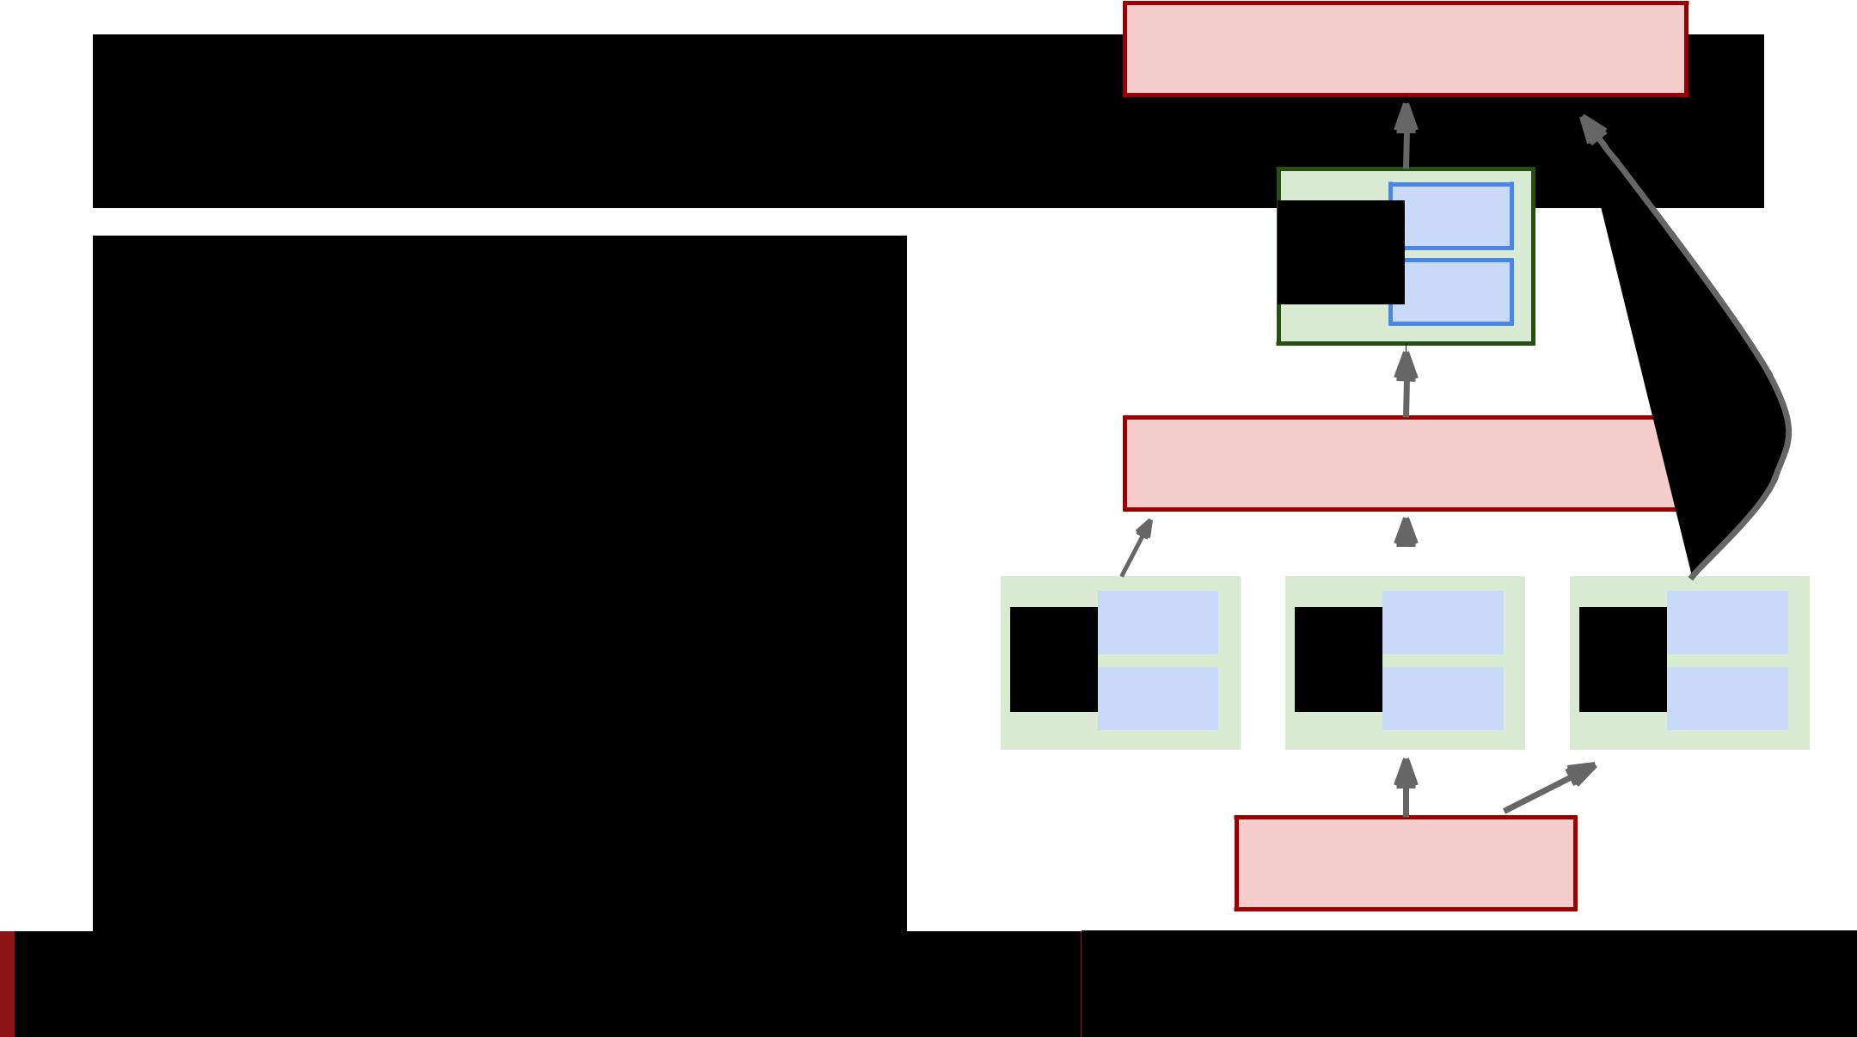

* **Layer**: Transforms bottomblobs to top blobs ([header + source](https://github.com/BVLC/caffe/blob/85bb397acfd383a676c125c75d877642d6b39ff6/include/caffe/layer.hpp))
* **Net**: Many layers;computes gradients via forward / backward ([header](https://github.com/BVLC/caffe/blob/85bb397acfd383a676c125c75d877642d6b39ff6/include/caffe/net.hpp) [source](https://github.com/BVLC/caffe/blob/85bb397acfd383a676c125c75d877642d6b39ff6/src/caffe/net.cpp))
* **Solver**: Uses gradients toupdate weights ([header](https://github.com/BVLC/caffe/blob/85bb397acfd383a676c125c75d877642d6b39ff6/include/caffe/solver.hpp) [source](https://github.com/BVLC/caffe/blob/85bb397acfd383a676c125c75d877642d6b39ff6/src/caffe/solver.cpp))

InnerProductLayer



|  |  |  |  |  |  |  |  |  |  |  |  |  |
| --- | --- | --- | --- | --- | --- | --- | --- | --- | --- | --- | --- | --- |
|  |  |  |  |  |  |  |  |  |  |  |  |  |
|  |  |  |  |  |  |  |  |  |  |  |  |  |
| W | data |  |  | X |  | data |  |  | y | data |  |  |
|  |  |  |  |  |  |  |  |  |  |
| diffs |  | diffs |  | diffs |  |
|  |  |  |  |  |  |  |  |  |  |  |  |  |



DataLayer

Fei Lecture 12 6 22 Feb 2016

**Caffe: Protocol Buffers**

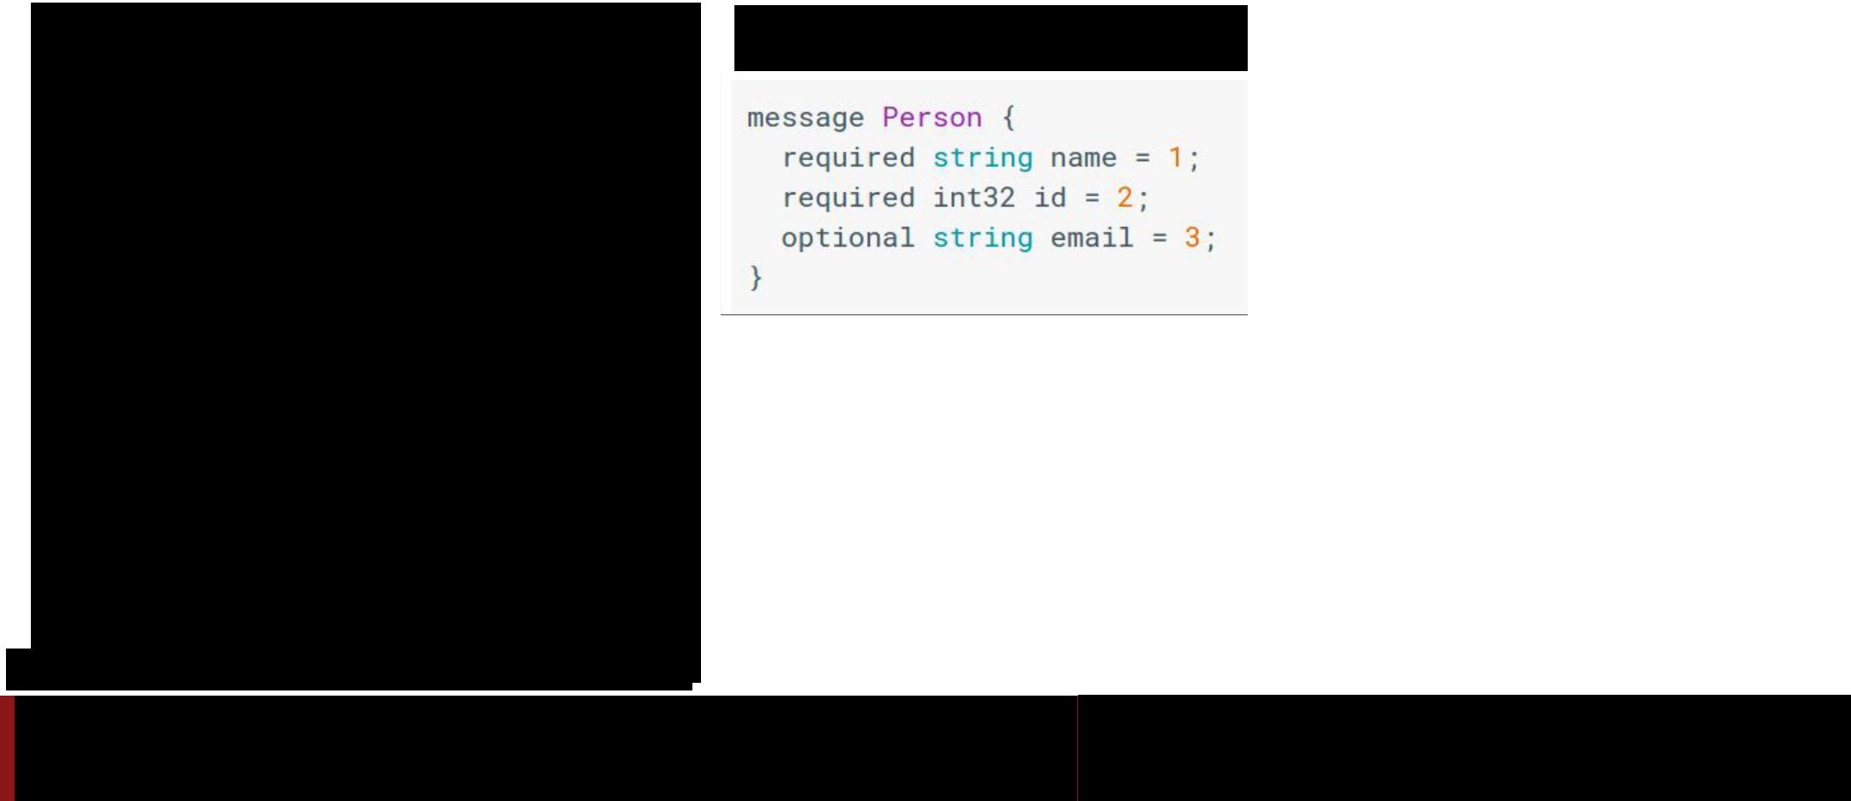

* “Typed JSON” from Google
* Define “message types” in .proto files

**.proto file**

<https://developers.google.com/protocol-buffers/>

Fei-Fei Li & Andrej Karpathy & Justin Johnson Lecture 12 7 22 Feb 2016

**Caffe: Protocol Buffers**

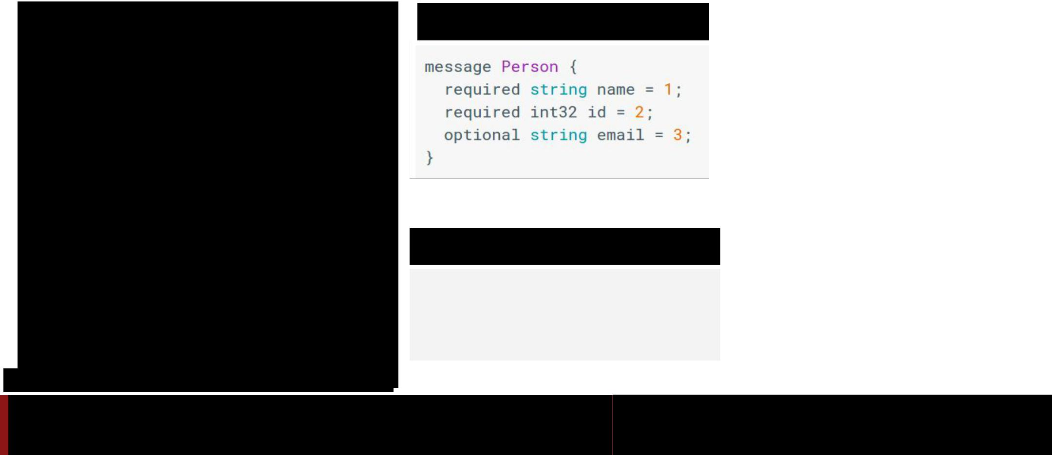

* “Typed JSON” from Google
* Define “message types” in .proto files
* Serialize instances to text files (.prototxt)

**.proto file**

**.prototxt file**

**name: “John Doe”**

**id: 1234**

**email: “jdoe@example.com”**

<https://developers.google.com/protocol-buffers/>

Fei-Fei Li & Andrej Karpathy & Justin Johnson Lecture 12 8 22 Feb 2016

**Caffe: Protocol Buffers**

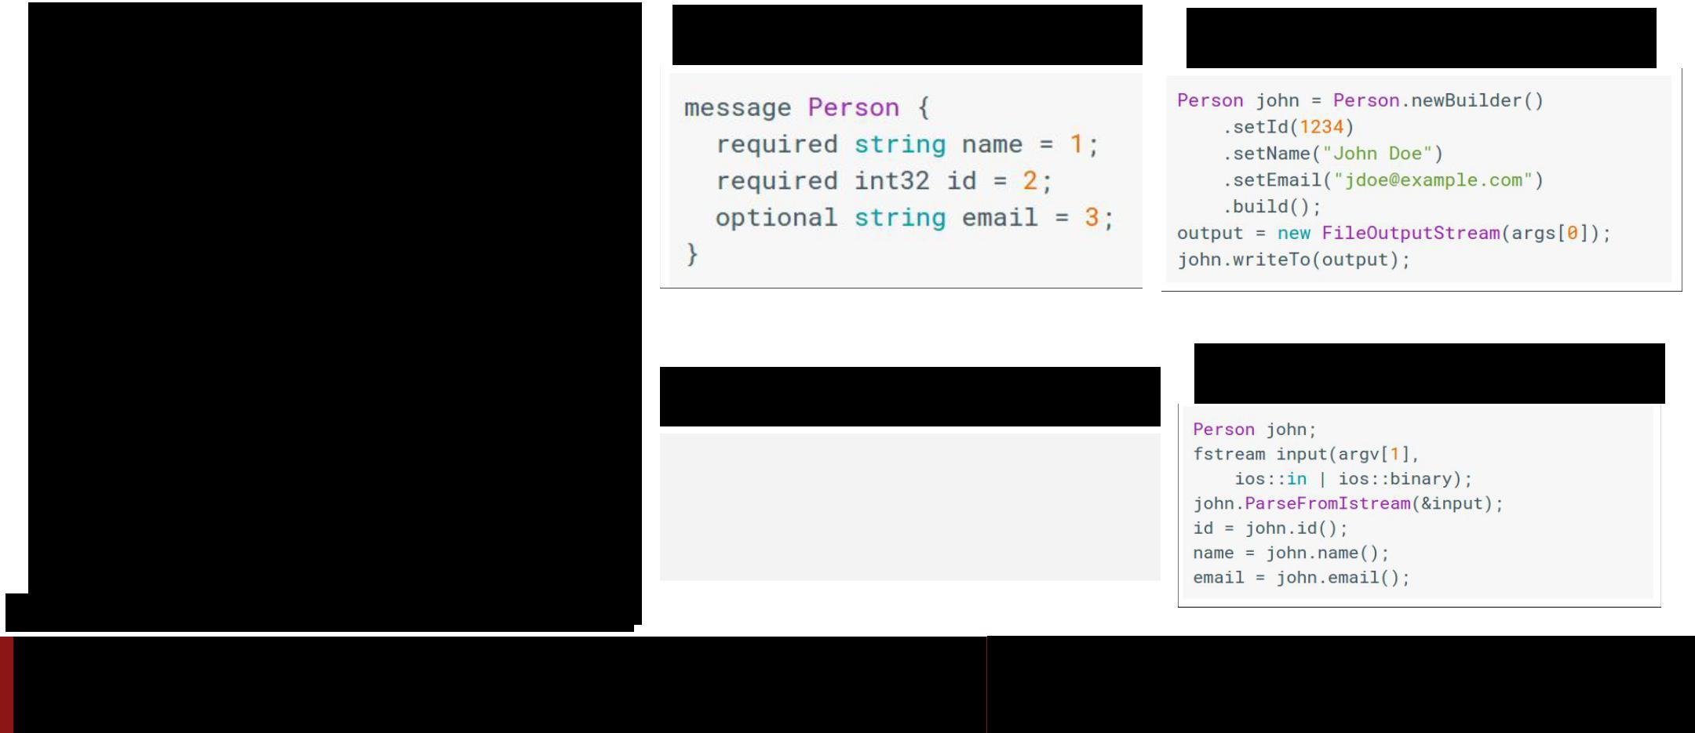

**●** “Typed JSON”

from Google

● Define “message

types” in .proto files

● Serialize instances to

**.proto file** **Java class**

text files (.prototxt)

● Compile classes for

**.prototxt file**

**name: “John Doe”**

**id: 1234**

**C++ class**

different languages

**email: “jdoe@example.com”**

<https://developers.google.com/protocol-buffers/>

Fei-Fei Li & Andrej Karpathy & Justin Johnson Lecture 12 9 22 Feb 2016

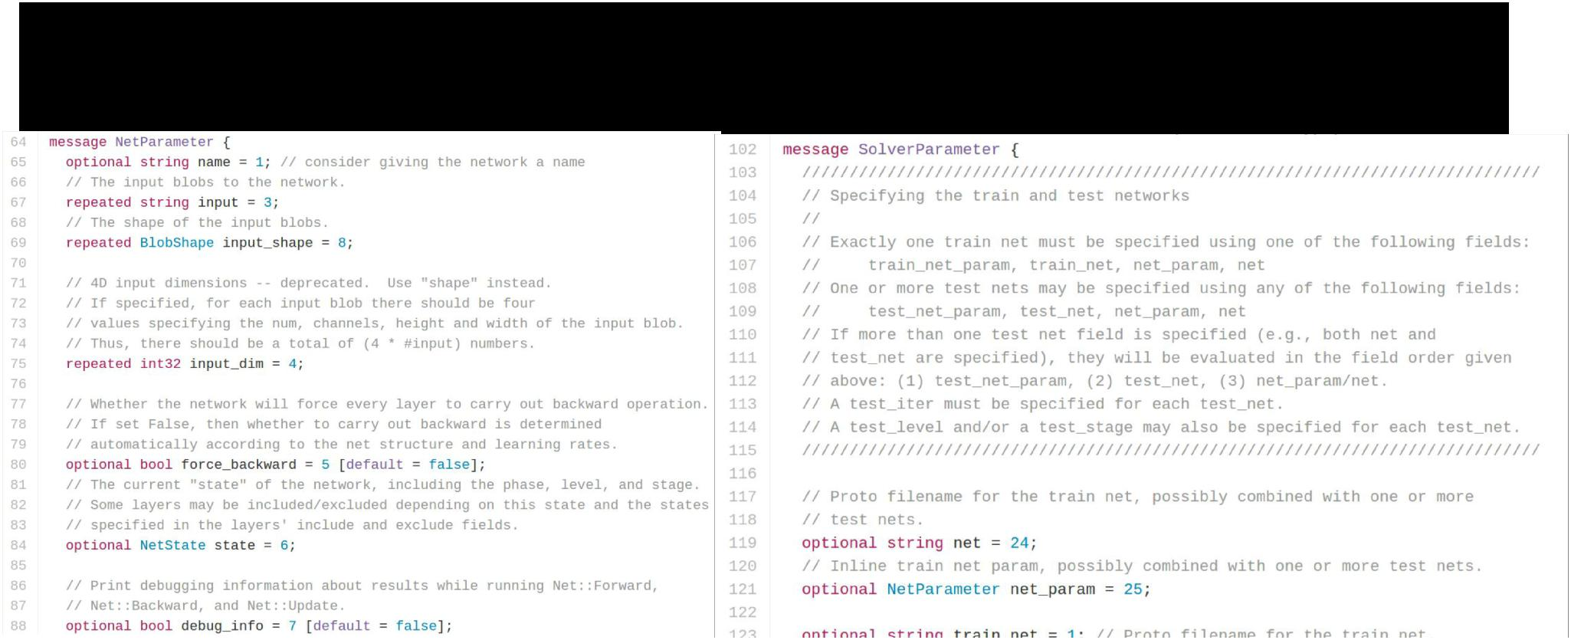**Caffe: Protocol Buffers**



<https://github.com/BVLC/caffe/blob/master/src/caffe/proto/caffe.proto> <- **All Caffe proto types defined here, good documentation!**



Fei-Fei Li & Andrej Karpathy & Justin Johnson Lecture 12 10 22 Feb 2016



**Caffe: Training / Finetuning**



No need to write code!

1. Convert data (run a script)
2. Define net (edit prototxt)
3. Define solver (edit prototxt)
4. Train (with pretrained weights) (run a script)

|  |  |
| --- | --- |
| Fei | 2016 |
|  |  |



**Caffe Step 1: Convert Data**



* DataLayer reading from LMDB is the easiest
* Create LMDB using [convert_imageset](https://github.com/BVLC/caffe/blob/85bb397acfd383a676c125c75d877642d6b39ff6/tools/convert_imageset.cpp)
* Need text file where each line is
  + “[path/to/image.jpeg] [label]”
* Create HDF5 file yourself using h5py

|  |  |
| --- | --- |
| Fei | 2016 |
|  |  |

**Caffe Step 1: Convert Data**



* ImageDataLayer: Read from image files
* WindowDataLayer: For detection
* HDF5Layer: Read from HDF5 file
* From memory, using Python interface
* All of these are harder to use (except Python)



Fei-Fei Li & Andrej Karpathy & Justin Johnson Lecture 12 13 22 Feb 2016

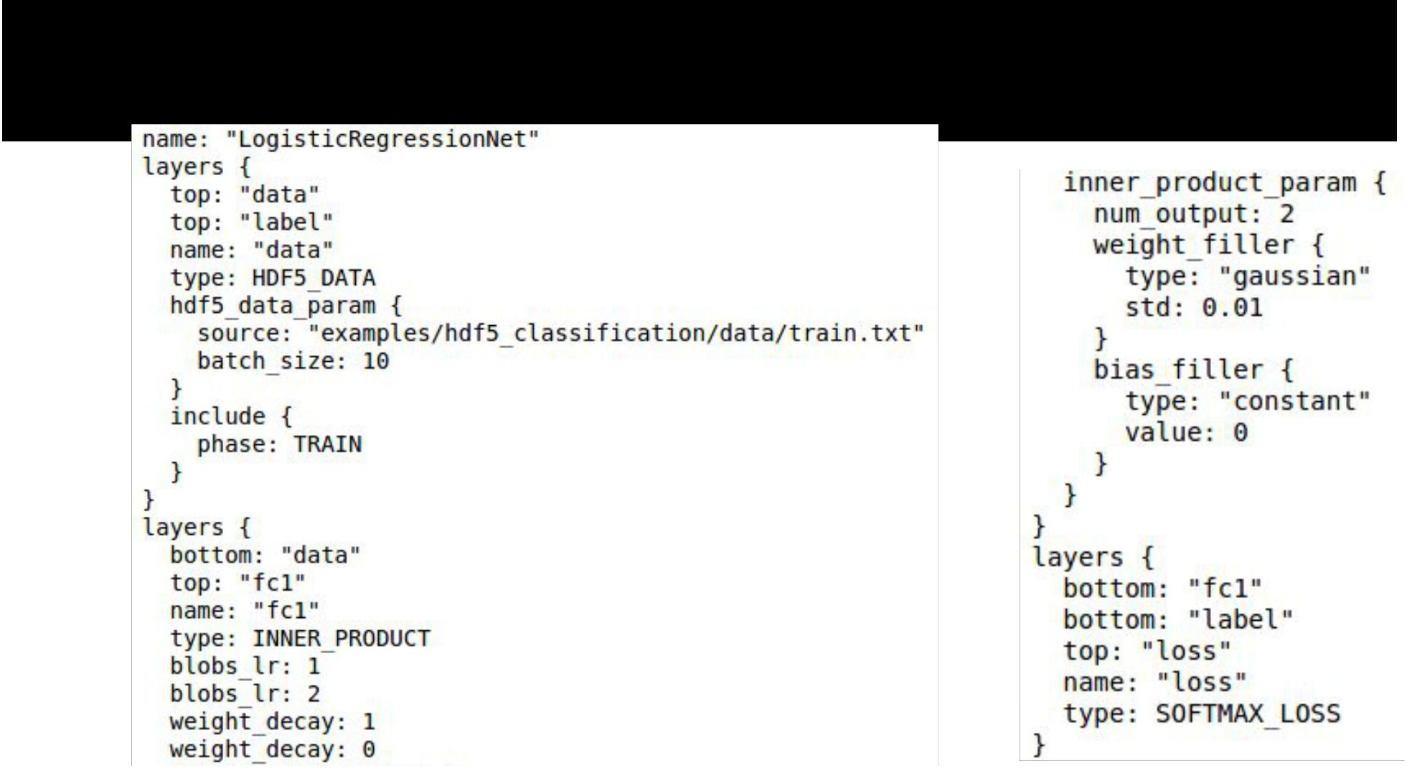**Caffe Step 2: Define Net**



Fei-Fei Li & Andrej Karpathy & Justin Johnson Lecture 12 14 22 Feb 2016

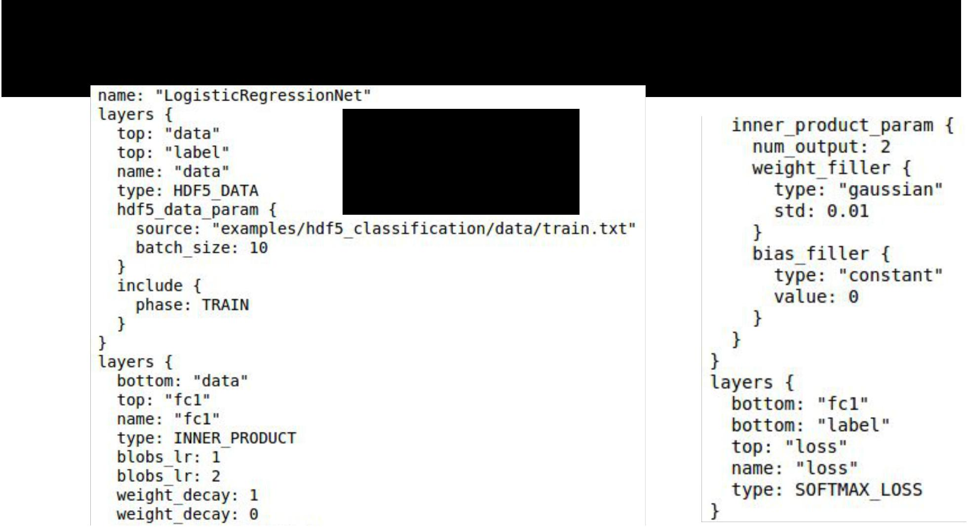**Caffe Step 2: Define Net**

Layers and Blobs



often have same



name!



Fei-Fei Li & Andrej Karpathy & Justin Johnson Lecture 12 15 22 Feb 2016

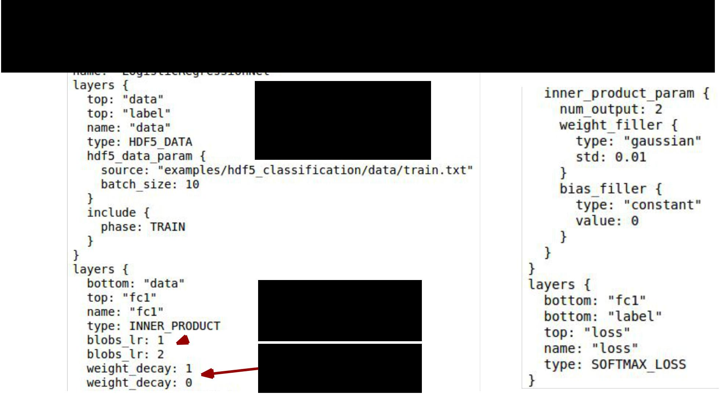**Caffe Step 2: Define Net**

Layers and Blobs



often have same



name!

Learning rates

(weight + bias)

Regularization

(weight + bias)



Fei-Fei Li & Andrej Karpathy & Justin Johnson Lecture 12 16 22 Feb 2016

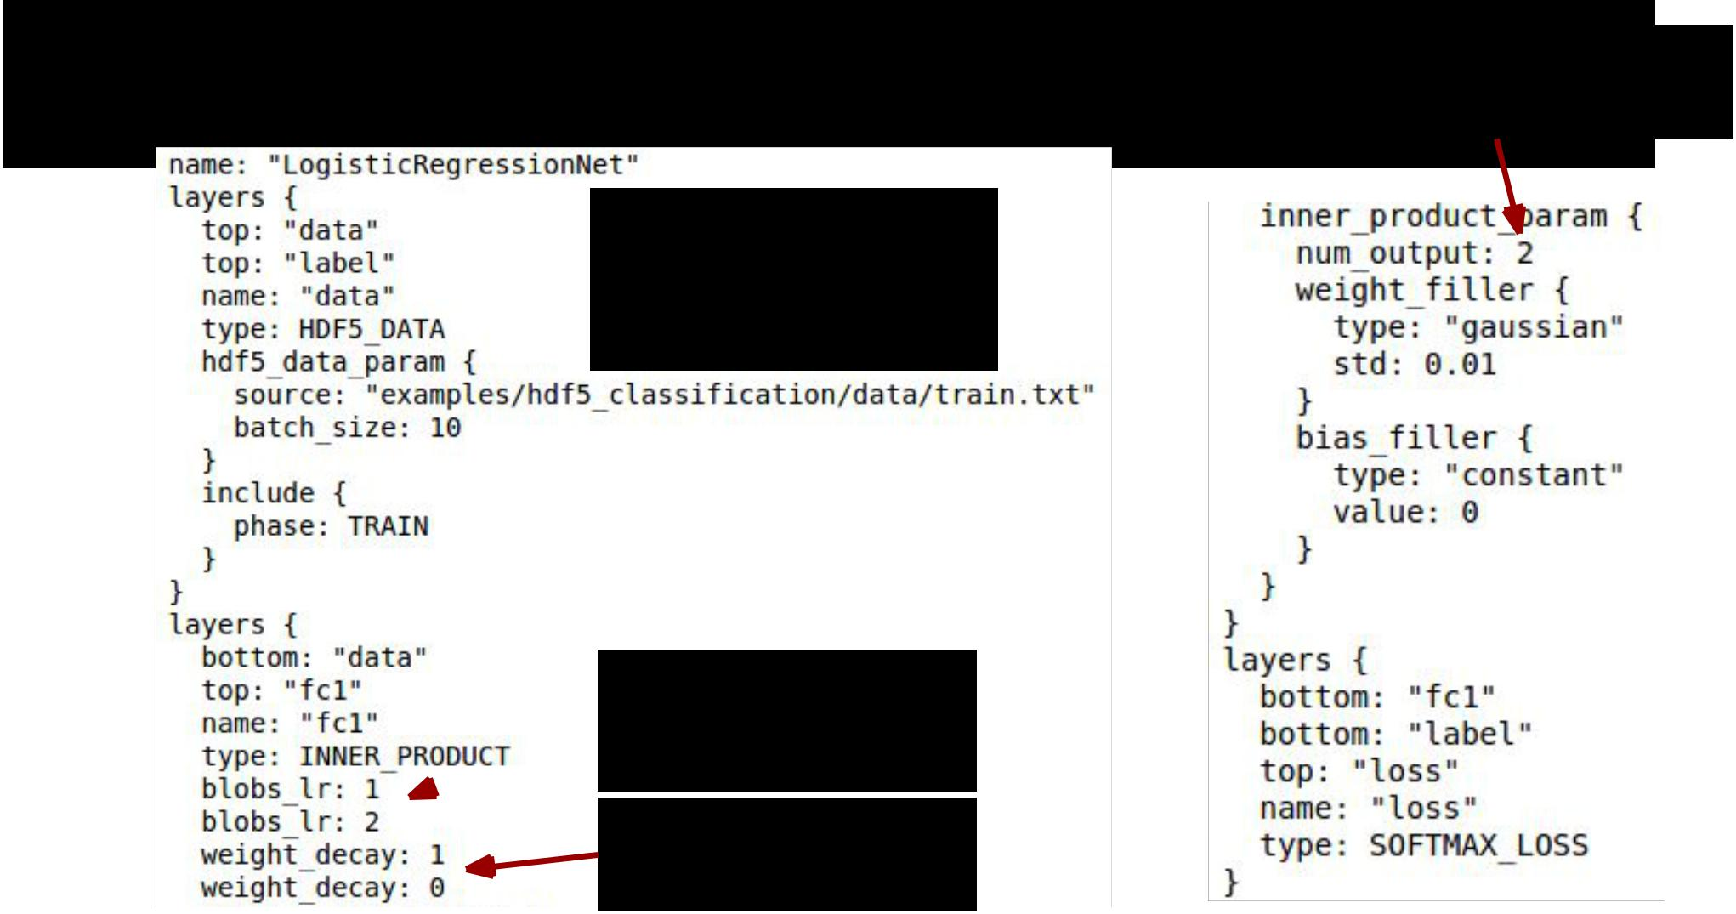**Caffe Step 2: Define Net**

Layers and Blobs often have same name!



Learning rates

(weight + bias)

Regularization

(weight + bias)



Fei-Fei Li & Andrej Karpathy & Justin Johnson

Number of output

classes

Lecture 12 17 22 Feb 2016

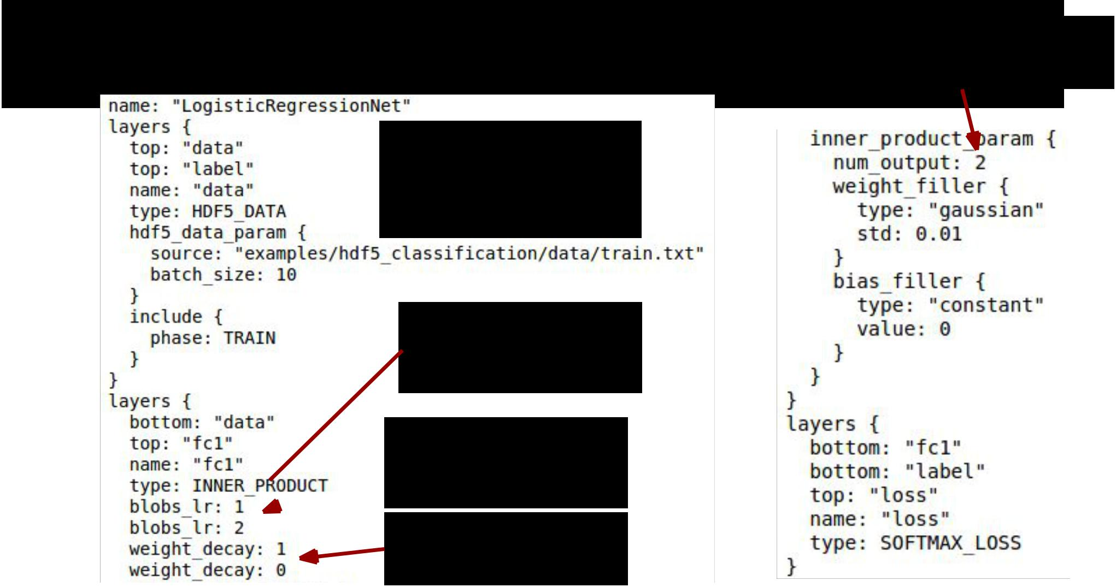**Caffe Step 2: Define Net**

Layers and Blobs



often have same



name!

Set these to 0 to

freeze a layer

Number of output

classes

Learning rates

(weight + bias)

Regularization

(weight + bias)



Fei-Fei Li & Andrej Karpathy & Justin Johnson Lecture 12 18 22 Feb 2016

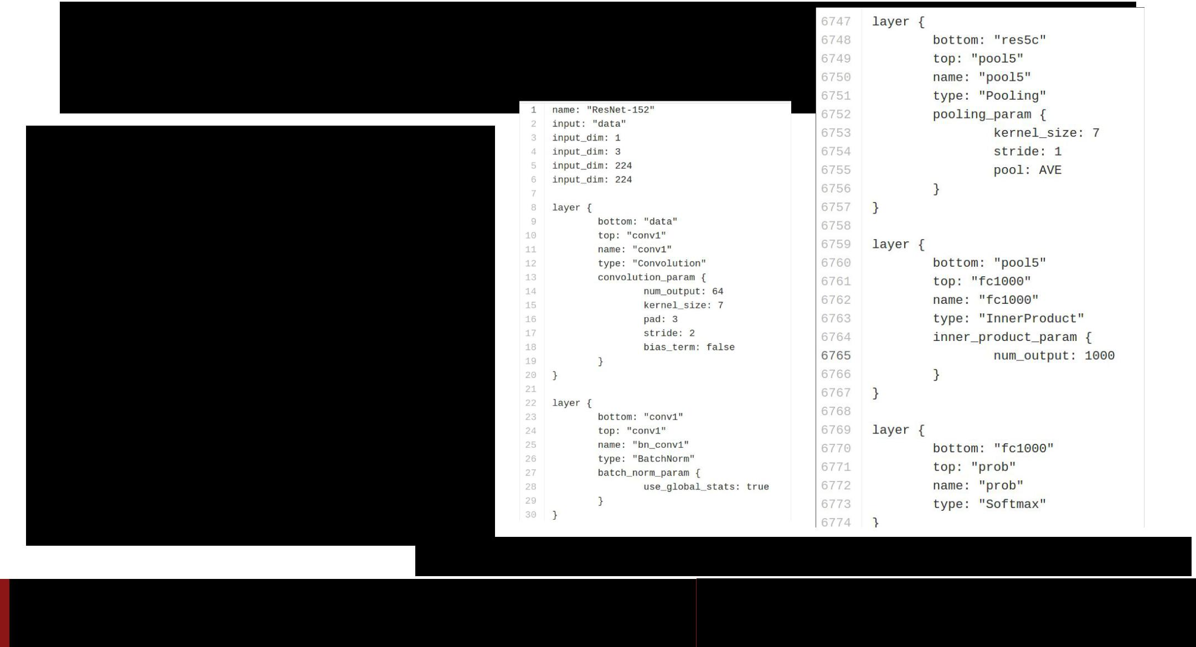**Caffe Step 2: Define Net**

* .prototxt can get ugly for big models
* ResNet-152 prototxt is 6775 lines long!
* Not “compositional”; can’t easily define a residual block and reuse

<https://github.com/KaimingHe/deep-residual-networks/blob/master/prototxt/ResNet-152-deploy.prototxt>

Fei-Fei Li & Andrej Karpathy & Justin Johnson Lecture 12 19 22 Feb 2016

**Caffe Step 2: Define Net (finetuning)**

**Original prototxt:**

**layer {**

**name: "fc7"**

**type: "InnerProduct" inner_product_param { num_output: 4096**

**}**

**}**

**[... ReLU, Dropout] layer {**

**name: "fc8"**

**type: "InnerProduct" inner_product_param { num_output: 1000**

**}**

**}**

**Pretrained weights:**

**“fc7.weight”: [values]**

**“fc7.bias”: [values]**

**“fc8.weight”: [values]**

**“fc8.bias”: [values]**

**Modified prototxt:**

**layer {**

**name: "fc7"**

**type: "InnerProduct" inner_product_param { num_output: 4096**

**}**

**}**

**[... ReLU, Dropout] layer {**

**name: "my-fc8" type: "InnerProduct" inner_product_param {**

**num_output: 10**

**}**

**}**

Fei-Fei Li & Andrej Karpathy & Justin Johnson Lecture 12 20 22 Feb 2016

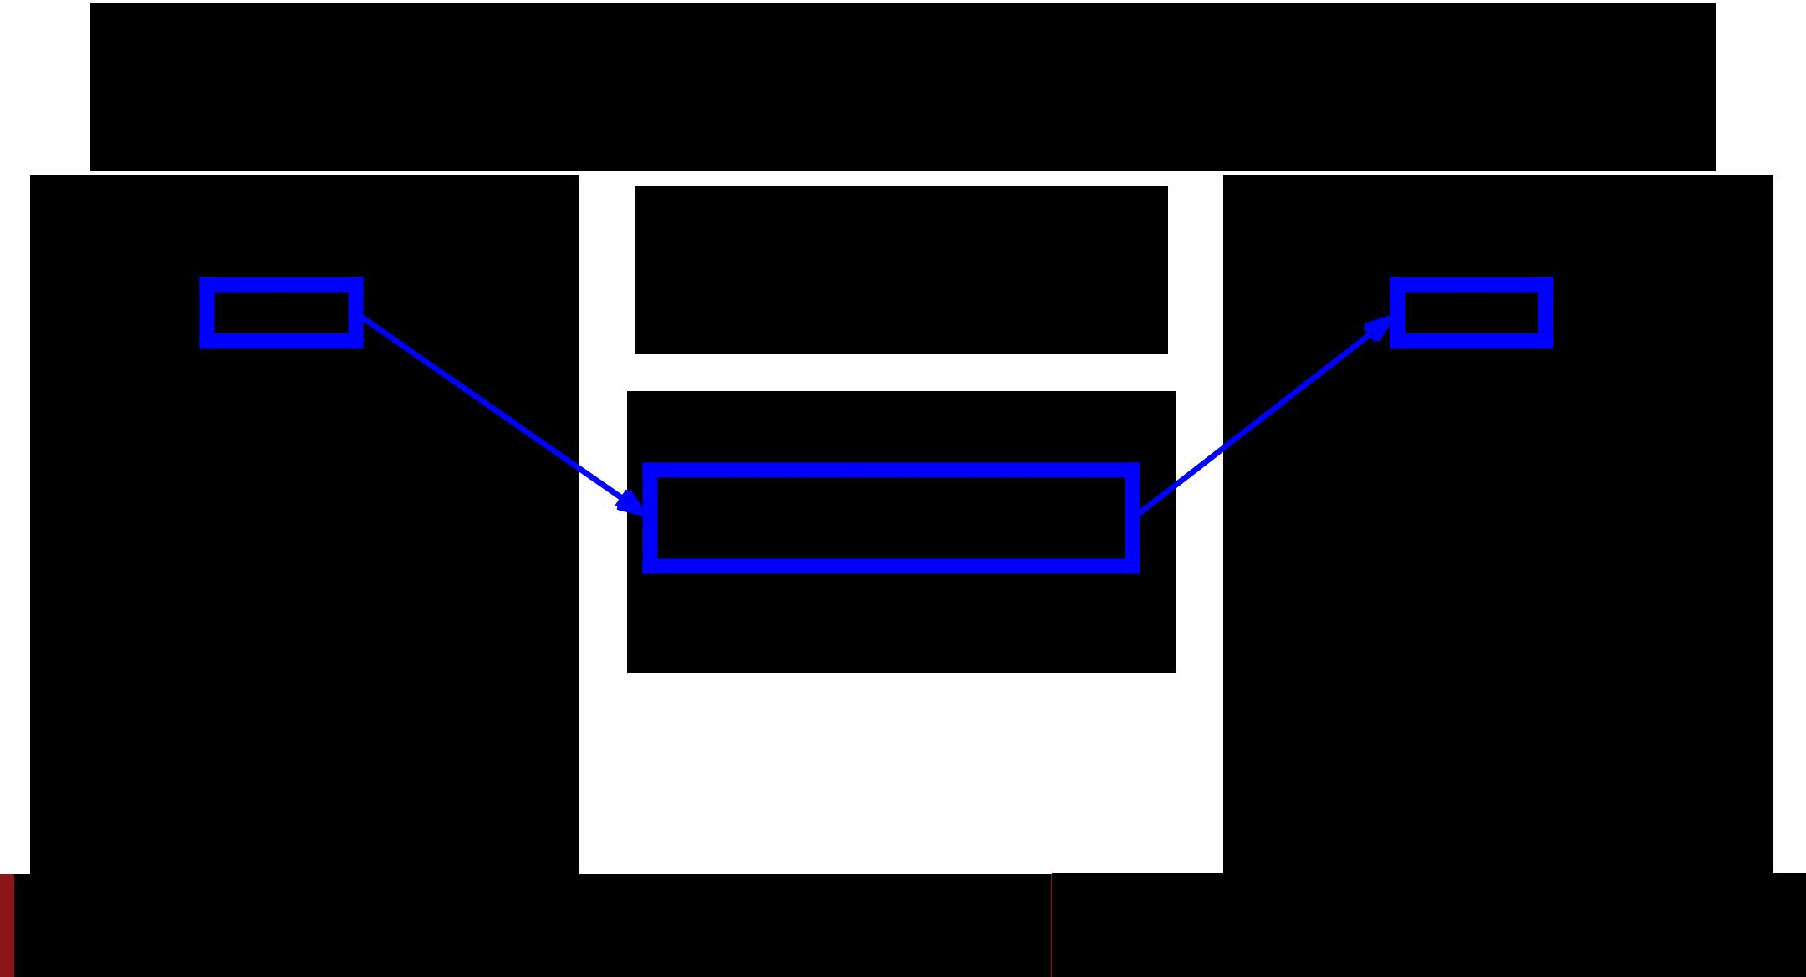**Caffe Step 2: Define Net (finetuning)**

**Original prototxt:**

**layer {**

**name:**

**type: "InnerProduct" inner_product_param { num_output: 4096**

**}**

**}**

**[... ReLU, Dropout] layer {**

**name: "fc8"**

**type: "InnerProduct" inner_product_param { num_output: 1000**

**}**

**}**

Same name:

weights copied

**Pretrained weights:**

**“fc8.weight”: [values]**

**“fc8.bias”: [values]**

**Modified prototxt:**

**layer {**

**name:**

**type: "InnerProduct" inner_product_param { num_output: 4096**

**}**

**}**

**[... ReLU, Dropout] layer {**

**name: "my-fc8" type: "InnerProduct" inner_product_param {**

**num_output: 10**

**}**

**}**

Fei-Fei Li & Andrej Karpathy & Justin Johnson Lecture 12 21 22 Feb 2016

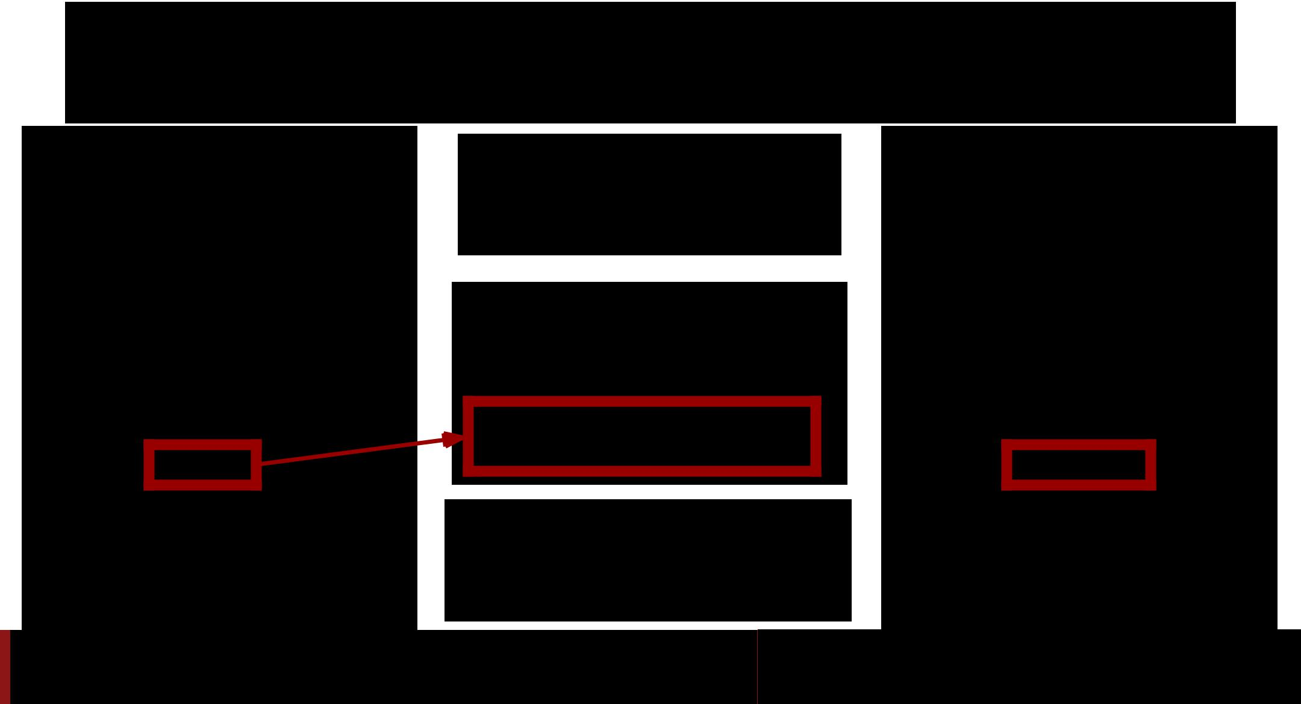**Caffe Step 2: Define Net (finetuning)**

**Original prototxt:**

**layer {**

**name: "fc7"**

**type: "InnerProduct" inner_product_param { num_output: 4096**

**}**

**}**

**[... ReLU, Dropout] layer {**

**name:**

**type: "InnerProduct" inner_product_param { num_output: 1000**

**}**

**}**

Same name:

weights copied

**Pretrained weights:**

**“fc7.weight”: [values]**

**“fc7.bias”: [values]**

Different name:

weights reinitialized

**Modified prototxt:**

**layer {**

**name: "fc7"**

**type: "InnerProduct" inner_product_param { num_output: 4096**

**}**

**}**

**[... ReLU, Dropout] layer {**

**name:**

**type: "InnerProduct" inner_product_param {**

**num_output: 10**

**}**

**}**

Fei-Fei Li & Andrej Karpathy & Justin Johnson Lecture 12 22 22 Feb 2016

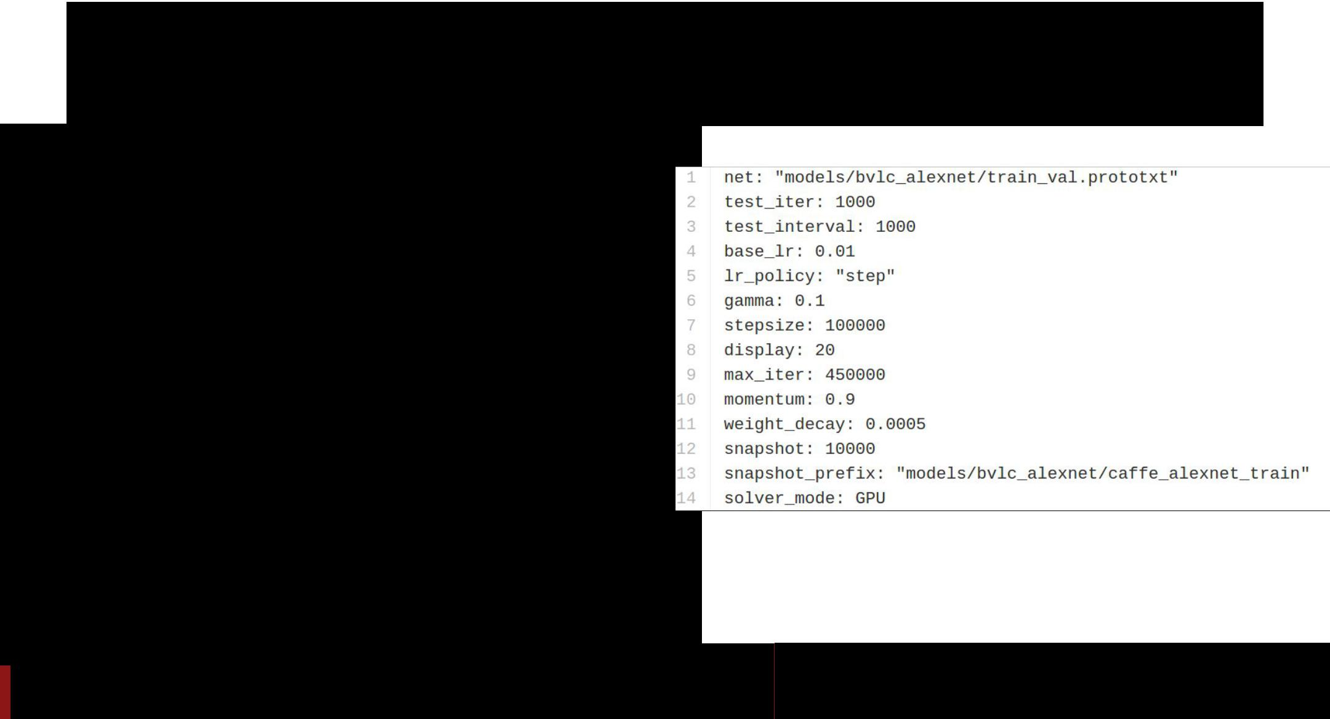**Caffe Step 3: Define Solver**

* Write a prototxt file defining a [SolverParameter](https://github.com/BVLC/caffe/blob/85bb397acfd383a676c125c75d877642d6b39ff6/src/caffe/proto/caffe.proto#L92)
* If finetuning, copy existing solver. prototxt file
  + Change net to be your net
  + Change snapshot_prefix to your output
  + Reduce base learning rate (divide by 100)
  + Maybe change max_iter and snapshot

Fei-Fei Li & Andrej Karpathy & Justin Johnson Lecture 12 23 22 Feb 2016

**Caffe Step 4: Train!**



**./build/tools/caffe train \ -gpu 0 \**

**-model path/to/trainval.prototxt \ -solver path/to/solver.prototxt \**

**-weights path/to/pretrained_weights.caffemodel**

<https://github.com/BVLC/caffe/blob/master/tools/caffe.cpp>



Fei-Fei Li & Andrej Karpathy & Justin Johnson Lecture 12 24 22 Feb 2016

**Caffe Step 4: Train!**

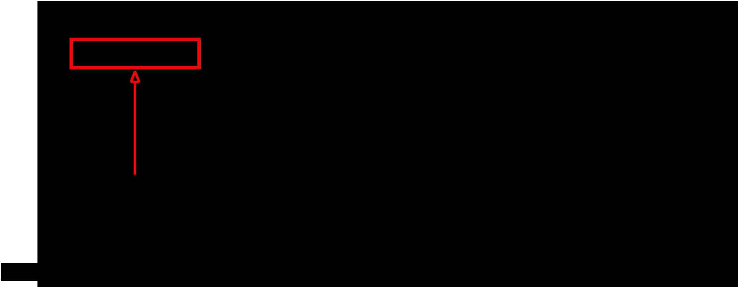

**./build/tools/caffe train \**

**-model path/to/trainval.prototxt \ -solver path/to/solver.prototxt \**



**-weights path/to/pretrained_weights.caffemodel**

**-gpu -1** 

<https://github.com/BVLC/caffe/blob/master/tools/caffe.cpp>



Fei-Fei Li & Andrej Karpathy & Justin Johnson Lecture 12 25 22 Feb 2016

**Caffe Step 4: Train!**



**./build/tools/caffe train \**

**-model path/to/trainval.prototxt \ -solver path/to/solver.prototxt \**



**-weights path/to/pretrained_weights.caffemodel**

**-gpu all** 

<https://github.com/BVLC/caffe/blob/master/tools/caffe.cpp>



Fei-Fei Li & Andrej Karpathy & Justin Johnson Lecture 12 26 22 Feb 2016

**Caffe: Model Zoo**



AlexNet, VGG, GoogLeNet, ResNet, plus others

<https://github.com/BVLC/caffe/wiki/Model-Zoo>



Fei-Fei Li & Andrej Karpathy & Justin Johnson Lecture 12 27 22 Feb 2016

**Caffe: Python Interface**



Not much documentation…

Read the code! Two most important files:

* [caffe/python/caffe/_caffe.cpp](https://github.com/BVLC/caffe/blob/master/python/caffe/_caffe.cpp):
  + Exports Blob, Layer, Net, and Solver classes
* [caffe/python/caffe/pycaffe.py](https://github.com/BVLC/caffe/blob/master/python/caffe/pycaffe.py)
  + Adds extra methods to Net class



Fei-Fei Li & Andrej Karpathy & Justin Johnson Lecture 12 28 22 Feb 2016

**Caffe: Python Interface**



Good for:

* Interfacing with numpy
* Extract features: Run net forward
* Compute gradients: Run net backward (DeepDream, etc)
* Define layers in Python with numpy (CPU only)



Fei-Fei Li & Andrej Karpathy & Justin Johnson Lecture 12 29 22 Feb 2016

**Caffe Pros / Cons**



* (+) Good for feedforward networks
* (+) Good for finetuning existing networks
* (+) Train models without writing any code!
* (+) Python interface is pretty useful!
* (-) Need to write C++ / CUDA for new GPU layers
* (-) Not good for recurrent networks
* (-) Cumbersome for big networks (GoogLeNet, ResNet)



Fei-Fei Li & Andrej Karpathy & Justin Johnson Lecture 12 30 22 Feb 2016

Torch



<http://torch.ch>



Fei-Fei Li & Andrej Karpathy & Justin Johnson Lecture 12 31 22 Feb 2016

Torch Overview



* From NYU + IDIAP
* Written in C and Lua
* Used a lot a Facebook, DeepMind



Fei-Fei Li & Andrej Karpathy & Justin Johnson Lecture 12 32 22 Feb 2016

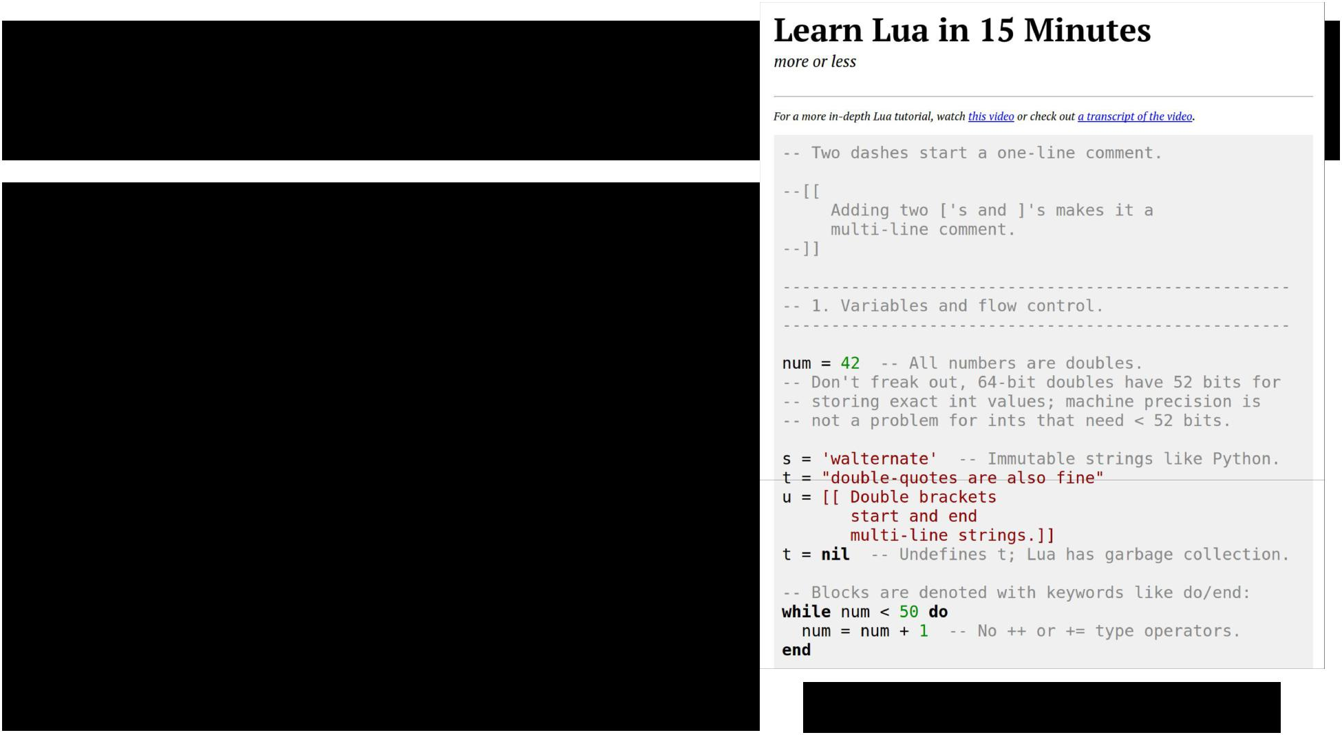

Torch: Lua

|  |  |  |  |  |  |  |
| --- | --- | --- | --- | --- | --- | --- |
| ● High level scripting language, easy to | | |  |  |  |  |
|  | interface with C | |  |  |  |  |
| ● | Similar to Javascript: | |  |  |  |  |
|  | ○ | One data structure: |  |  |  |  |
|  |  | table == JS object |  |  |  |  |
|  | ○ | Prototypical inheritance |  |  |  |  |
|  |  | metatable == JS prototype |  |  |  |  |
|  | ○ First-class functions | |  |  |  |  |
| ● | Some gotchas: | |  |  |  |  |
|  | ○ | 1-indexed =( |  |  |  |  |
|  | ○ Variables global by default =( | |  |  |  |  |
|  | ○ | Small standard library |  | <http://tylerneylon.com/a/learn-lua/> | |  |
|  |  |  |  |  |  |  |
| Fei-Fei Li & Andrej Karpathy & Justin Johnson | | | Lecture 12 33 | | 22 Feb 2016 | |
|  |  |  |  |  |  |  |



Torch: Tensors

Torch tensors are just like numpy arrays



Fei-Fei Li & Andrej Karpathy & Justin Johnson Lecture 12 34 22 Feb 2016

Torch: Tensors

Torch tensors are just like numpy arrays

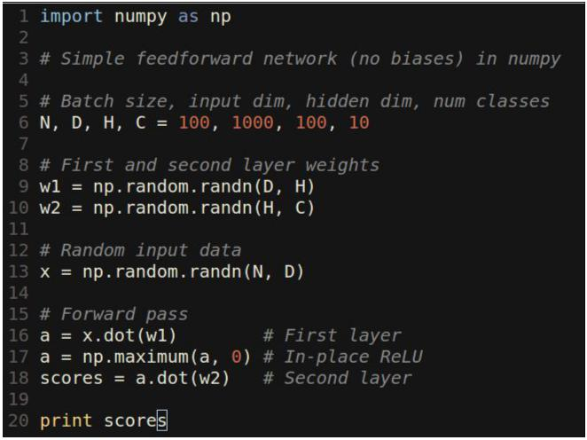

Fei-Fei Li & Andrej Karpathy & Justin Johnson Lecture 12 35 22 Feb 2016

Torch: Tensors

Torch tensors are just like numpy arrays

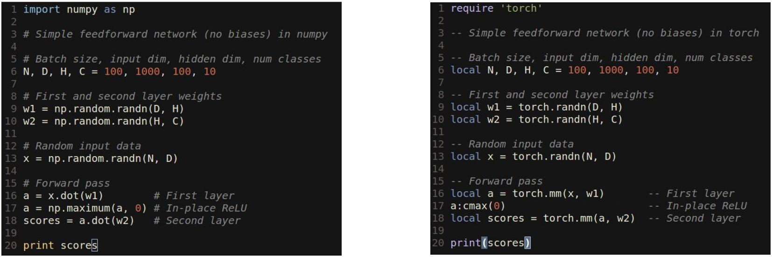

Fei-Fei Li & Andrej Karpathy & Justin Johnson Lecture 12 36 22 Feb 2016

Torch: Tensors

Like numpy, can easily change data type:

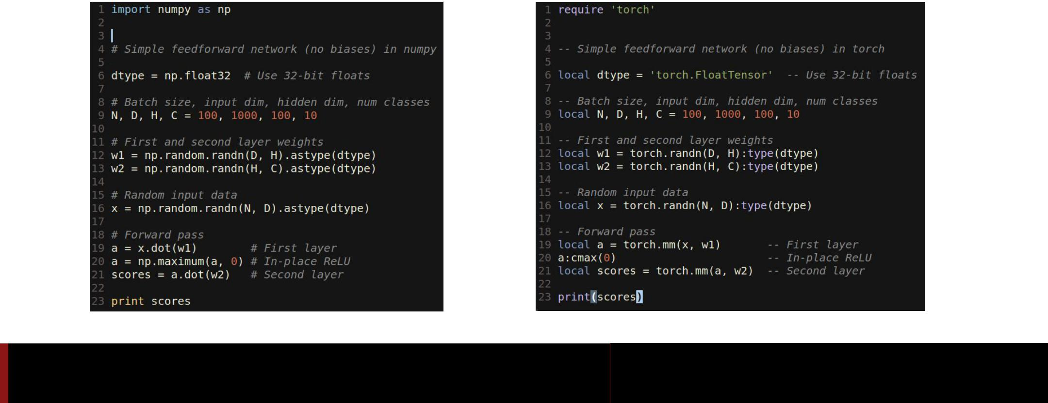

Fei-Fei Li & Andrej Karpathy & Justin Johnson Lecture 12 37 22 Feb 2016

Torch: Tensors

Unlike numpy, GPU is just a datatype away:

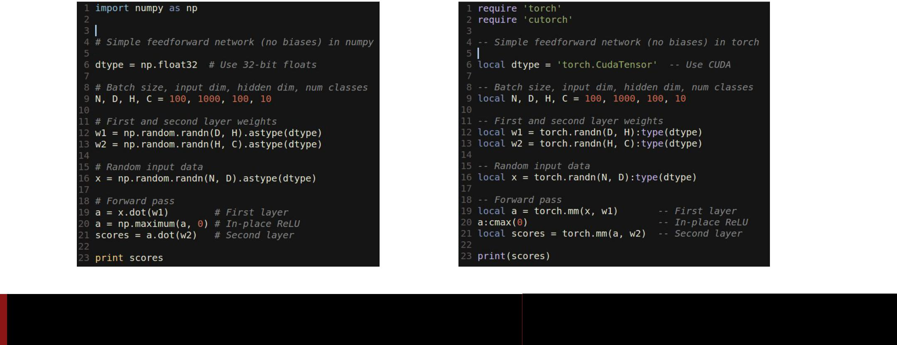

Fei-Fei Li & Andrej Karpathy & Justin Johnson Lecture 12 38 22 Feb 2016

Torch: Tensors

Documentation on GitHub:

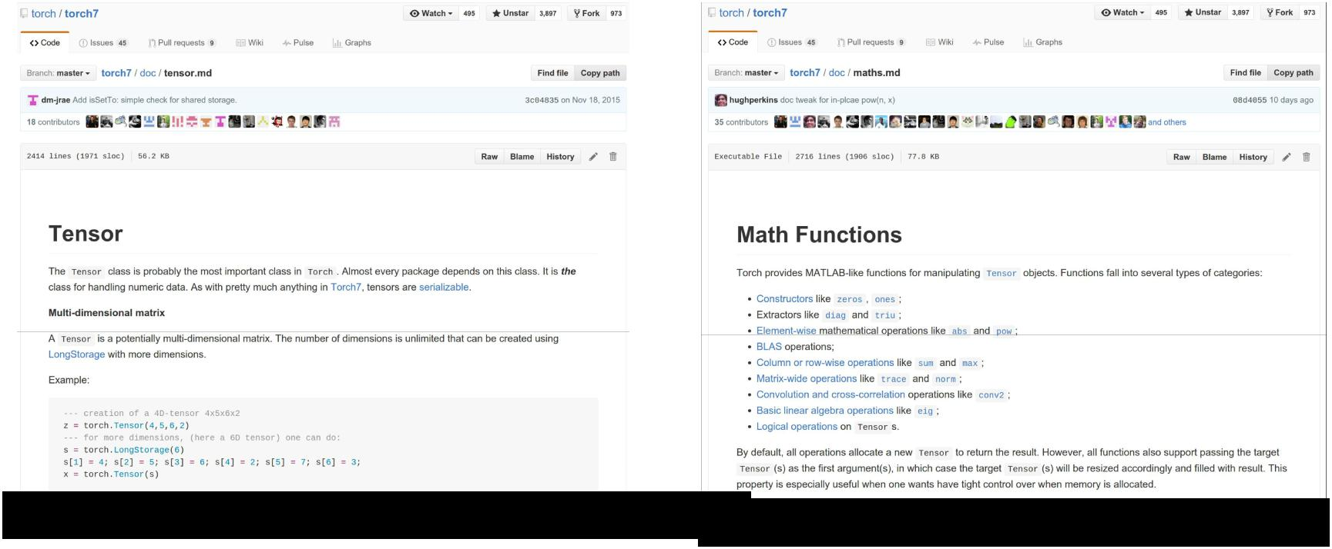

https://github.com/torch/torch7/blob/master/doc/tensor.md <https://github.com/torch/torch7/blob/master/doc/maths.md>



Fei-Fei Li & Andrej Karpathy & Justin Johnson Lecture 12 39 22 Feb 2016

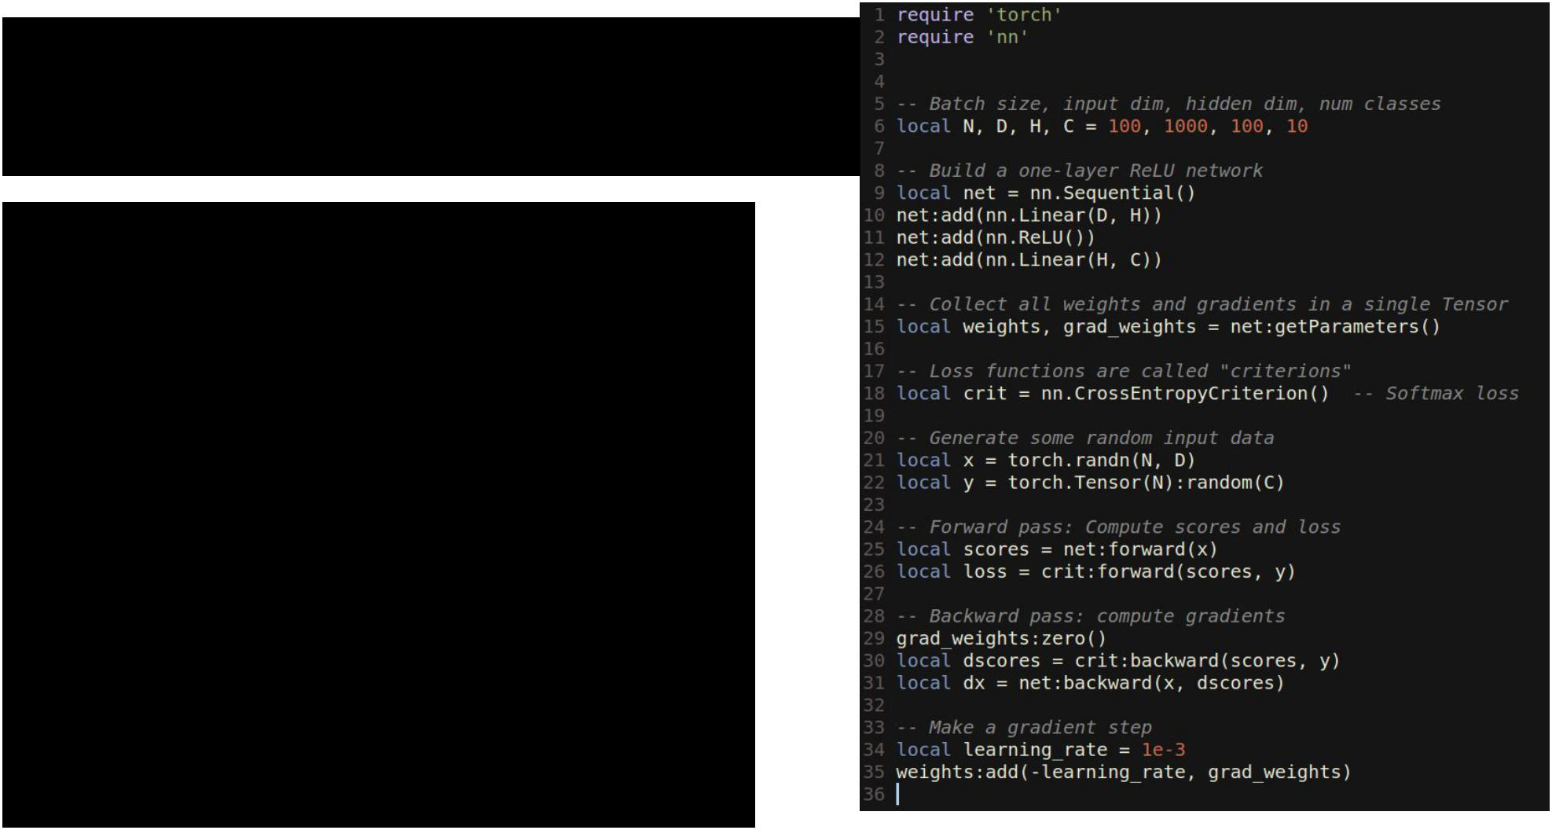Torch: nn

* nn module lets you easily build and train neural nets



Fei-Fei Li & Andrej Karpathy & Justin Johnson Lecture 12 40 22 Feb 2016

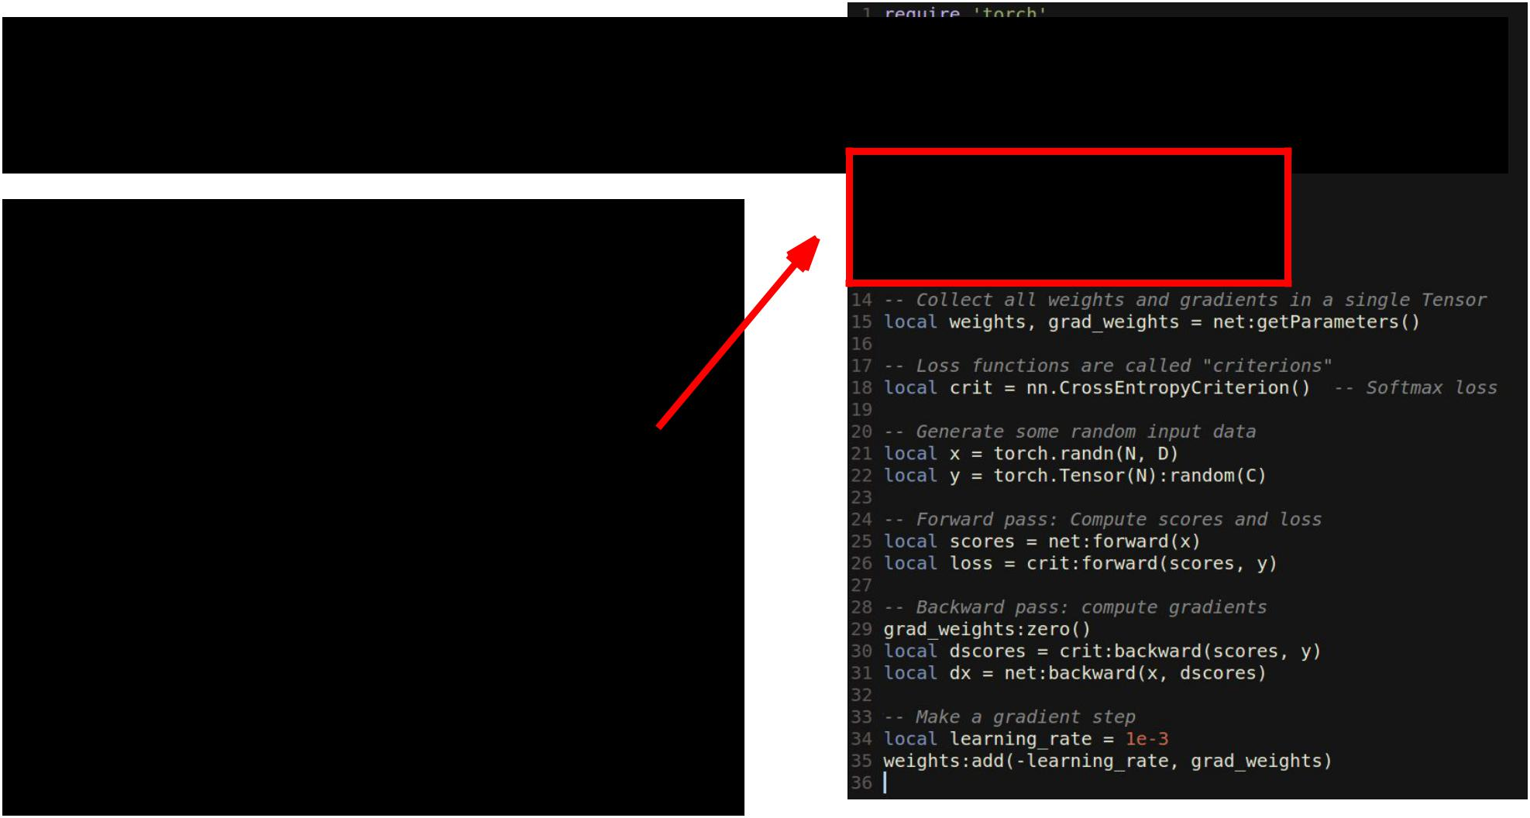Torch: nn

1. module lets you easily build and train neural nets

Build a two-layer ReLU net



Fei-Fei Li & Andrej Karpathy & Justin Johnson Lecture 12 41 22 Feb 2016

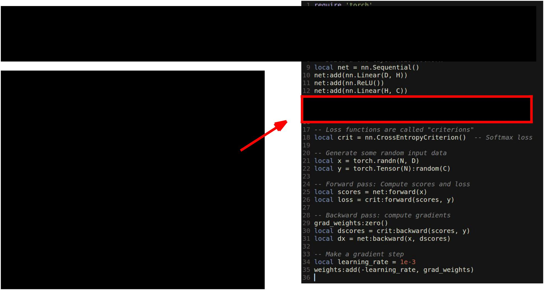Torch: nn

1. module lets you easily build and train neural nets

Get weights and gradient for entire network



Fei-Fei Li & Andrej Karpathy & Justin Johnson Lecture 12 42 22 Feb 2016

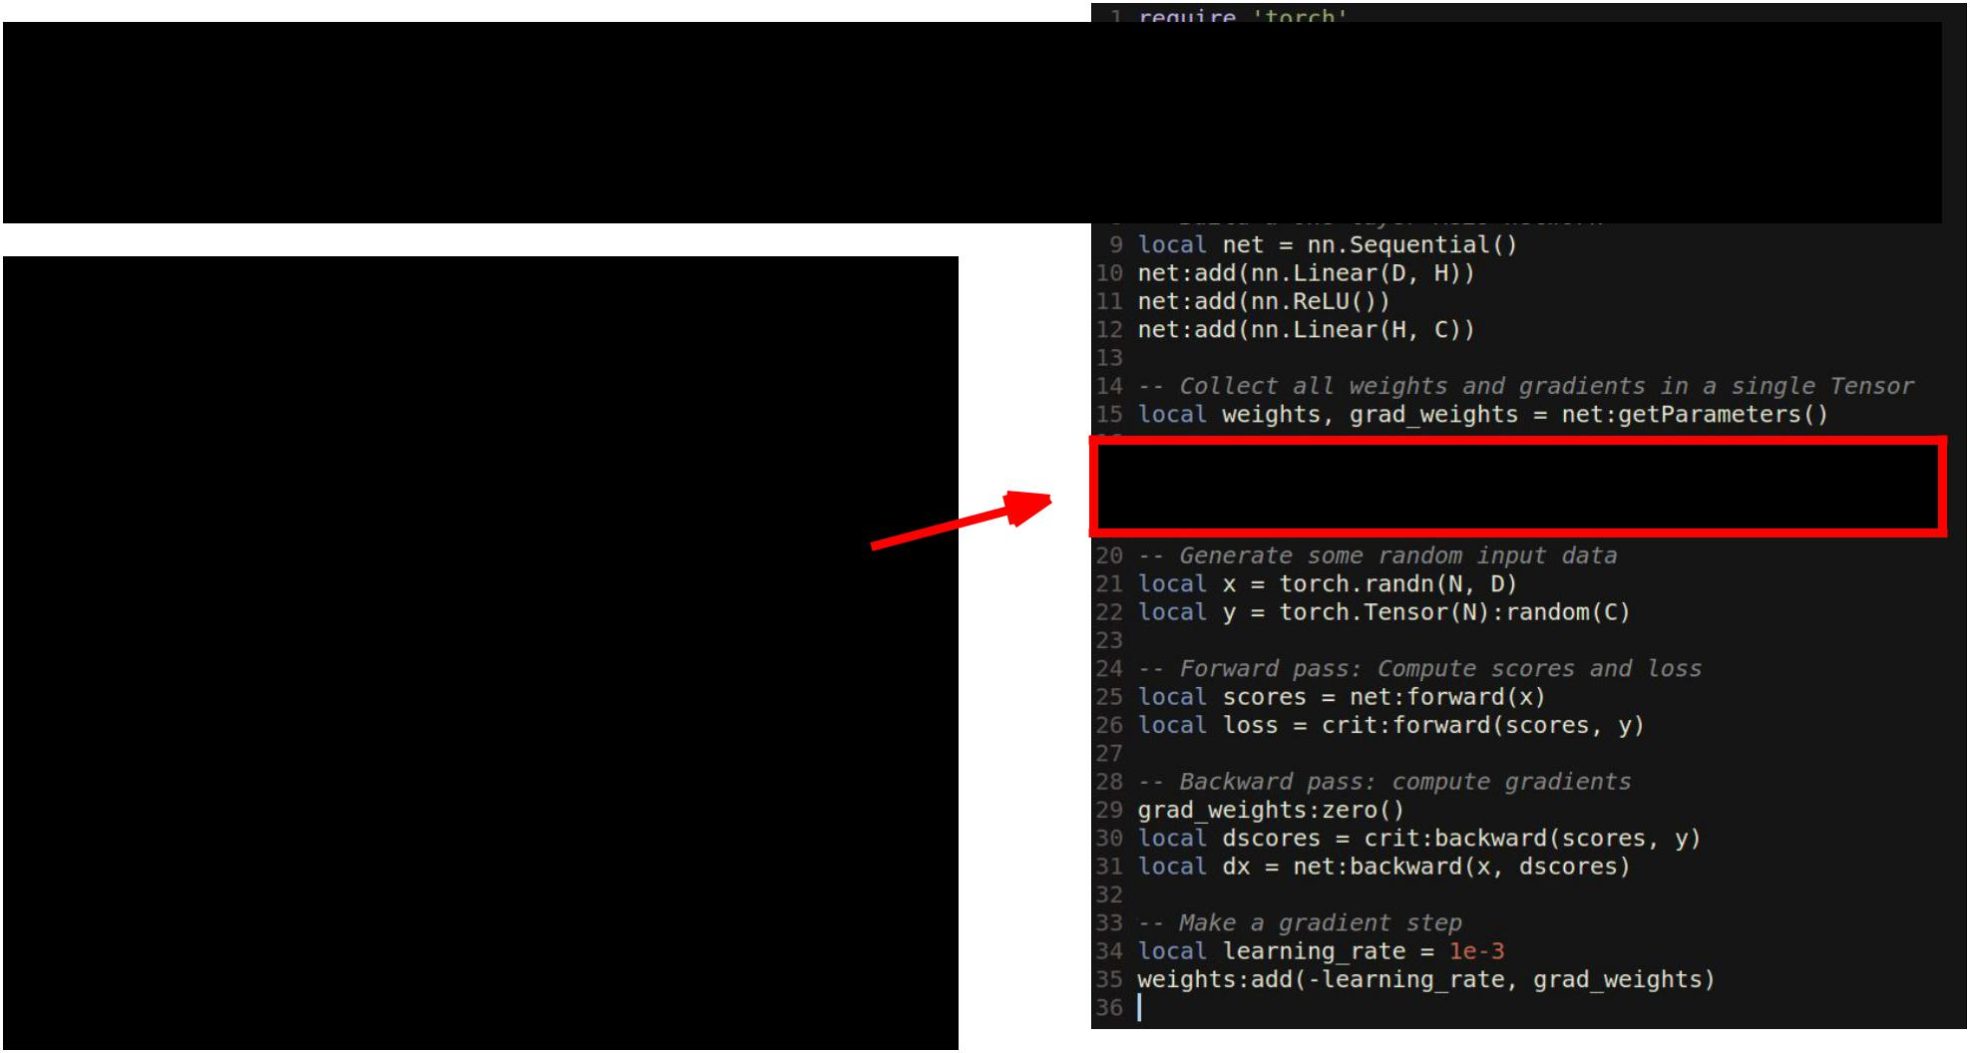Torch: nn

1. module lets you easily build and train neural nets

Use a softmax loss function



Fei-Fei Li & Andrej Karpathy & Justin Johnson Lecture 12 43 22 Feb 2016

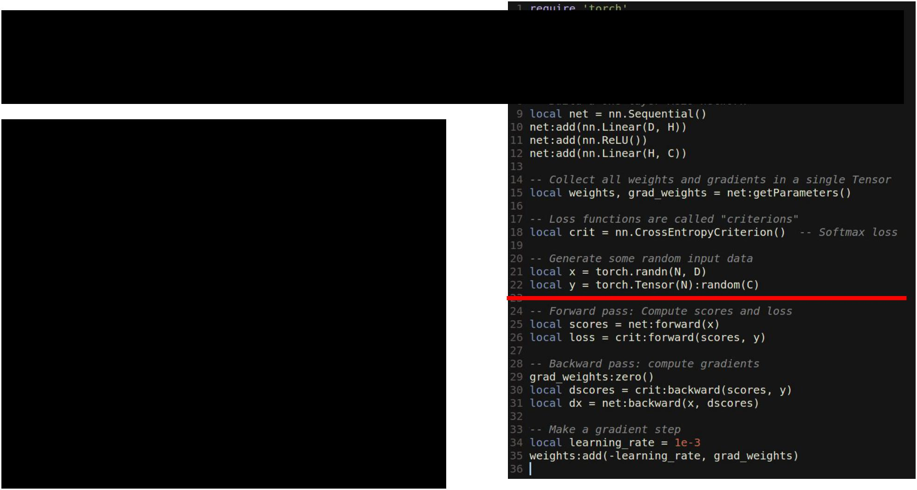Torch: nn

1. module lets you easily build and train neural nets

Generate random data 



Fei-Fei Li & Andrej Karpathy & Justin Johnson Lecture 12 44 22 Feb 2016

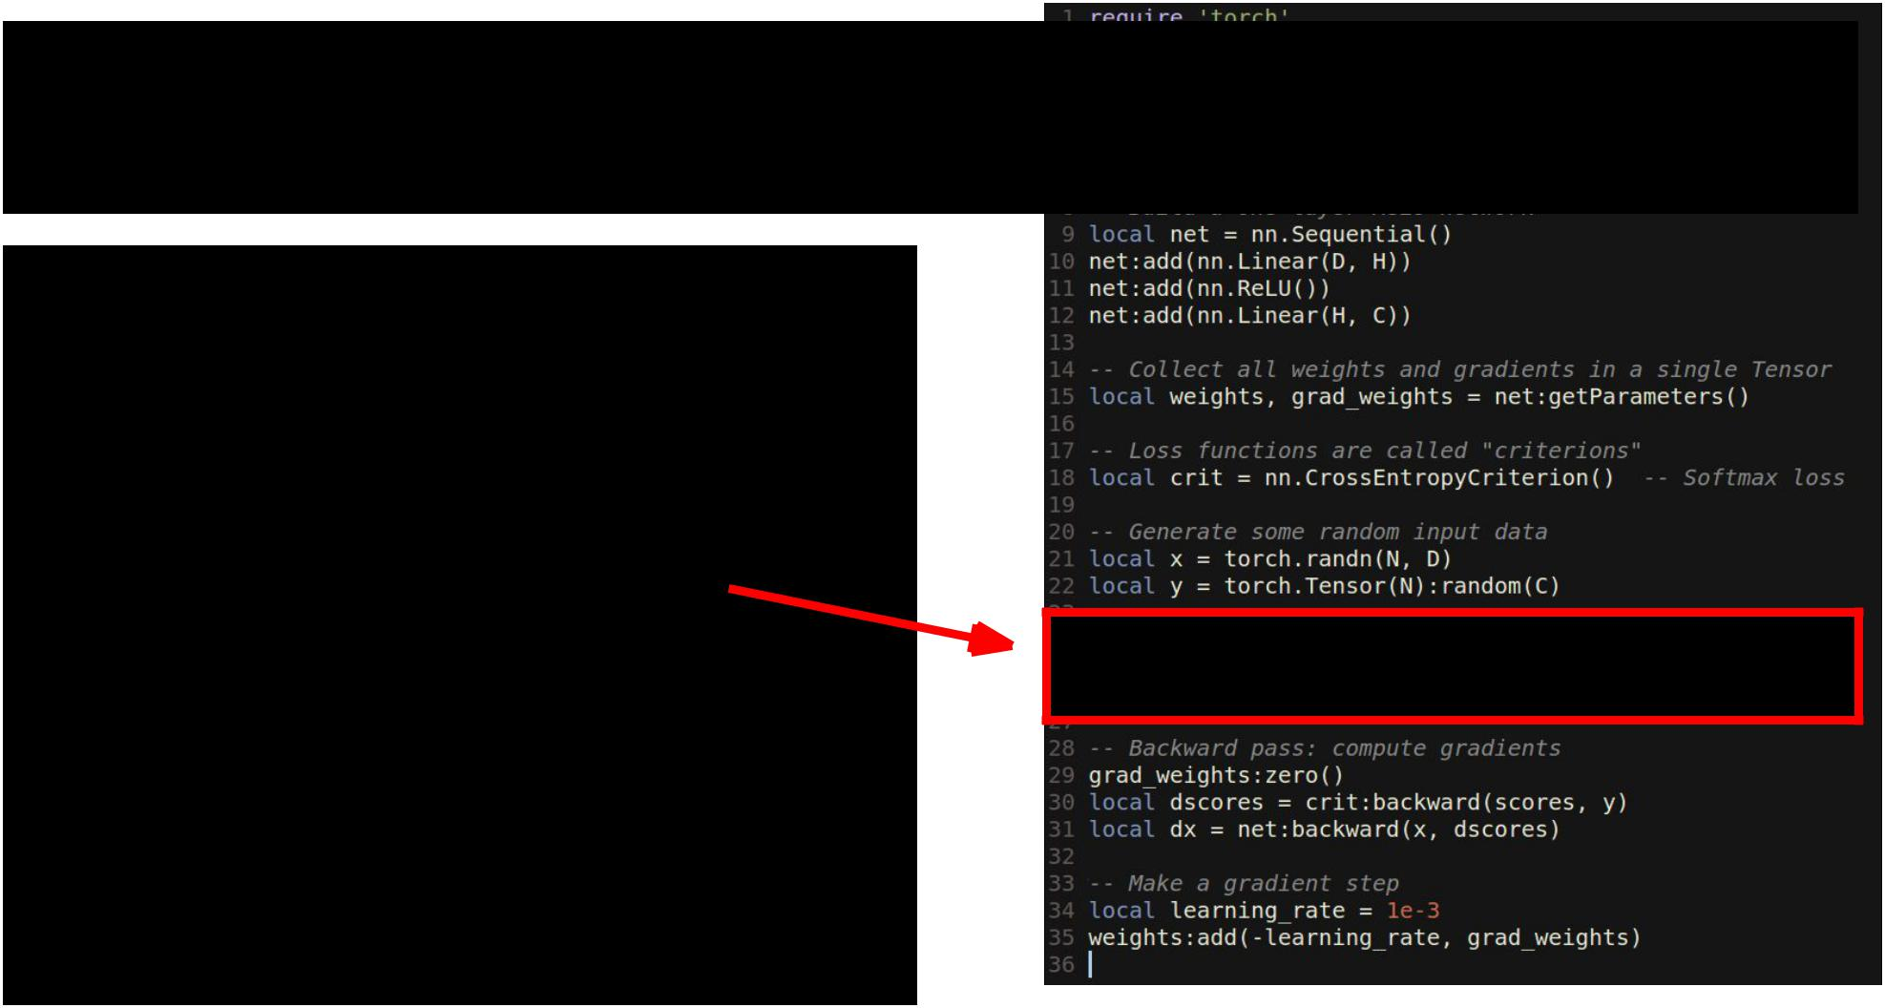Torch: nn

1. module lets you easily build and train neural nets

**Forward pass**: computescores and loss



Fei-Fei Li & Andrej Karpathy & Justin Johnson Lecture 12 45 22 Feb 2016

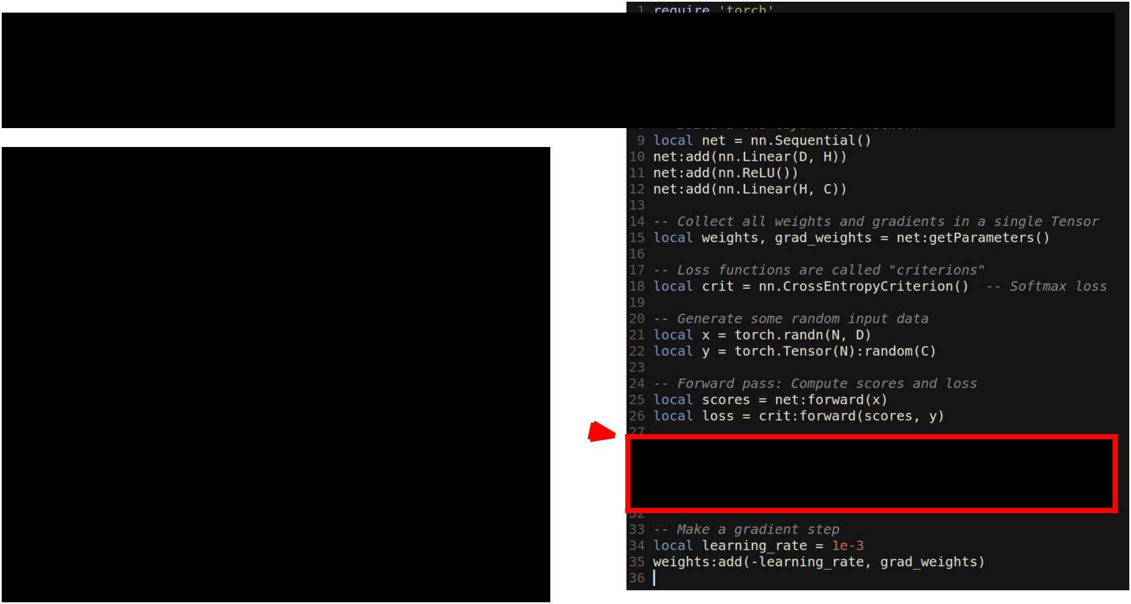Torch: nn

1. module lets you easily build and train neural nets

**Backward pass**: Compute

gradients. Remember to set

weight gradients to zero!



Fei-Fei Li & Andrej Karpathy & Justin Johnson Lecture 12 46 22 Feb 2016

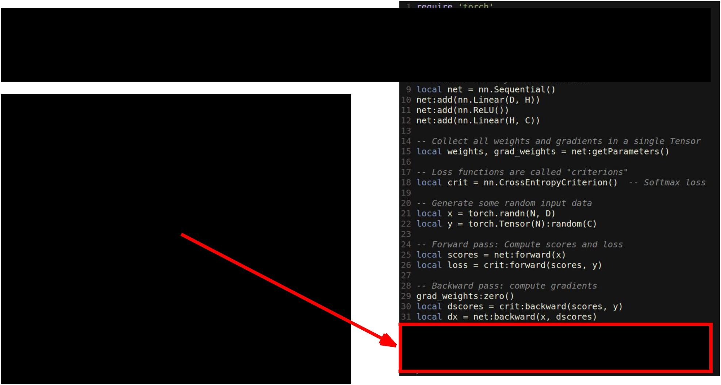Torch: nn

1. module lets you easily build and train neural nets

**Update**: Make a gradientdescent step



Fei-Fei Li & Andrej Karpathy & Justin Johnson Lecture 12 47 22 Feb 2016

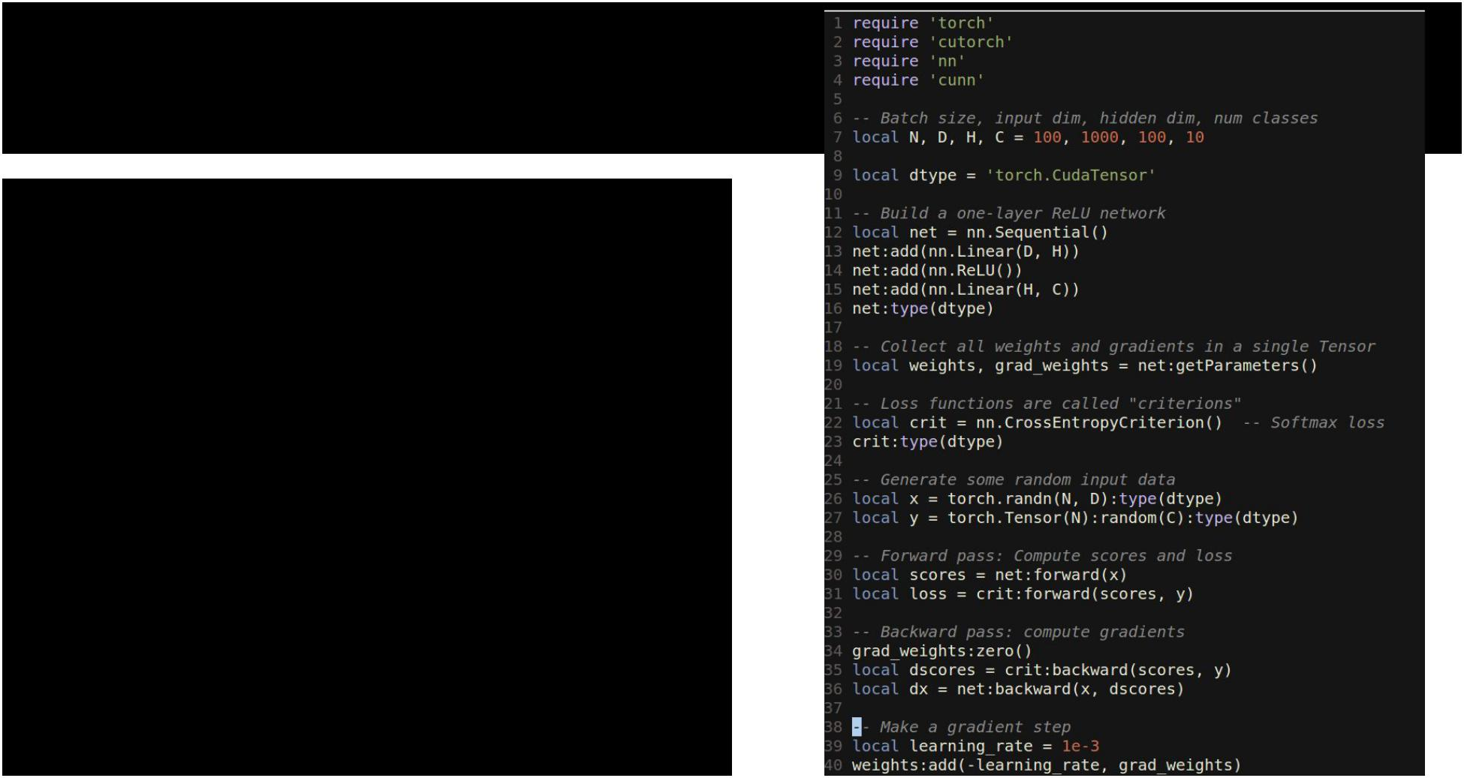Torch: cunn

Running on GPU is easy:



Fei-Fei Li & Andrej Karpathy & Justin Johnson Lecture 12 48 22 Feb 2016

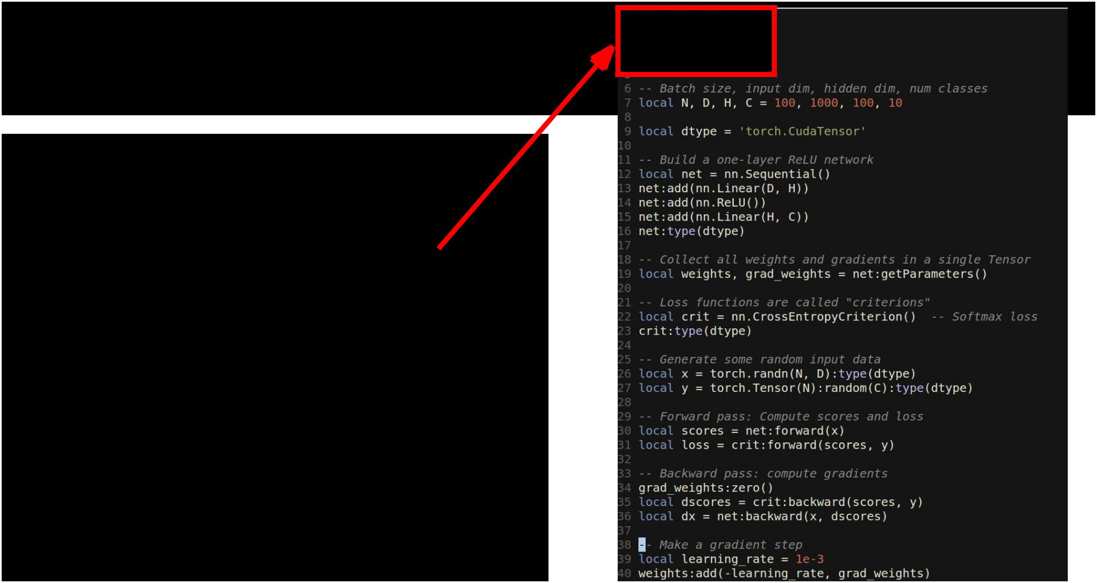Torch: cunn

Running on GPU is easy:

Import a few new packages



Fei-Fei Li & Andrej Karpathy & Justin Johnson Lecture 12 49 22 Feb 2016

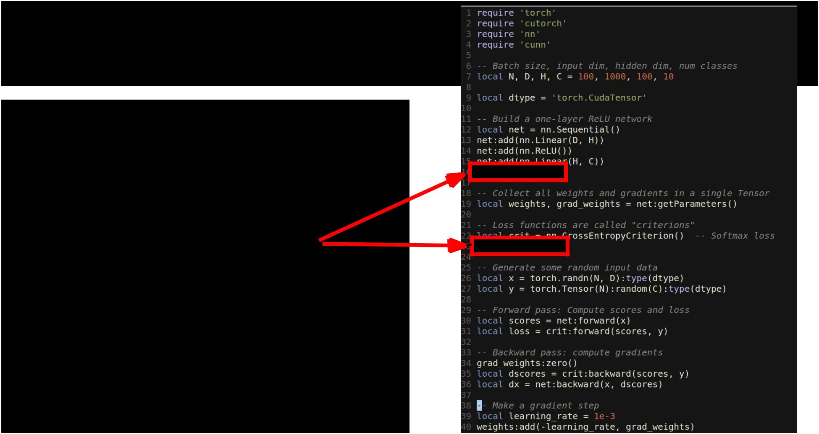Torch: cunn

Running on GPU is easy:

Import a few new packages

Cast network and criterion



Fei-Fei Li & Andrej Karpathy & Justin Johnson Lecture 12 50 22 Feb 2016

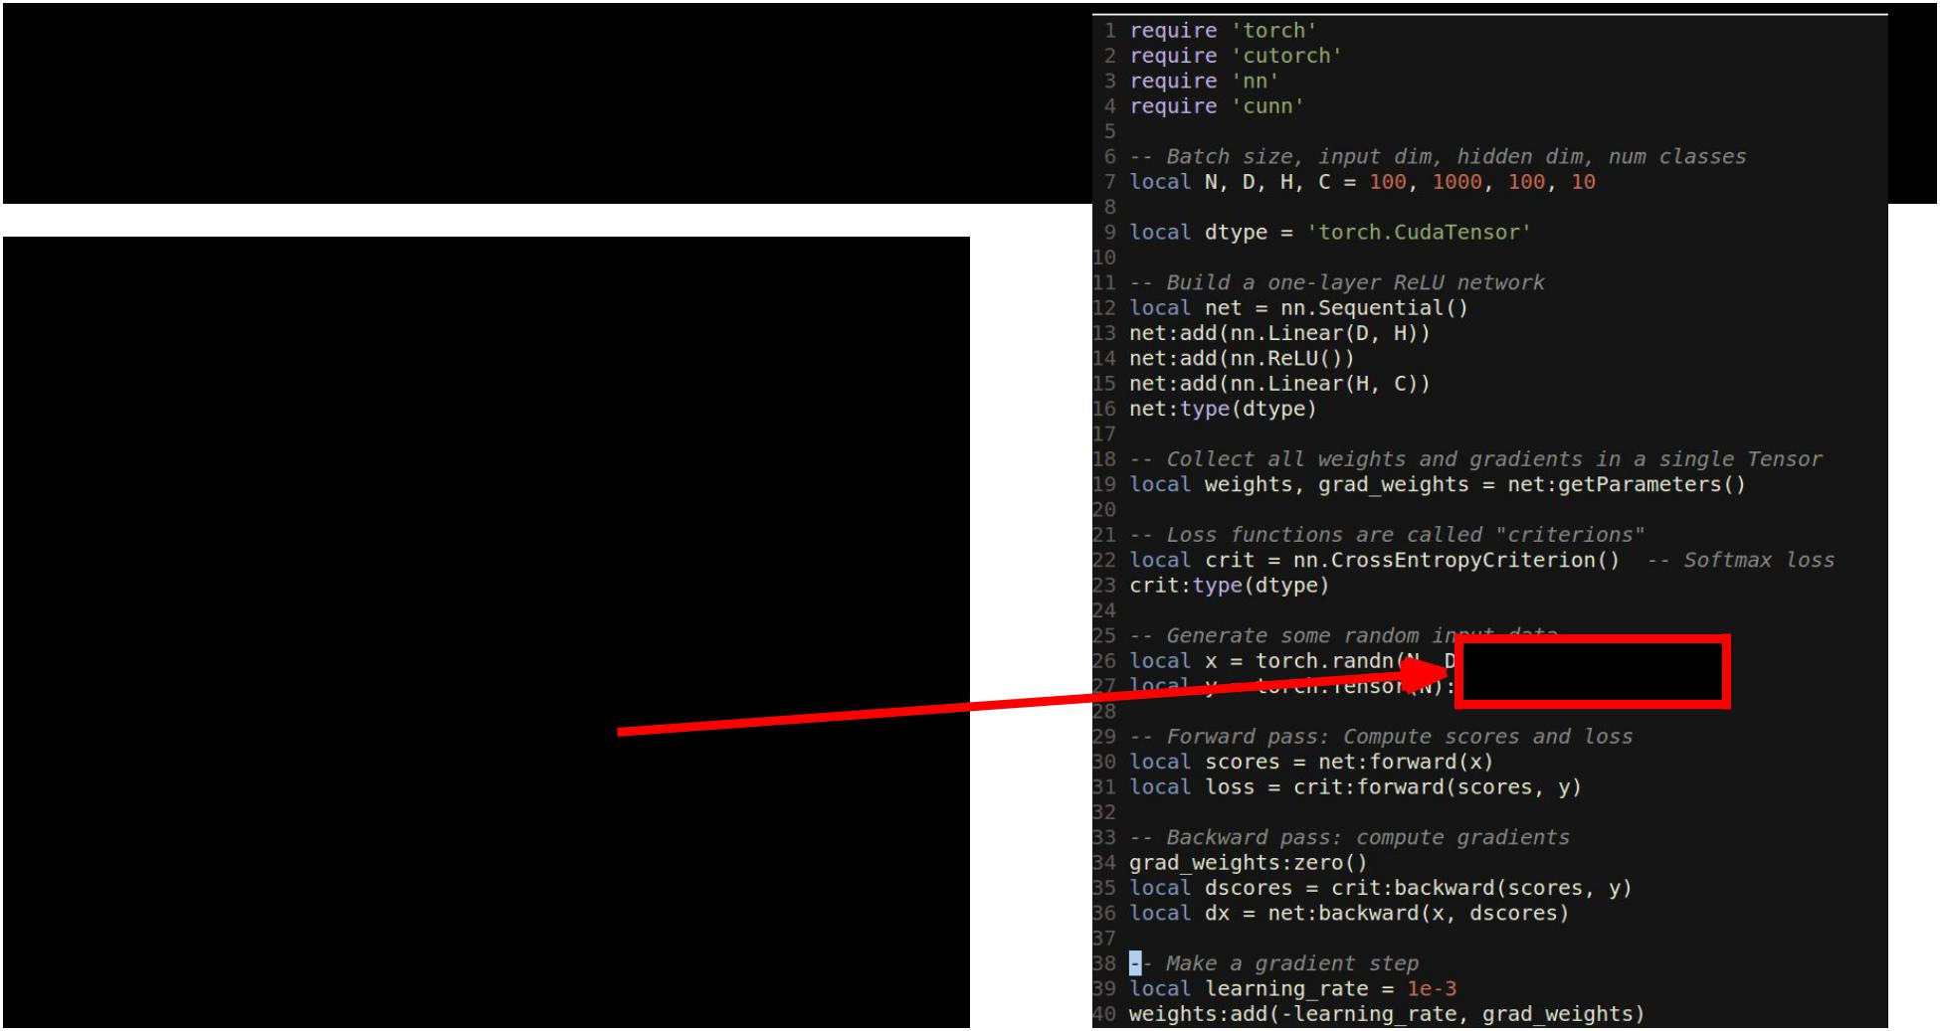Torch: cunn

Running on GPU is easy:

Import a few new packages

Cast network and criterion

Cast data and labels



Fei-Fei Li & Andrej Karpathy & Justin Johnson Lecture 12 51 22 Feb 2016

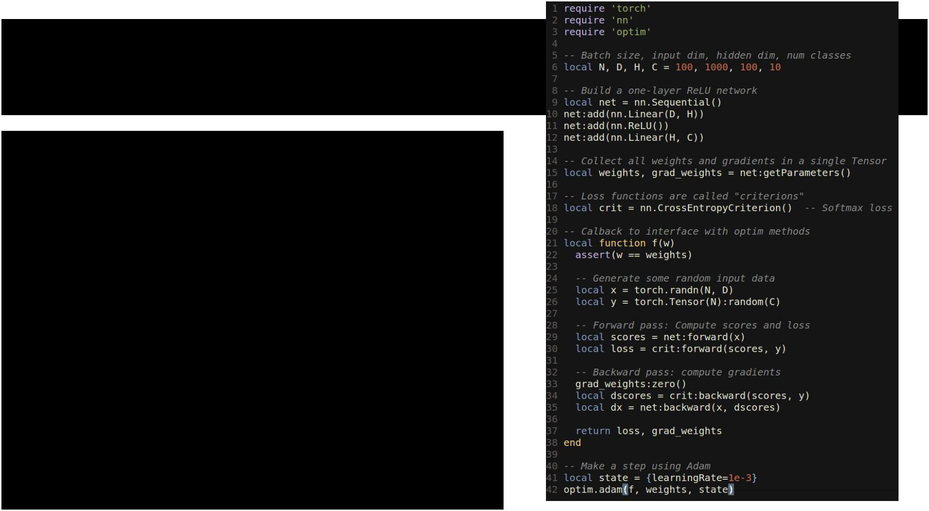Torch: optim

optim package implements different update rules: momentum, Adam, etc



Fei-Fei Li & Andrej Karpathy & Justin Johnson Lecture 12 52 22 Feb 2016

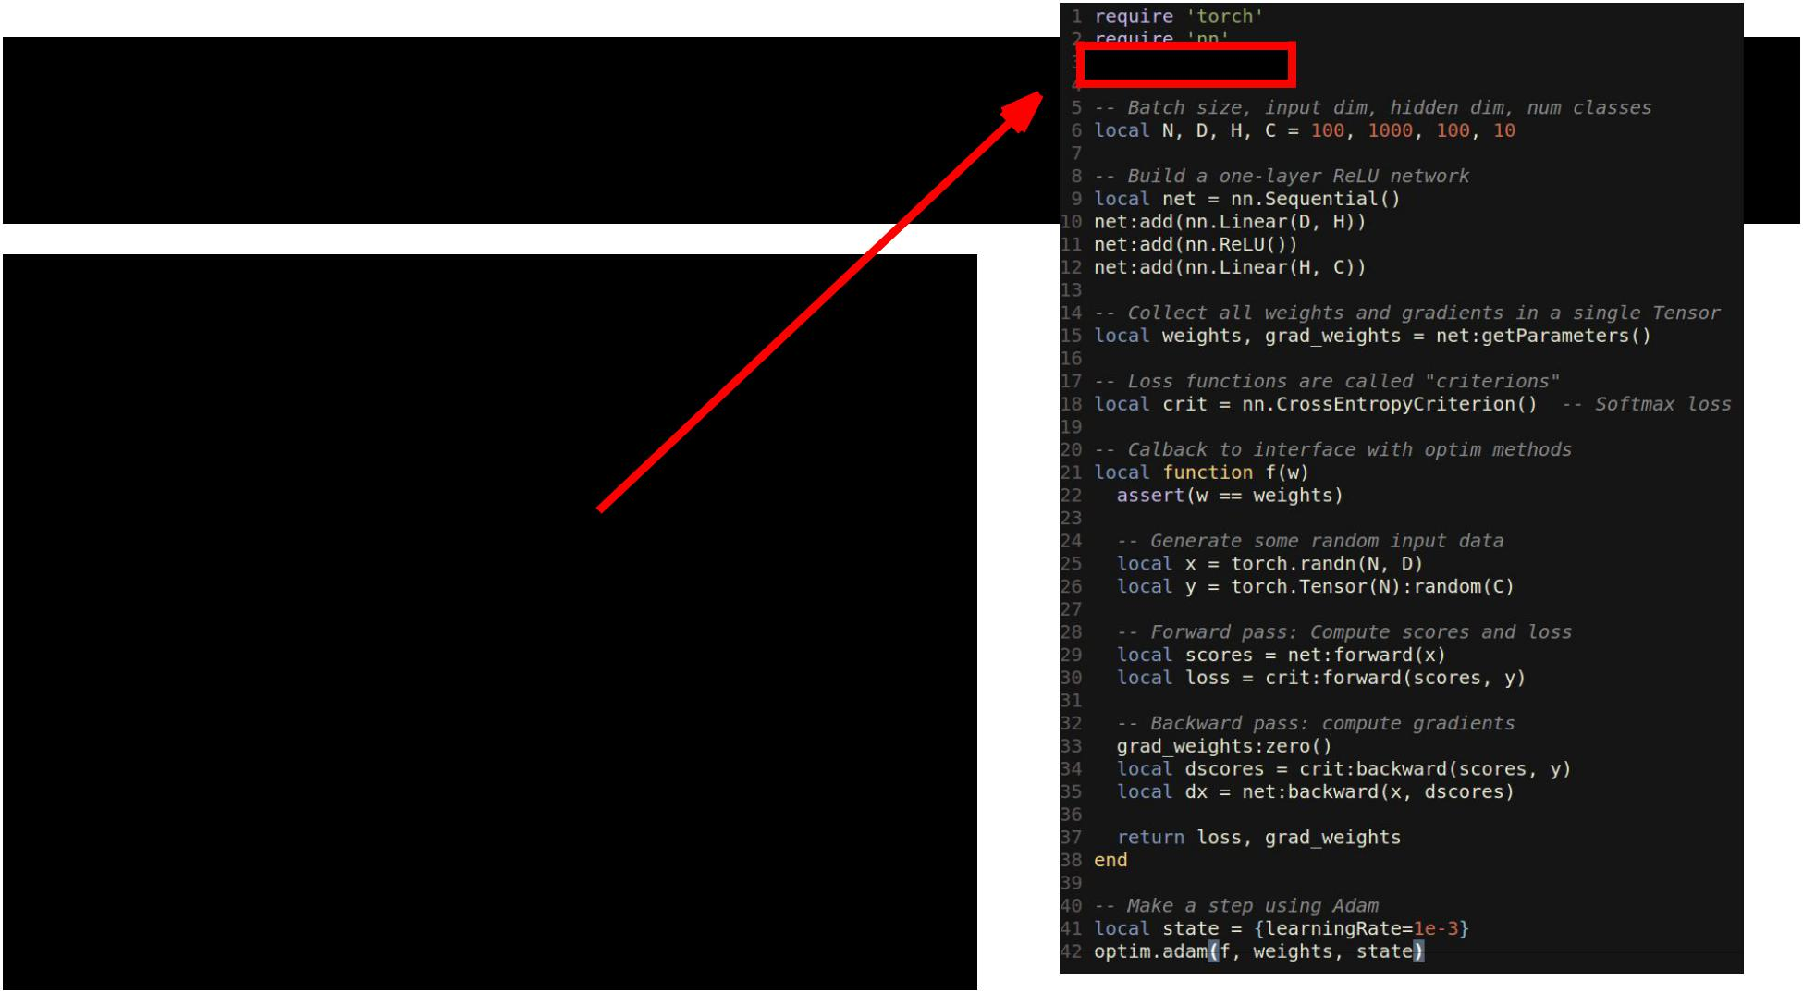Torch: optim

optim package implements different update rules: momentum, Adam, etc

Import optim package



Fei-Fei Li & Andrej Karpathy & Justin Johnson Lecture 12 53 22 Feb 2016

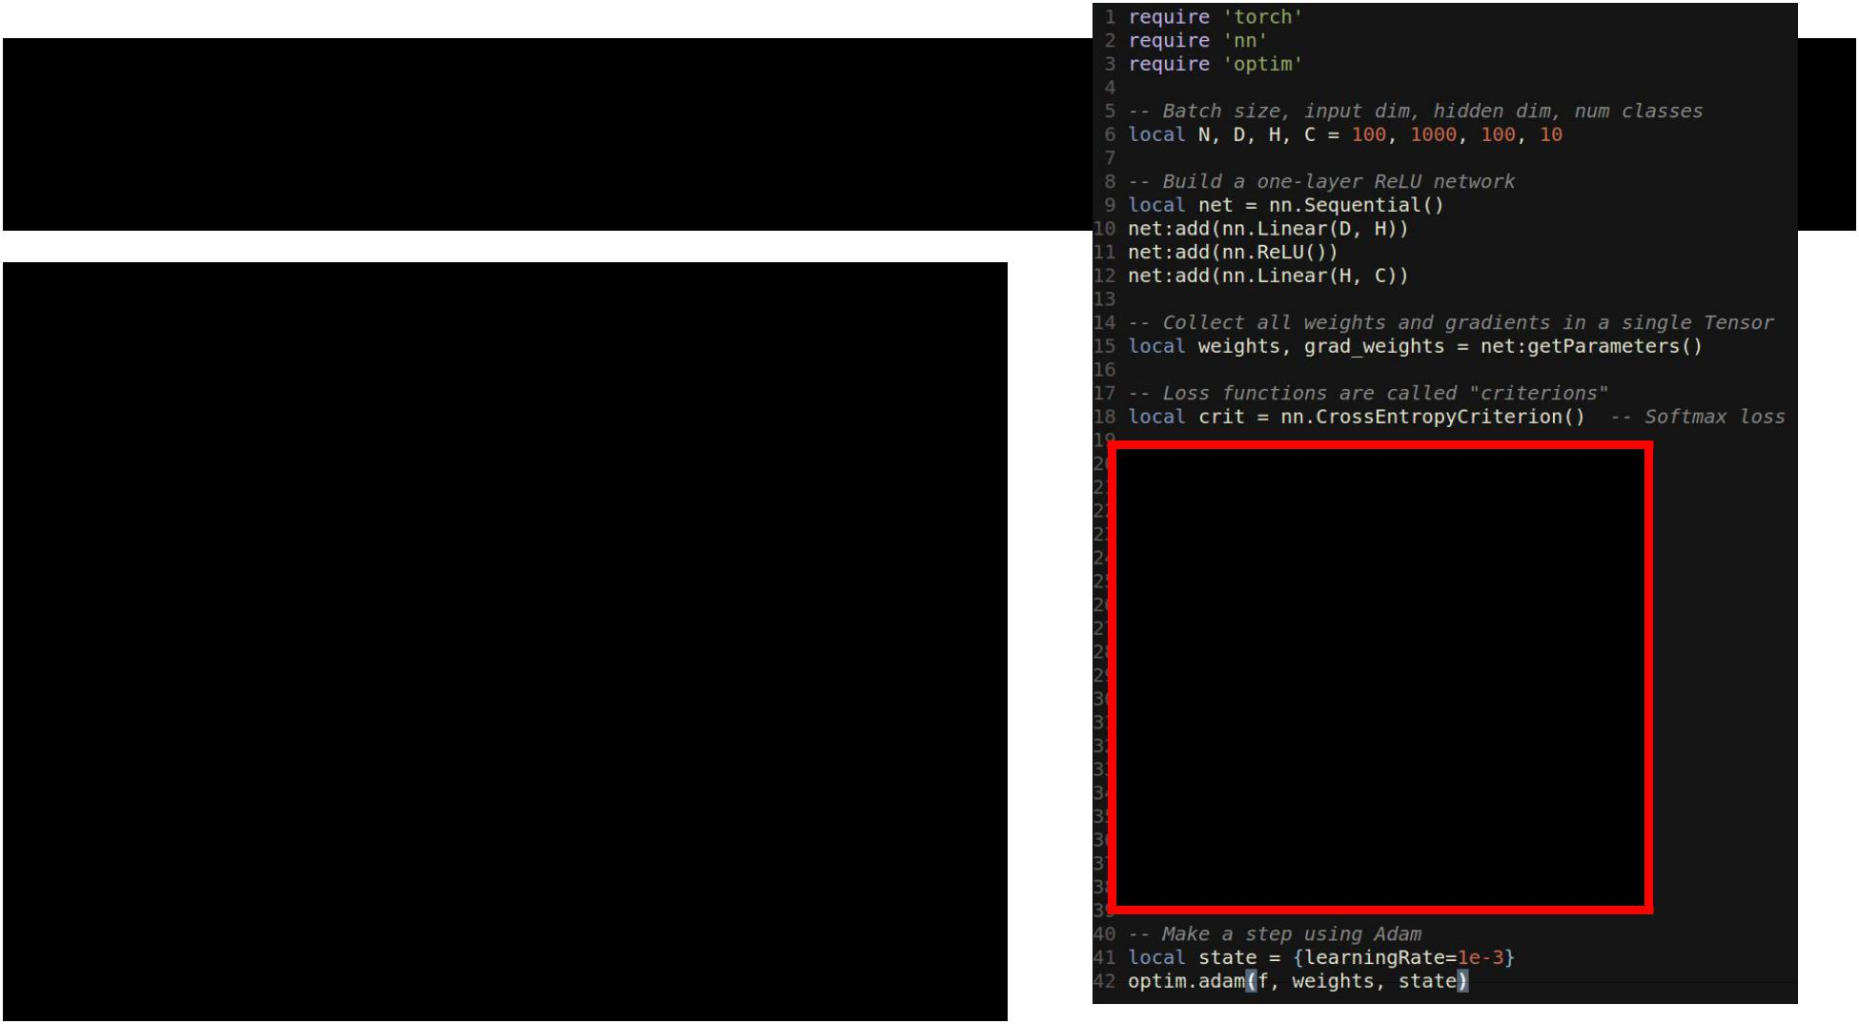Torch: optim

optim package implements different update rules: momentum, Adam, etc

Import optim package

Write a callback function that returns loss and gradients



Fei-Fei Li & Andrej Karpathy & Justin Johnson Lecture 12 54 22 Feb 2016

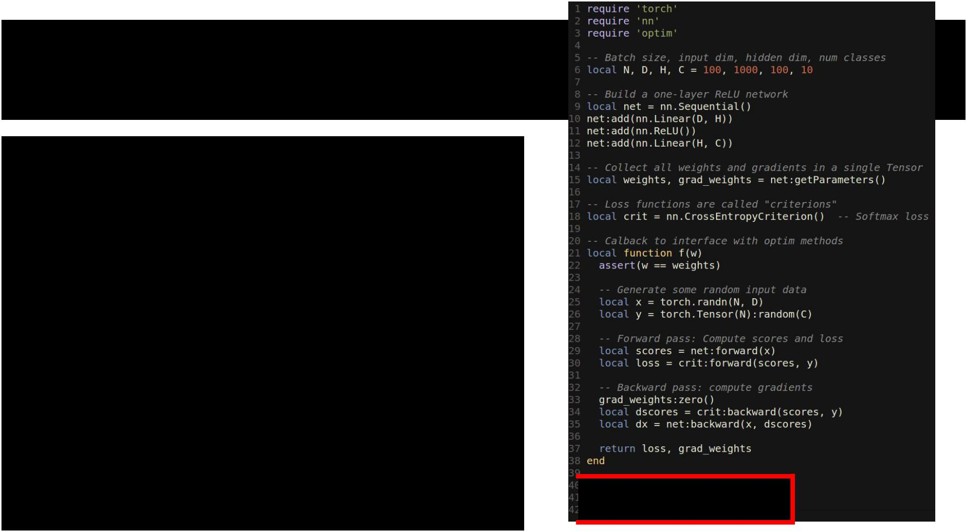Torch: optim

optim package implements different update rules: momentum, Adam, etc

Import optim package

Write a callback function that returns loss and gradients

state variable holds hyperparameters, cached values, etc; pass it to adam 



Fei-Fei Li & Andrej Karpathy & Justin Johnson Lecture 12 55 22 Feb 2016

Torch: Modules



Caffe has Nets and Layers;

Torch just has Modules



Fei-Fei Li & Andrej Karpathy & Justin Johnson Lecture 12 56 22 Feb 2016

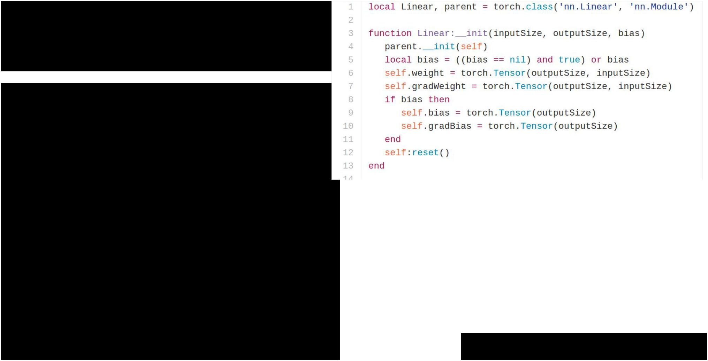Torch: Modules

Caffe has Nets and Layers; Torch just has Modules

Modules are classes written in Lua; easy to read and write

Forward / backward written in Lua

using Tensor methods

Same code runs on CPU / GPU

<https://github.com/torch/nn/blob/master/Linear.lua>



Fei-Fei Li & Andrej Karpathy & Justin Johnson Lecture 12 57 22 Feb 2016

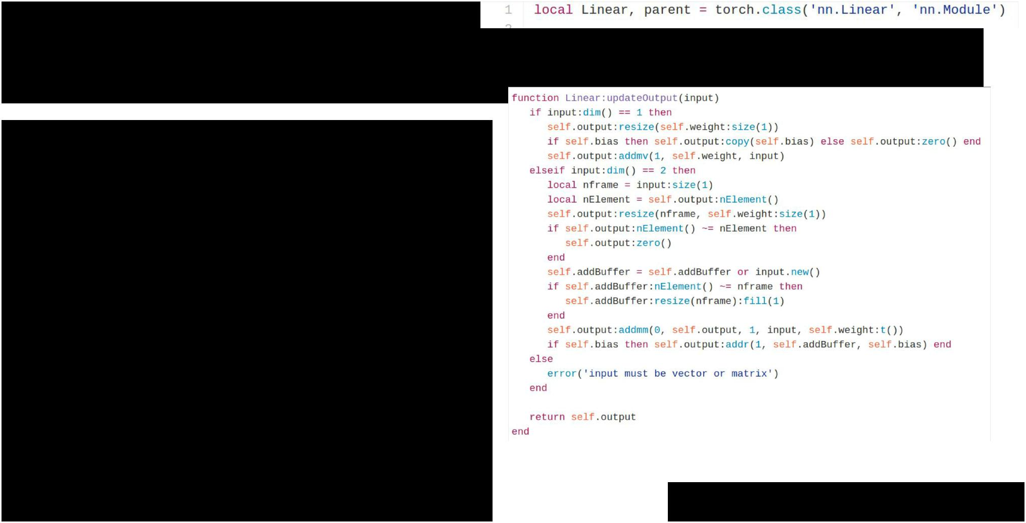Torch: Modules

Caffe has Nets and Layers; Torch just has Modules

Modules are classes written in Lua; easy to read and write

**updateOutput**: Forward pass;compute output

<https://github.com/torch/nn/blob/master/Linear.lua>



Fei-Fei Li & Andrej Karpathy & Justin Johnson Lecture 12 58 22 Feb 2016

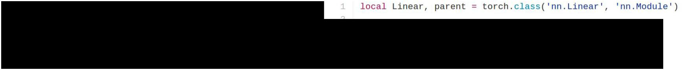Torch: Modules

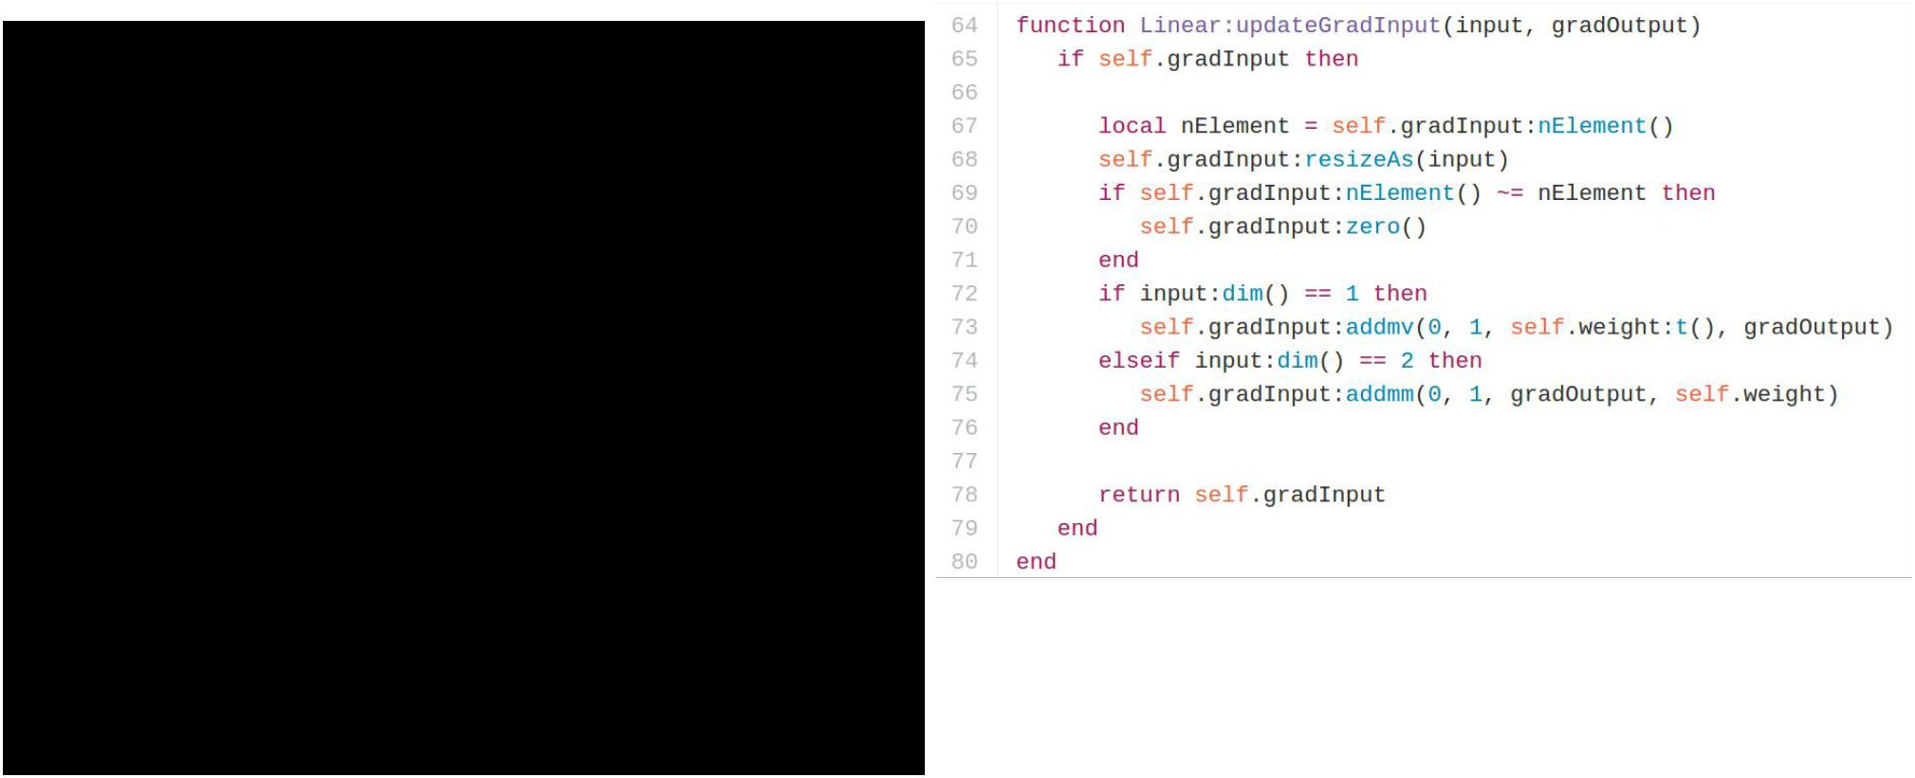

Caffe has Nets and Layers; Torch just has Modules

Modules are classes written in Lua; easy to read and write

**updateGradInput:** Backward;compute gradient of input



<https://github.com/torch/nn/blob/master/Linear.lua>



Fei-Fei Li & Andrej Karpathy & Justin Johnson Lecture 12 59 22 Feb 2016

Torch: Modules



Caffe has Nets and Layers; Torch just has Modules

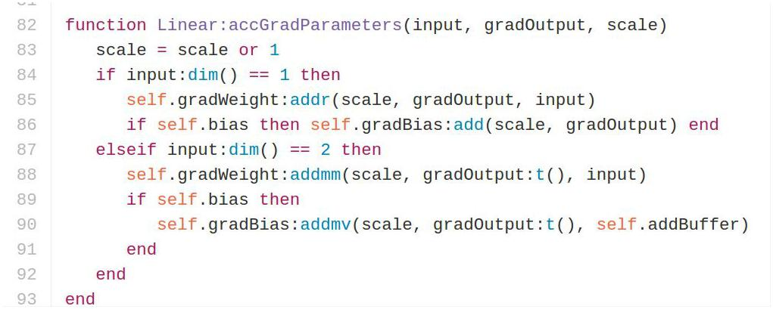

Modules are classes written in Lua; easy to read and write

**accGradParameters:** Backward;compute gradient of weights



<https://github.com/torch/nn/blob/master/Linear.lua>



Fei-Fei Li & Andrej Karpathy & Justin Johnson Lecture 12 60 22 Feb 2016

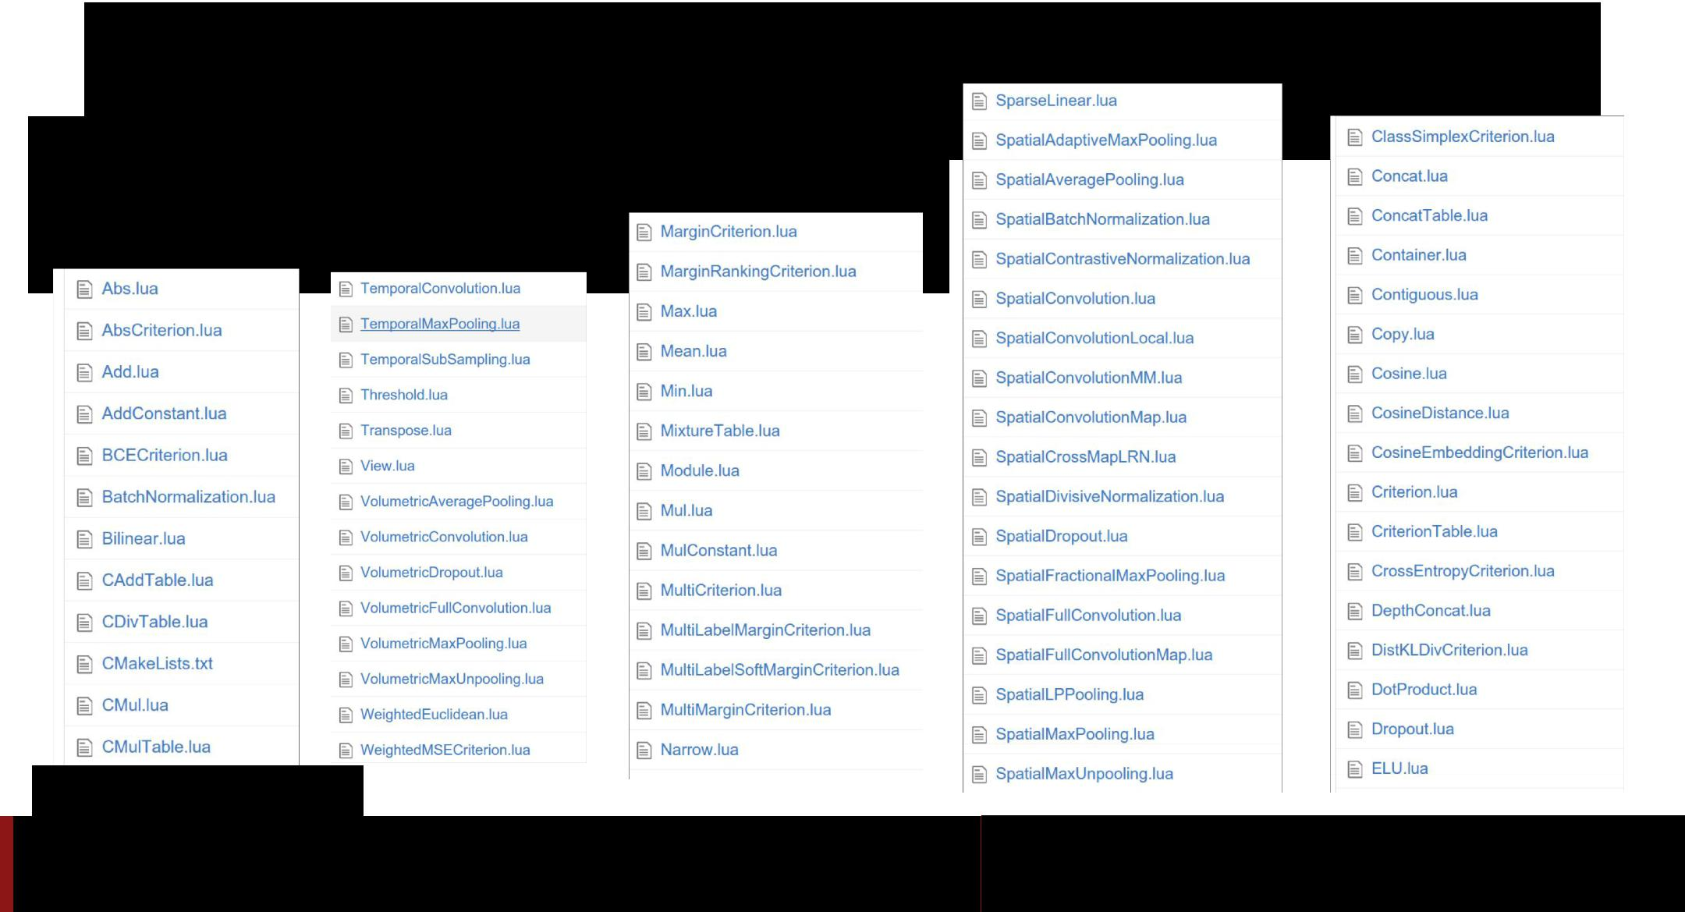Torch: Modules

Tons of built-in modules and loss functions

<https://github.com/torch/nn>

Fei-Fei Li & Andrej Karpathy & Justin Johnson Lecture 12 61 22 Feb 2016

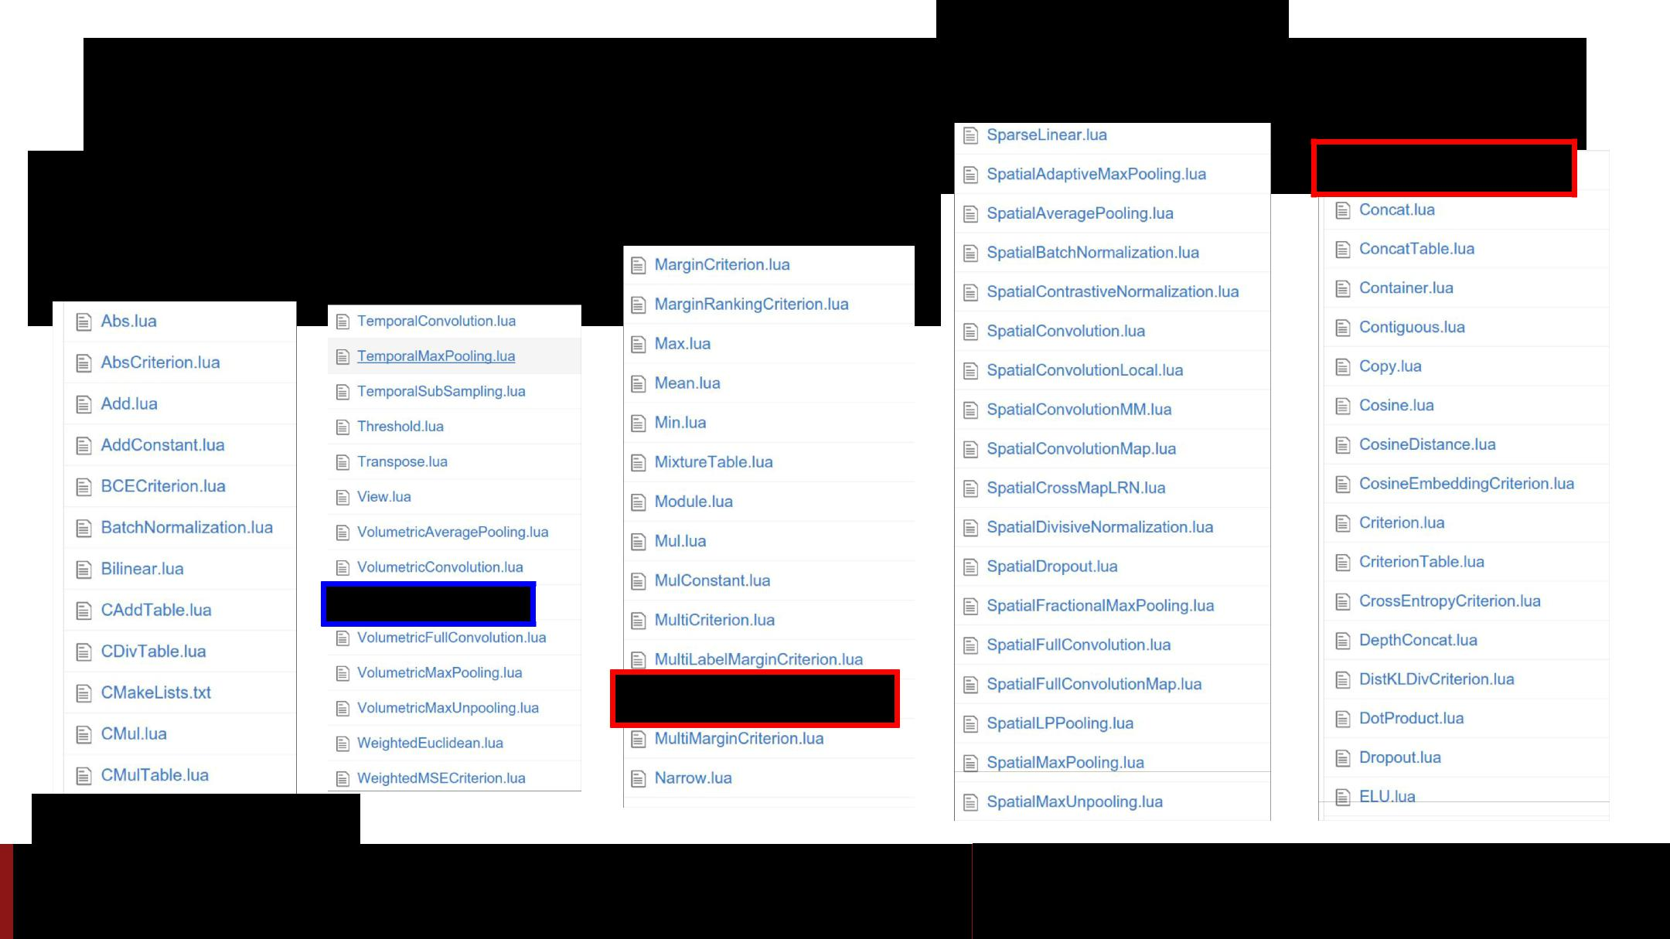

Torch: Modules

Tons of built-in modules and loss functions

New ones all the time:

<https://github.com/torch/nn>

Added 2/19/2016

Added 2/16/2016

Fei-Fei Li & Andrej Karpathy & Justin Johnson Lecture 12 62 22 Feb 2016

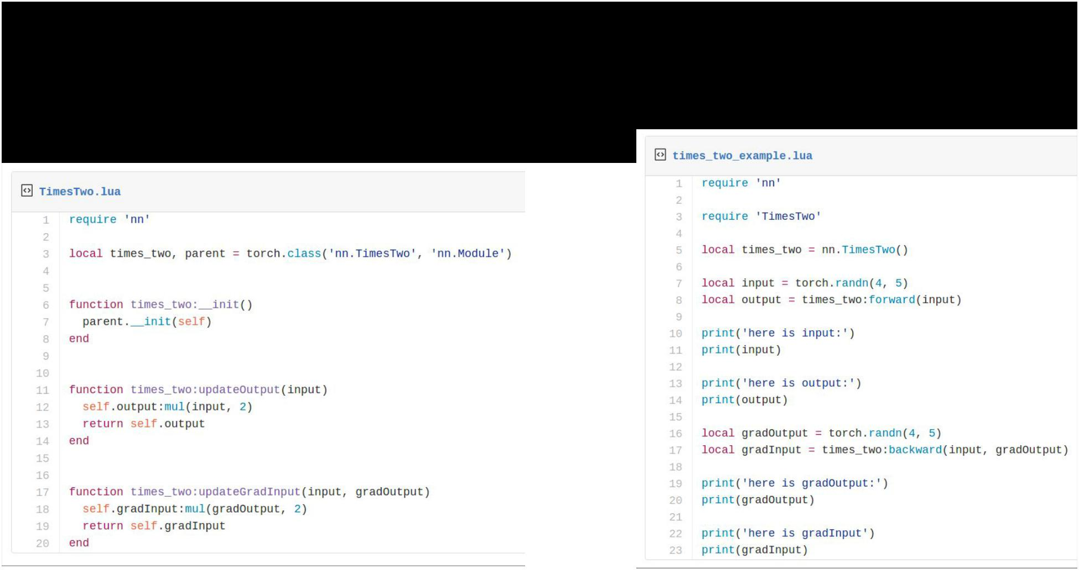Torch: Modules

Writing your own modules is easy!



Fei-Fei Li & Andrej Karpathy & Justin Johnson Lecture 12 63 22 Feb 2016

Torch: Modules

*Container* modules allow you to combine multiple modules



Fei-Fei Li & Andrej Karpathy & Justin Johnson Lecture 12 64 22 Feb 2016

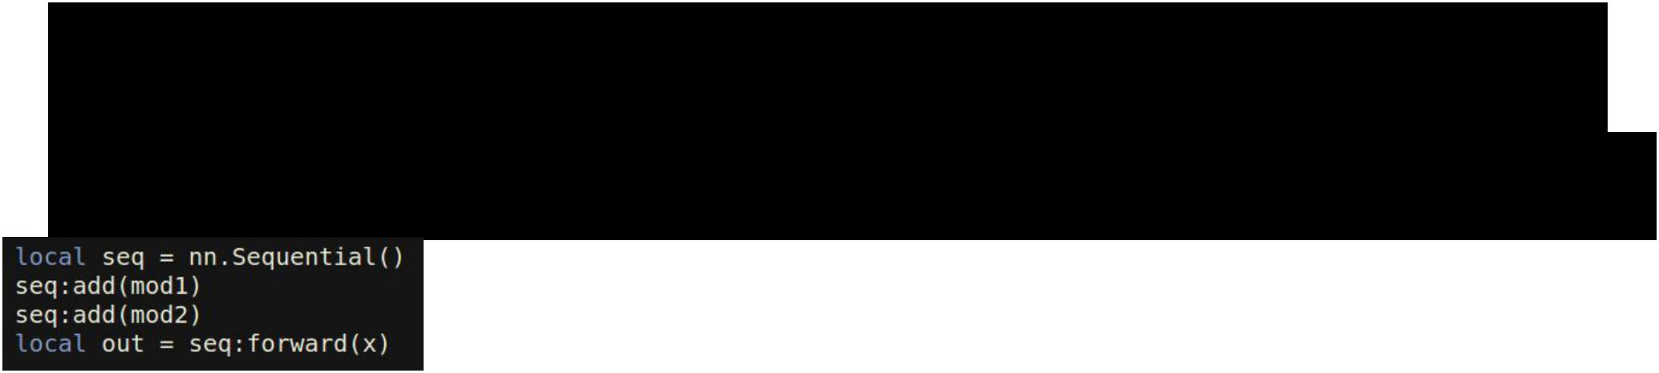Torch: Modules

*Container* modules allow you to combine multiple modules

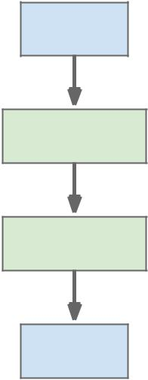

x



mod1



mod2



out



Fei-Fei Li & Andrej Karpathy & Justin Johnson Lecture 12 65 22 Feb 2016

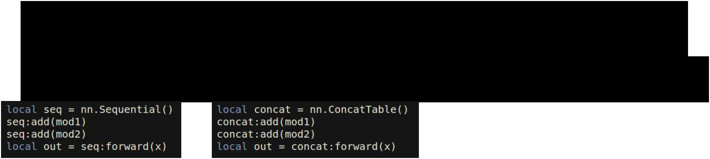

Torch: Modules

*Container* modules allow you to combine multiple modules

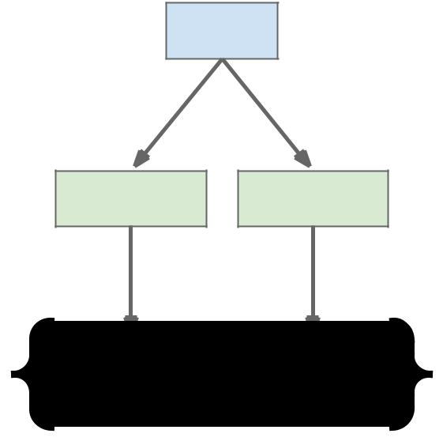

|  |  |  |  |  |
| --- | --- | --- | --- | --- |
| x |  | x |  |  |
|  |  |  |  |
| mod1 | mod1 | mod2 |  |  |
|  |  |  |
| mod2 |  |  |  |  |
| out | out[1] | out[2] |  |  |
|  |  |  |  |
| Fei-Fei Li & Andrej Karpathy & Justin Johnson | | | Lecture 12 66 22 Feb 2016 |  |

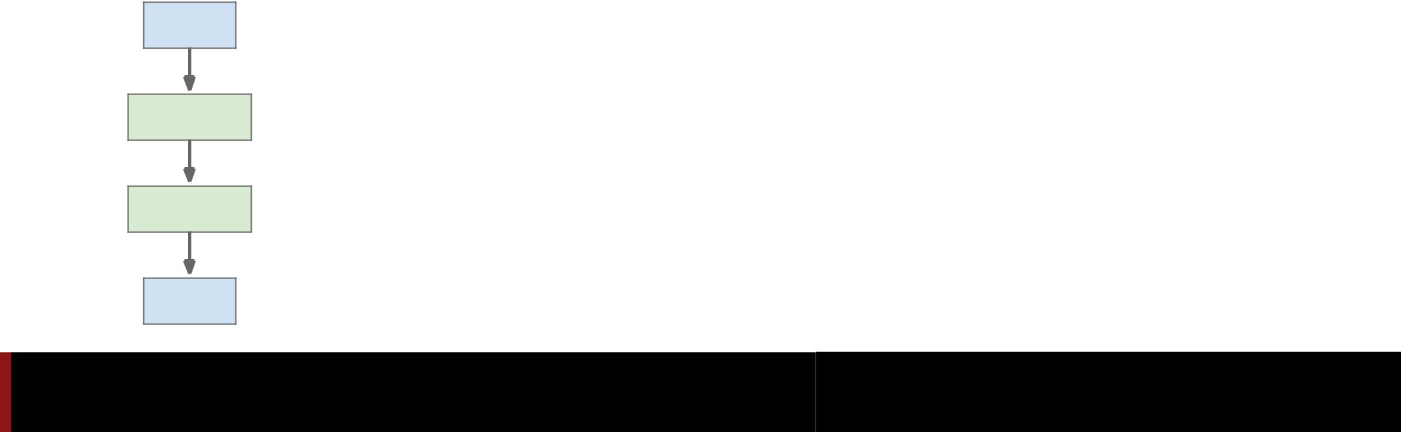

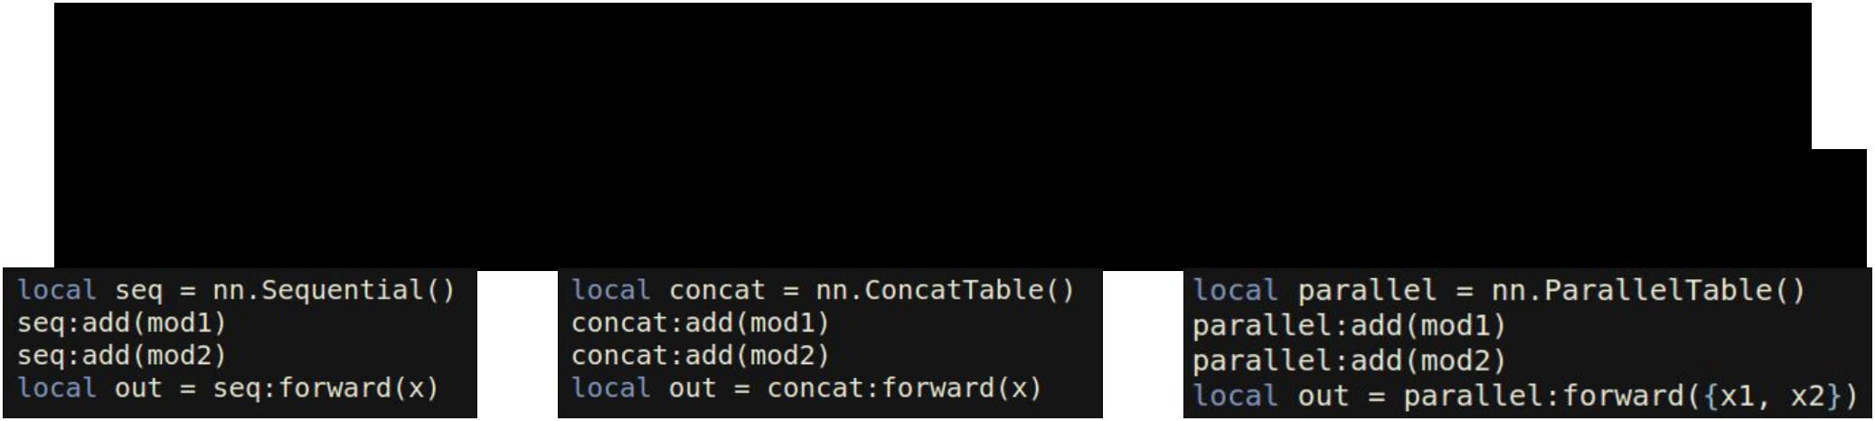

Torch: Modules

*Container* modules allow you to combine multiple modules

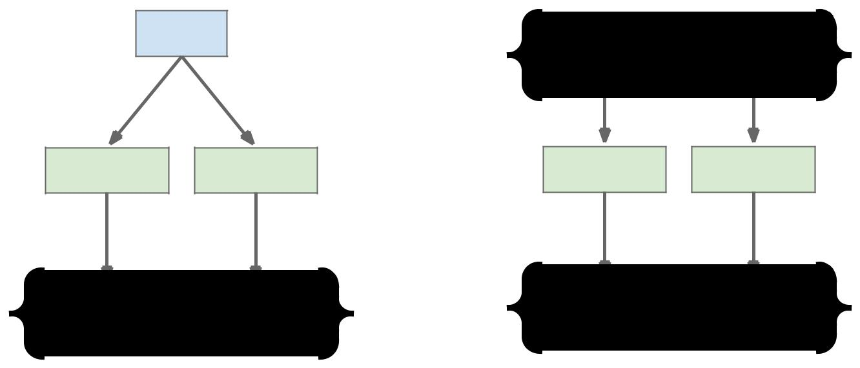

|  |  |  |  |  |  |
| --- | --- | --- | --- | --- | --- |
| x |  | x | x1 | x2 |  |
|  |  |  |
| mod1 | mod1 | mod2 | mod1 | mod2 |  |
|  |  |
| mod2 |  |  |  |  |  |
| out | out[1] | out[2] | out[1] | out[2] |  |
|  |  |  |  |  |
| Fei-Fei Li & Andrej Karpathy & Justin Johnson | | | Lecture 12 67 | 22 Feb 2016 |  |

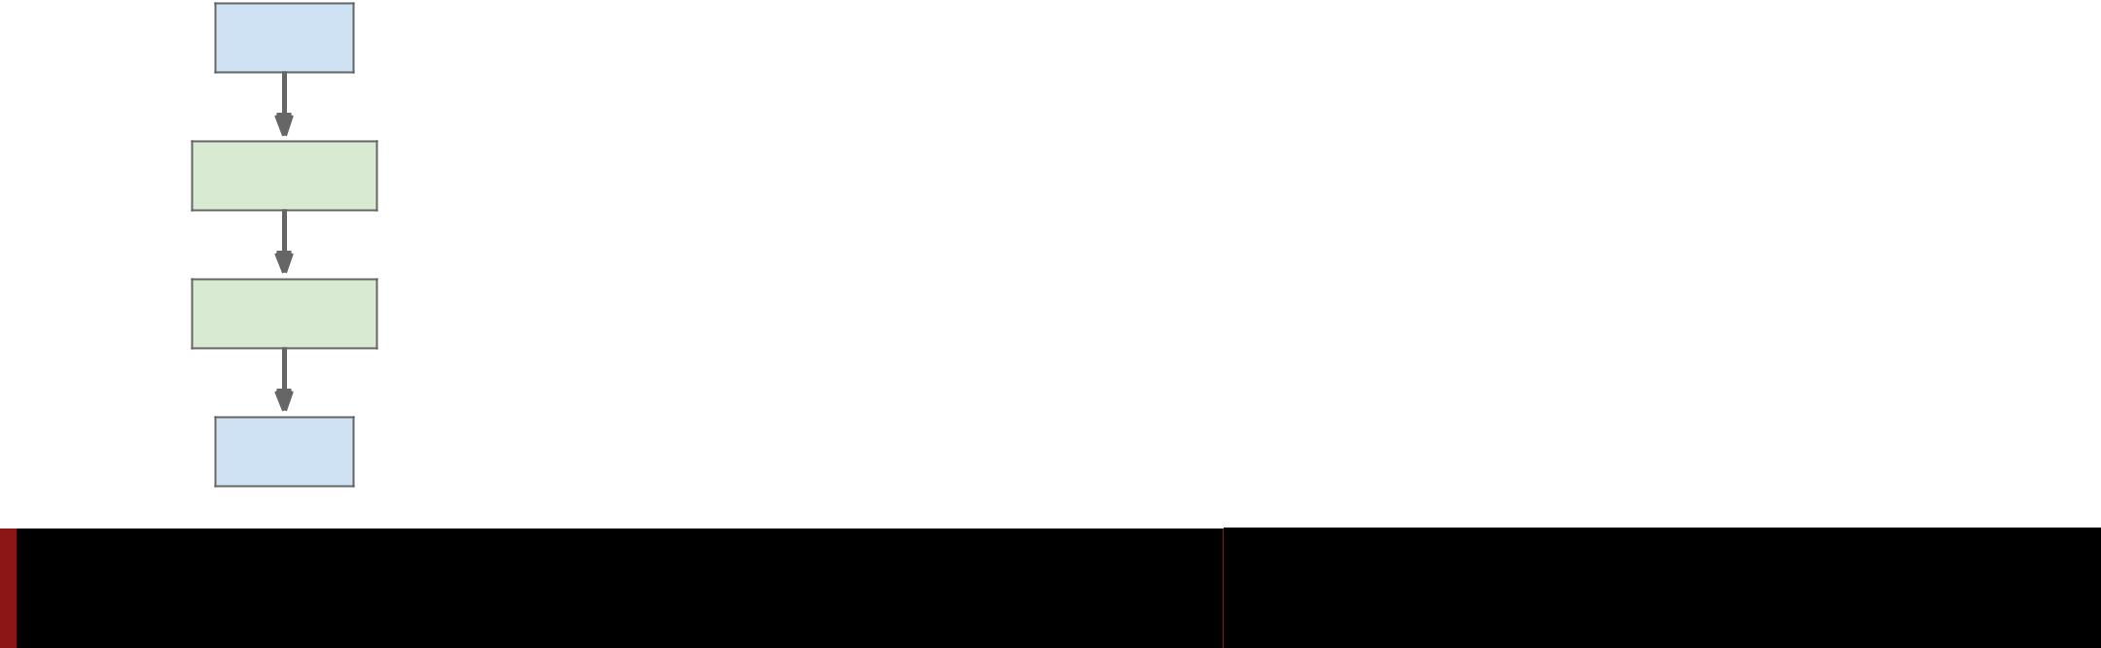

Torch: nngraph



Use nngraph to build modules

that combine their inputs in

complex ways

**Inputs**: x, y, z

**Outputs**: c

a = x + y

b = a ☉ z

c = a + b



Fei-Fei Li & Andrej Karpathy & Justin Johnson Lecture 12 68 22 Feb 2016

|  |  |  |
| --- | --- | --- |
| Torch: nngraph x | y | z |
|  | + |  |

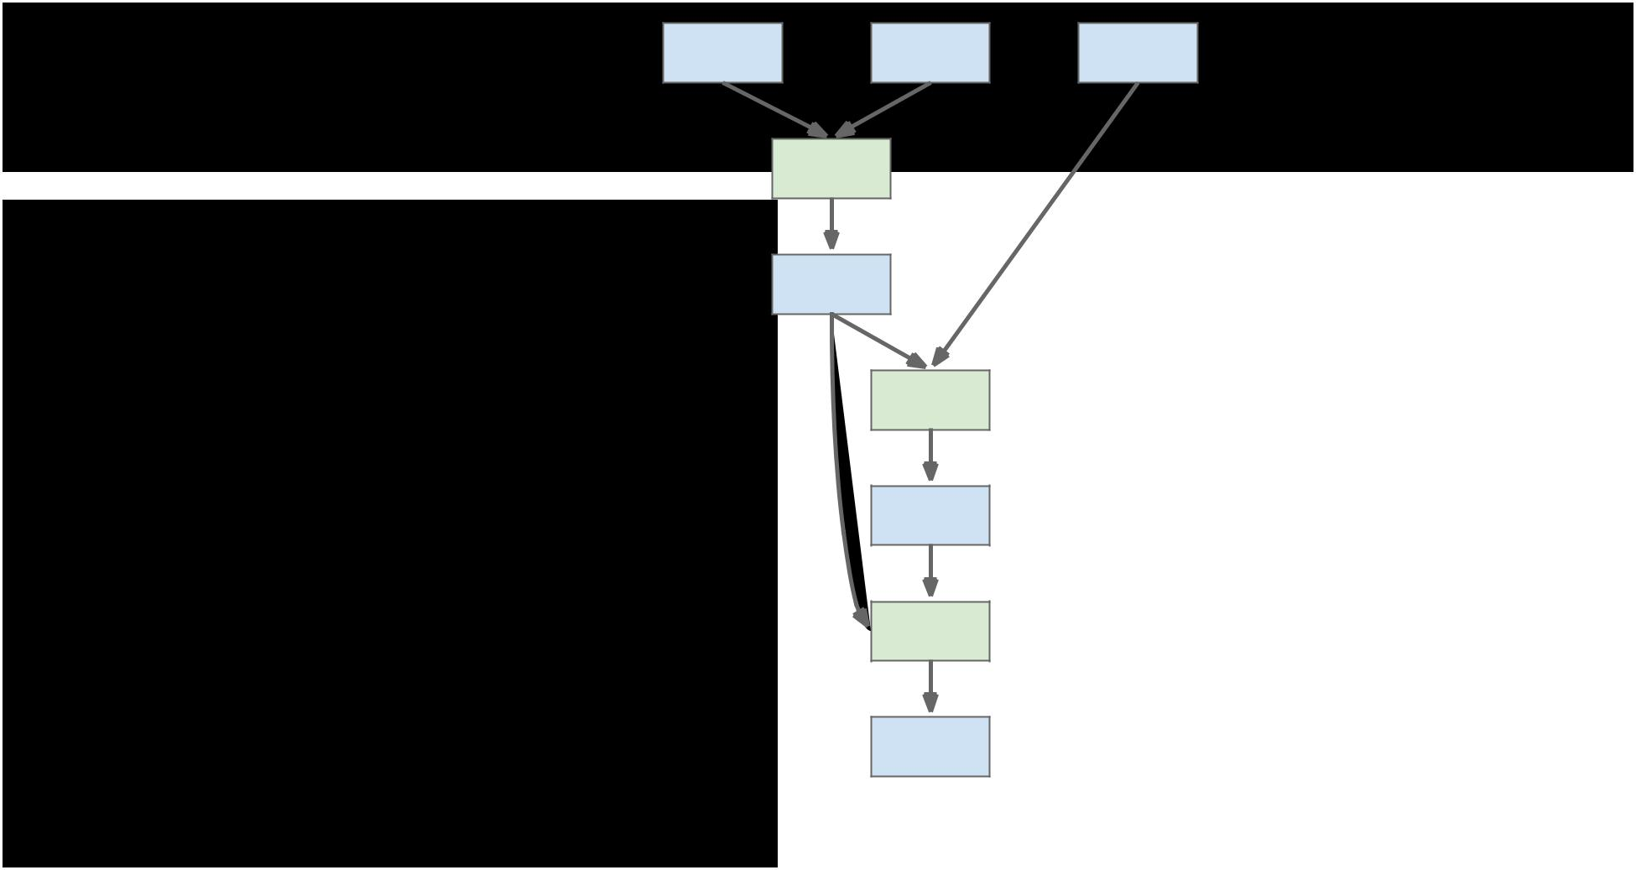

Use nngraph to build modules that combine their inputs in complex ways

**Inputs**: x, y, z

**Outputs**: c

a = x + y

b = a ☉ z

c = a + b

a



☉



b



+



c

Fei-Fei Li & Andrej Karpathy & Justin Johnson Lecture 12 69 22 Feb 2016

|  |  |  |
| --- | --- | --- |
| Torch: nngraph x | y | z |
|  | + |  |

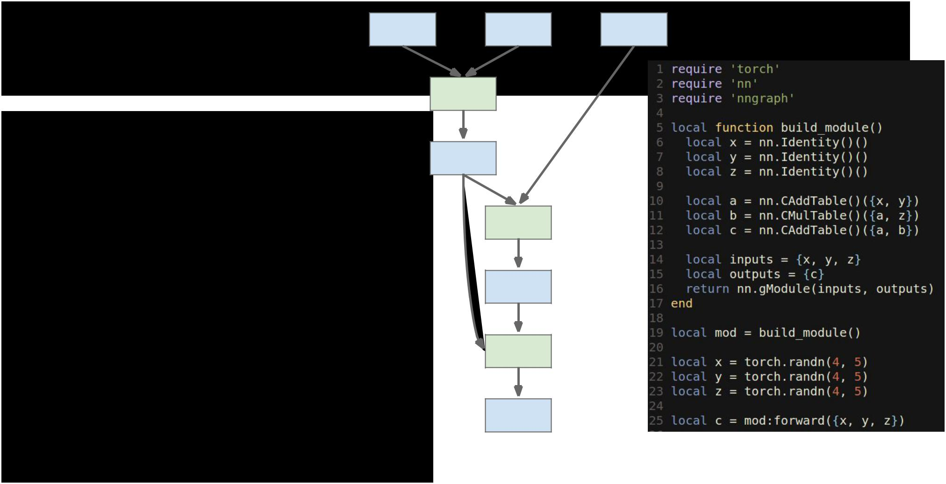

Use nngraph to build modules that combine their inputs in complex ways

**Inputs**: x, y, z

**Outputs**: c

a = x + y

b = a ☉ z

c = a + b

a



☉



b



+



c

Fei-Fei Li & Andrej Karpathy & Justin Johnson Lecture 12 70 22 Feb 2016

Torch: Pretrained Models



**loadcaffe**: Load pretrained Caffe models: AlexNet, VGG, some others

<https://github.com/szagoruyko/loadcaffe>

**GoogLeNet v1**:<https://github.com/soumith/inception.torch>

**GoogLeNet v3**:<https://github.com/Moodstocks/inception-v3.torch>

**ResNet**:<https://github.com/facebook/fb.resnet.torch>



Fei-Fei Li & Andrej Karpathy & Justin Johnson Lecture 12 71 22 Feb 2016

Torch: Package Management

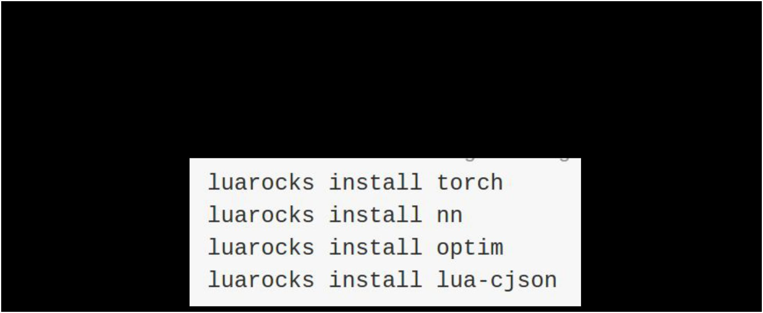

After installing torch, use luarocks to install or update Lua packages

(Similar to pip install from Python)



Fei-Fei Li & Andrej Karpathy & Justin Johnson Lecture 12 72 22 Feb 2016

<https://github.com/twitter/torch-autograd>

<https://github.com/hughperkins/cltorch>, <https://github.com/hughperkins/clnn>

<https://luarocks.org/modules/luarocks/lua-cjson>

<https://github.com/deepmind/torch-hdf5>

Torch: Other useful packages



* **torch.cudnn**: Bindings for NVIDIA cuDNN kernels

<https://github.com/soumith/cudnn.torch>

* **torch-hdf5**: Read and write HDF5 files from Torch
* **lua-cjson**: Read and write JSON files from Lua
* **cltorch, clnn**: OpenCL backend for Torch, and port of nn
* **torch-autograd**: Automatic differentiation; sort of like more powerful

nngraph, similar to Theano or TensorFlow

* **fbcunn**: Facebook: FFT conv, multi-GPU (DataParallel, ModelParallel)

<https://github.com/facebook/fbcunn>



Fei-Fei Li & Andrej Karpathy & Justin Johnson Lecture 12 73 22 Feb 2016

Torch: Typical Workflow



**Step 1**: Preprocess data; usually use a Python script todump data to HDF5

**Step 2**: Train a model in Lua / Torch; read from HDF5datafile, save trained model to disk

**Step 3:** Use trained model for something, often with anevaluation script



Fei-Fei Li & Andrej Karpathy & Justin Johnson Lecture 12 74 22 Feb 2016

(<https://github.com/jcjohnson/torch-rnn/blob/master/sample.lua>)

([https://github.com/jcjohnson/torch-rnn/blob/master/train.](https://github.com/jcjohnson/torch-rnn/blob/master/train.lua)

(<https://github.com/jcjohnson/torch-rnn/blob/master/scripts/preprocess.py>)



Torch: Typical Workflow



**Example:** <https://github.com/jcjohnson/torch-rnn>

**Step 1**: Preprocess data; usually use a Python script todump data to HDF5

**Step 2**: Train a model in Lua / Torch; read from HDF5datafile, save trained model to disk

[lua](https://github.com/jcjohnson/torch-rnn/blob/master/train.lua) )

**Step 3:** Use trained model for something, often with anevaluation script



Fei-Fei Li & Andrej Karpathy & Justin Johnson Lecture 12 75 22 Feb 2016

Torch: Pros / Cons



* (-) Lua
* (-) Less plug-and-play than Caffe
  + You usually write your own training code
* (+) Lots of modular pieces that are easy to combine
* (+) Easy to write your own layer types and run on GPU
* (+) Most of the library code is in Lua, easy to read
* (+) Lots of pretrained models!
* (-) Not great for RNNs



Fei-Fei Li & Andrej Karpathy & Justin Johnson Lecture 12 76 22 Feb 2016

Theano



<http://deeplearning.net/software/theano/>



Fei-Fei Li & Andrej Karpathy & Justin Johnson Lecture 12 77 22 Feb 2016

Theano Overview



From Yoshua Bengio’s group at University of Montreal

Embracing computation graphs, symbolic computation

High-level wrappers: Keras, Lasagne



Fei-Fei Li & Andrej Karpathy & Justin Johnson Lecture 12 78 22 Feb 2016

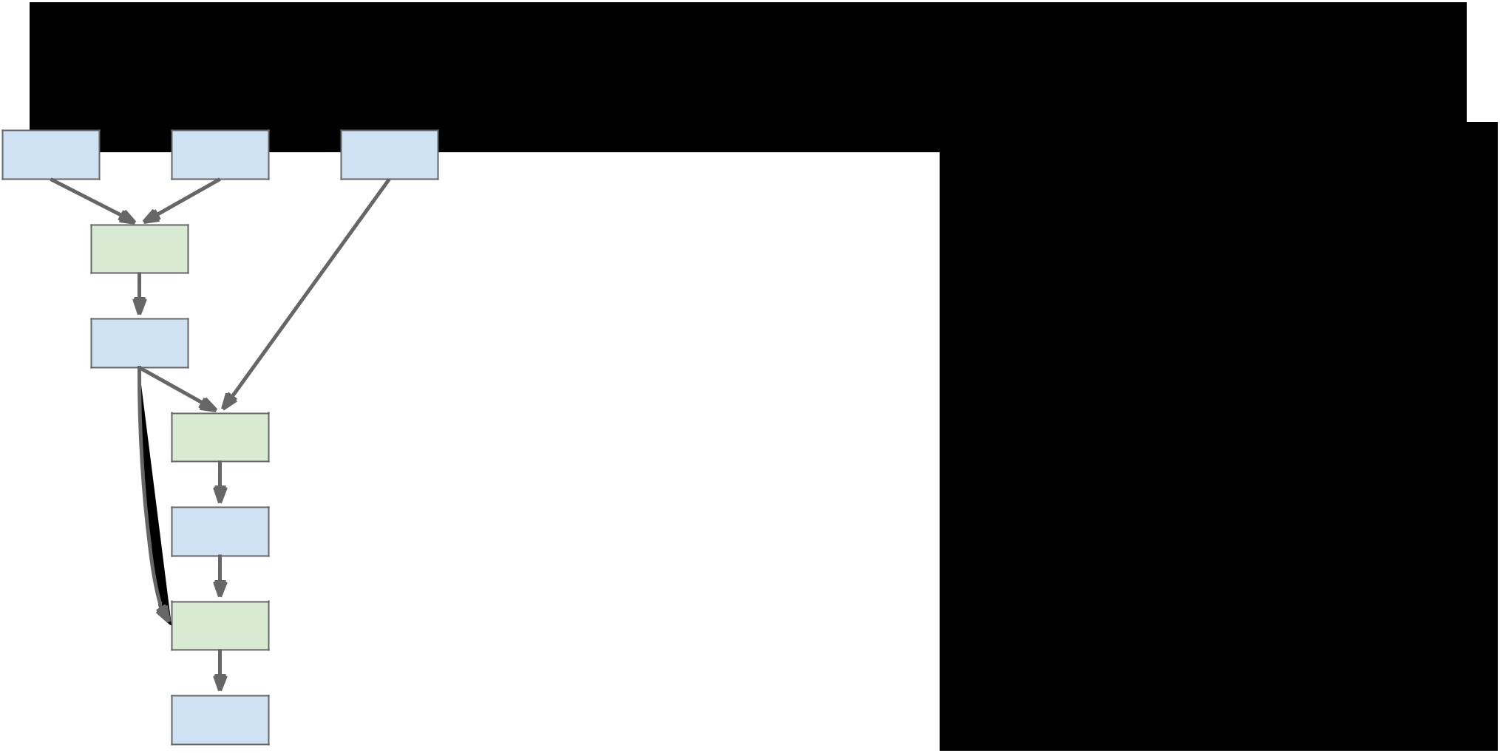Theano: Computational Graphs

x y z

+



a

☉



b



+



c



Fei-Fei Li & Andrej Karpathy & Justin Johnson Lecture 12 79 22 Feb 2016

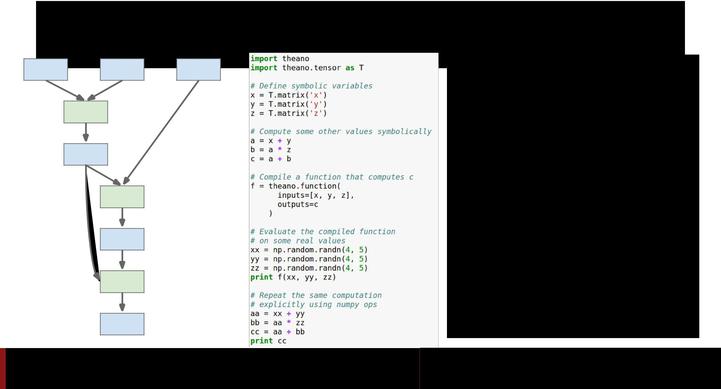Theano: Computational Graphs

x y z

+



a

☉



b



+



c

Fei-Fei Li & Andrej Karpathy & Justin Johnson Lecture 12 80 22 Feb 2016

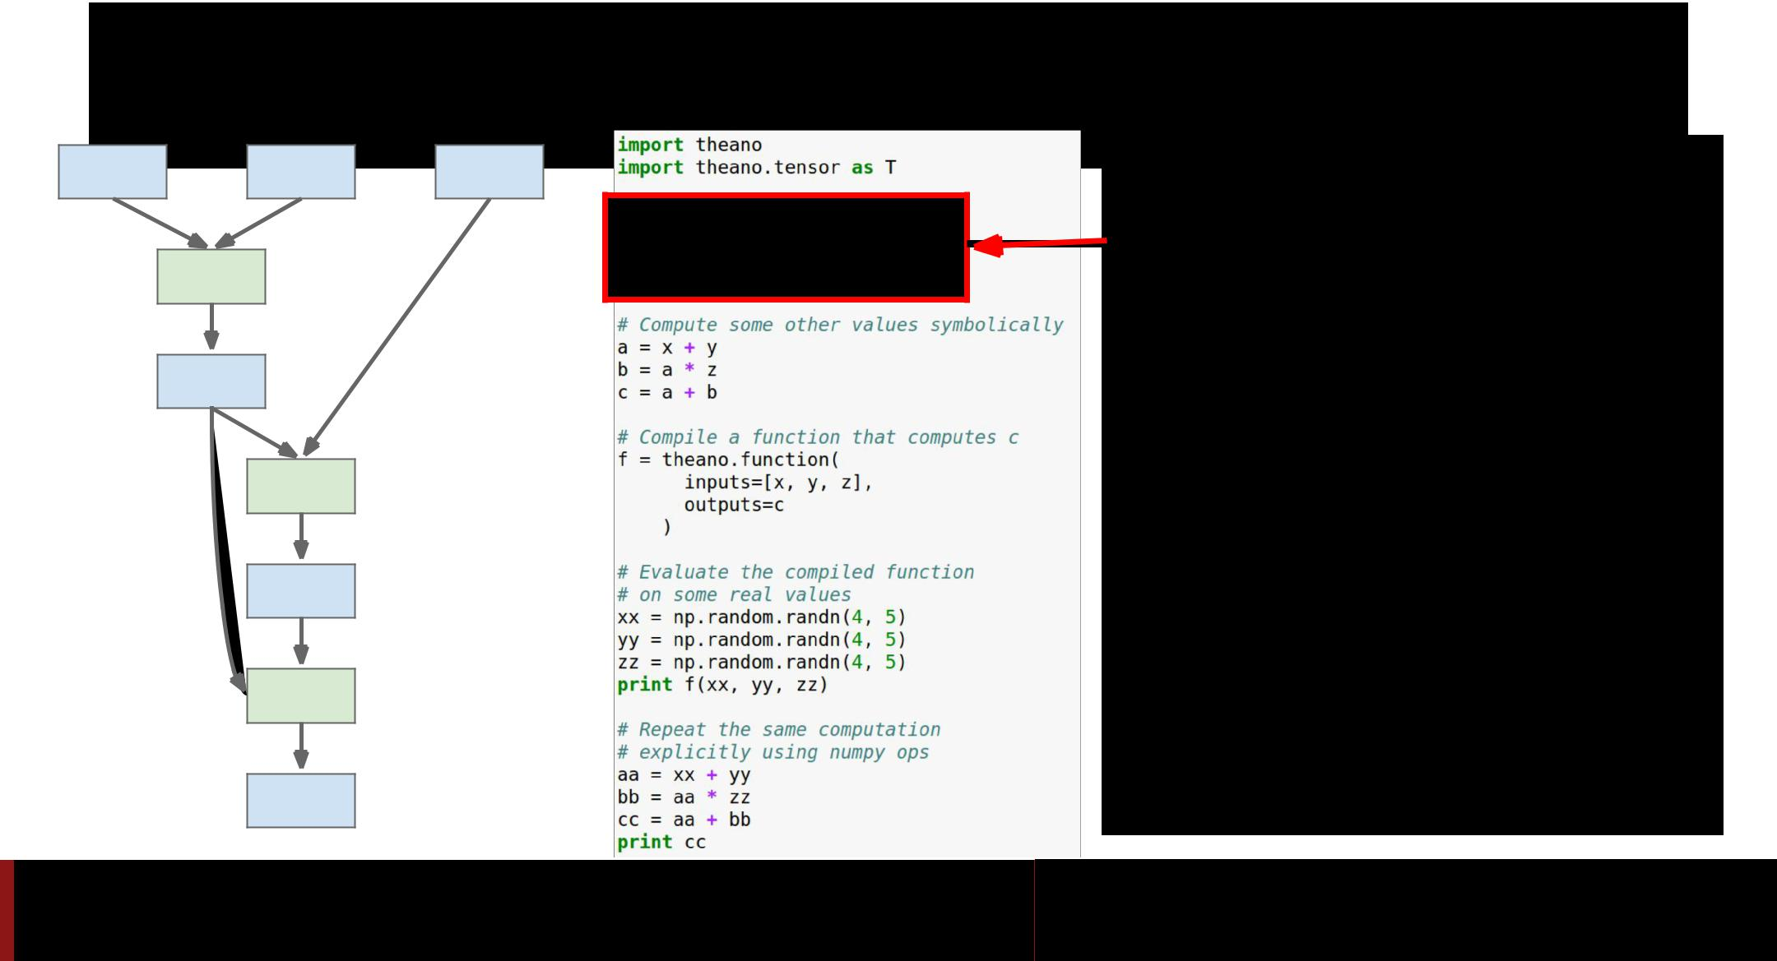Theano: Computational Graphs

|  |  |  |  |  |
| --- | --- | --- | --- | --- |
| x | y | z | Define symbolic variables; |  |
|  | + |  | these are inputs to the |  |
|  |  | graph |  |
|  |  |  |  |
|  | a |  |  |  |



☉



b



+



c

Fei-Fei Li & Andrej Karpathy & Justin Johnson Lecture 12 81 22 Feb 2016

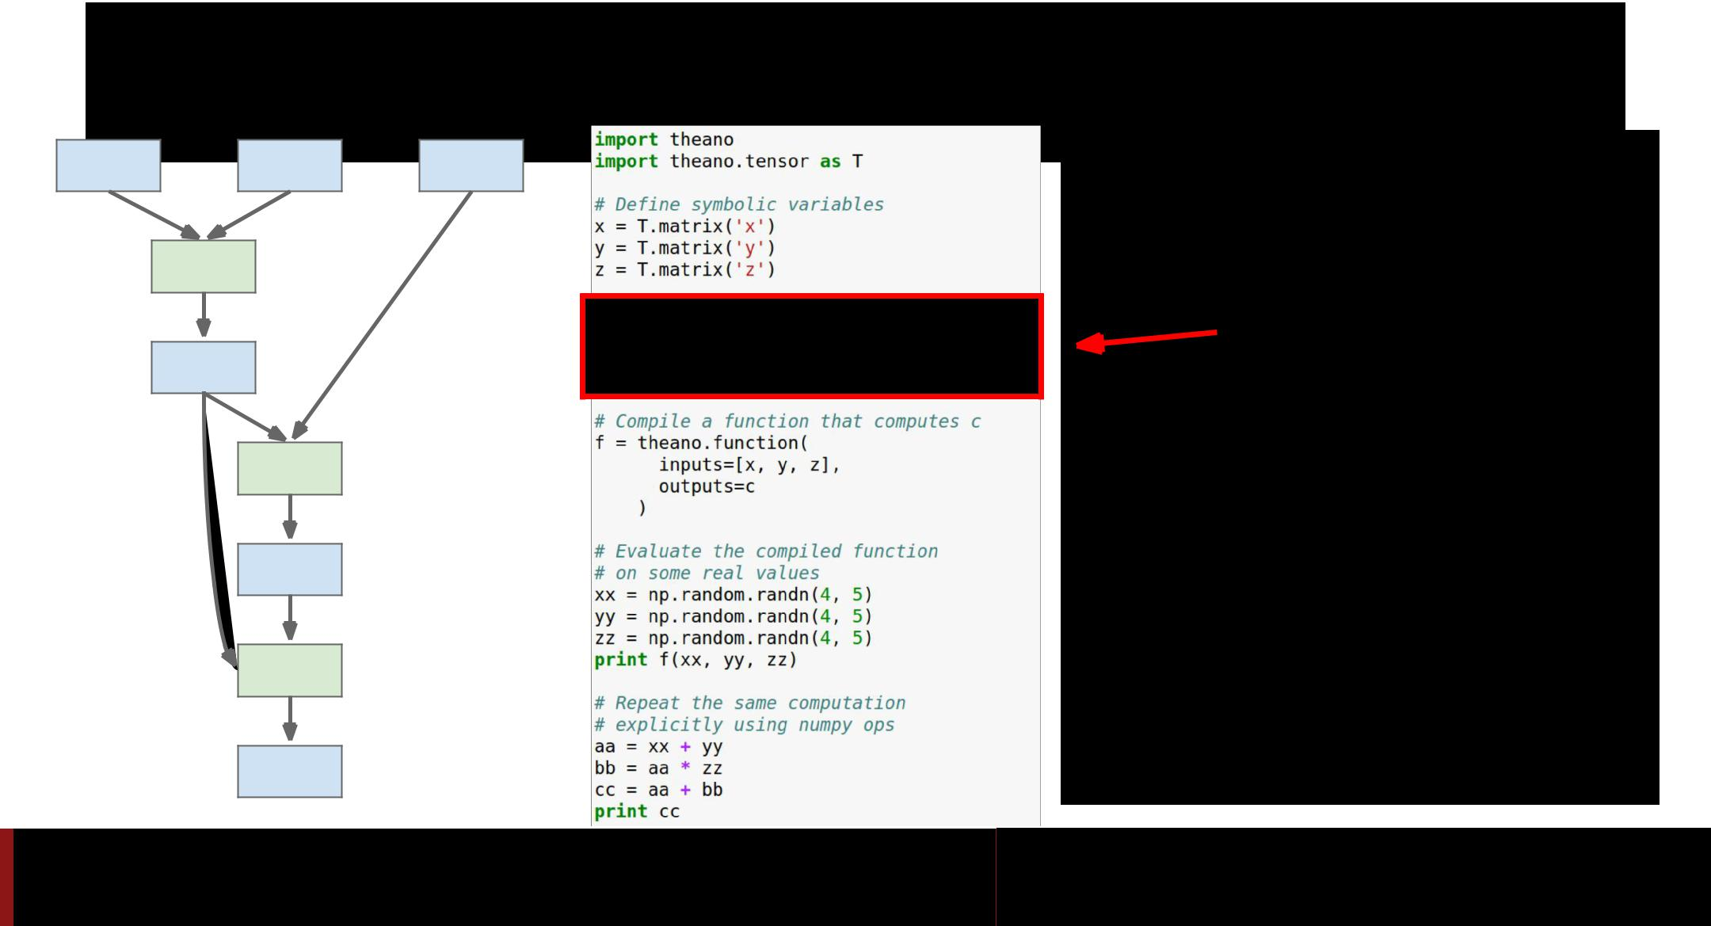Theano: Computational Graphs

x y z

+



a

☉



b



+



c

Fei-Fei Li & Andrej Karpathy & Justin Johnson

Compute intermediates and outputs symbolically

Lecture 12 82 22 Feb 2016

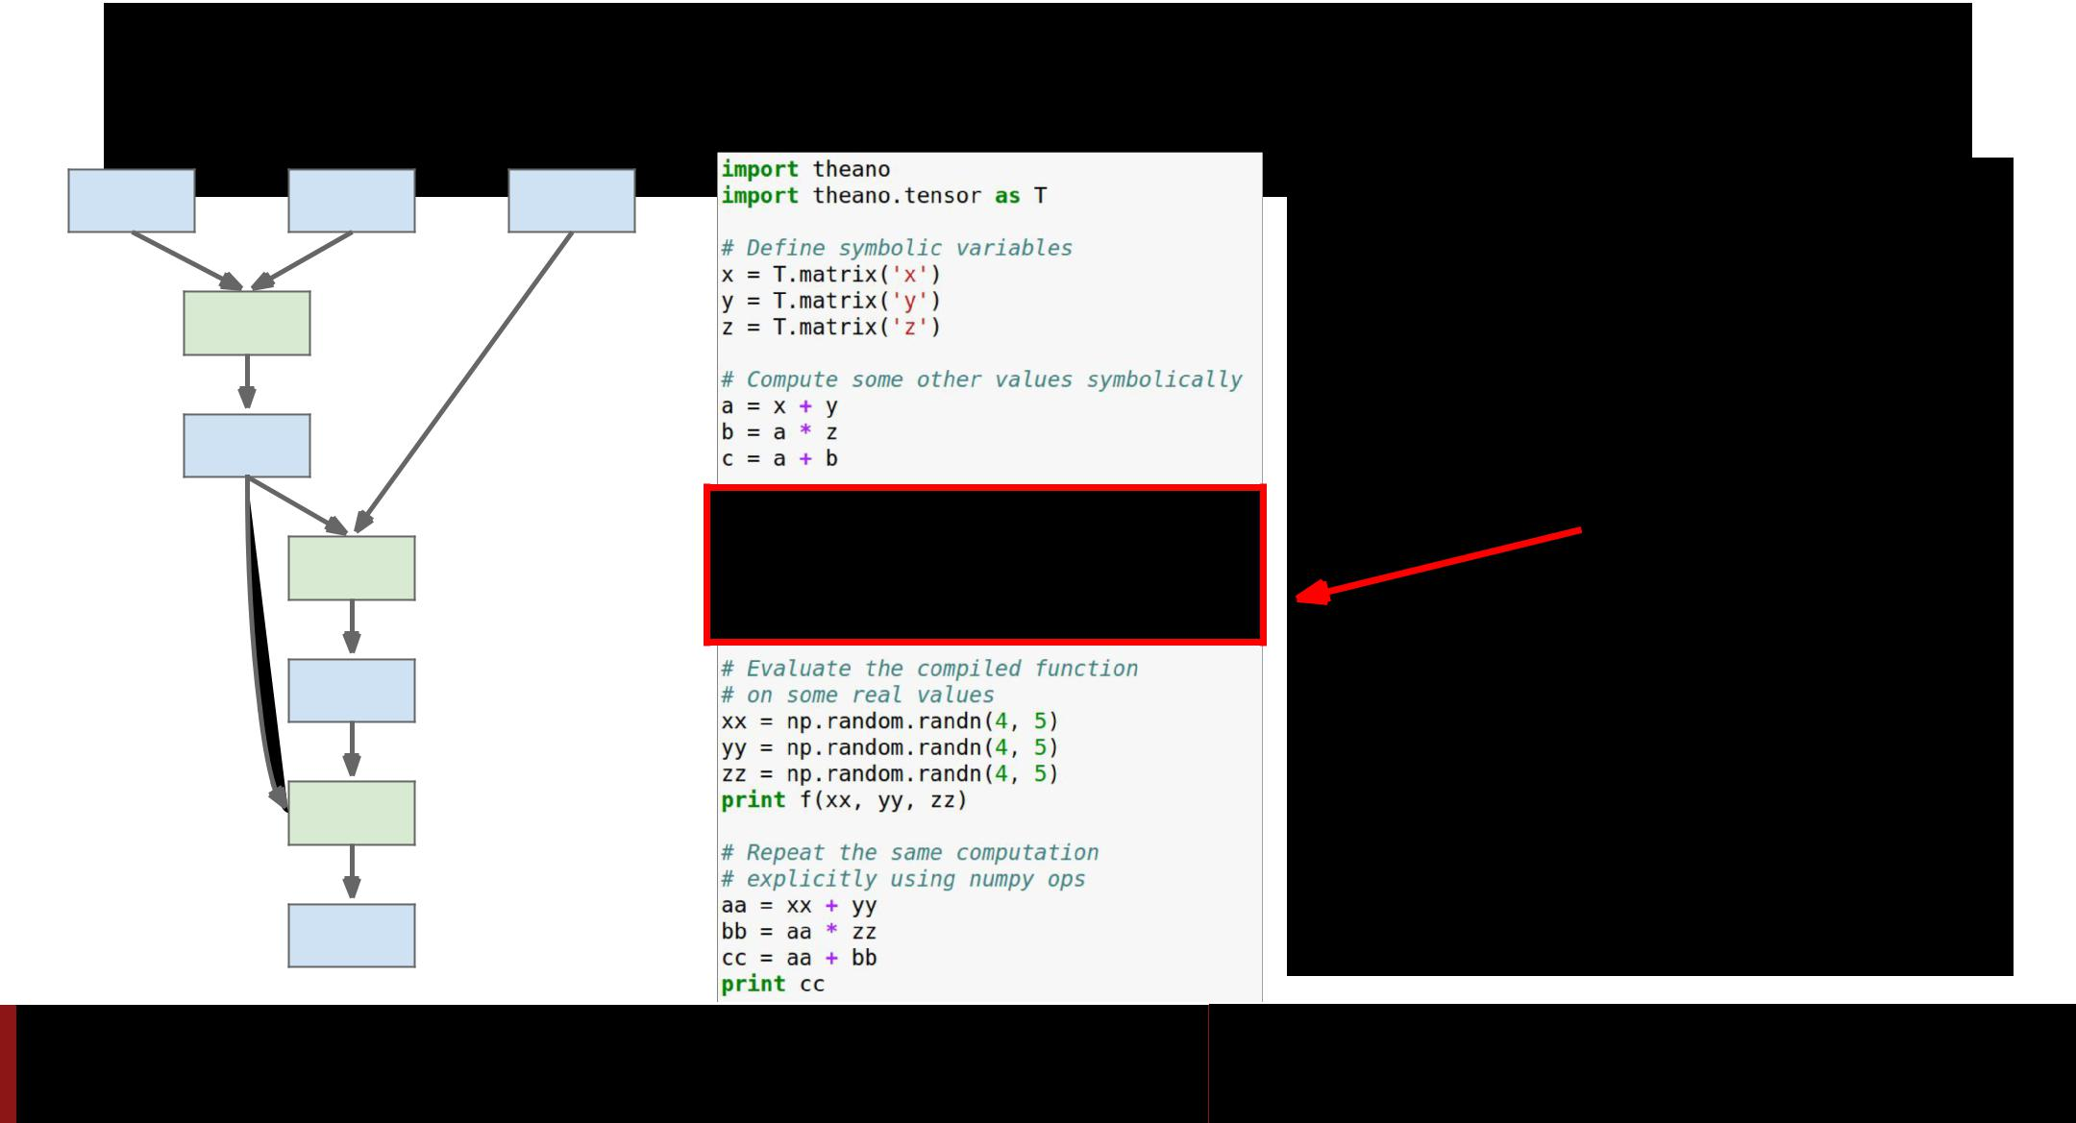Theano: Computational Graphs

x y z

+



a

☉



b



+



c

Fei-Fei Li & Andrej Karpathy & Justin Johnson

Compile a function that produces c from x, y, z (generates code)

Lecture 12 83 22 Feb 2016

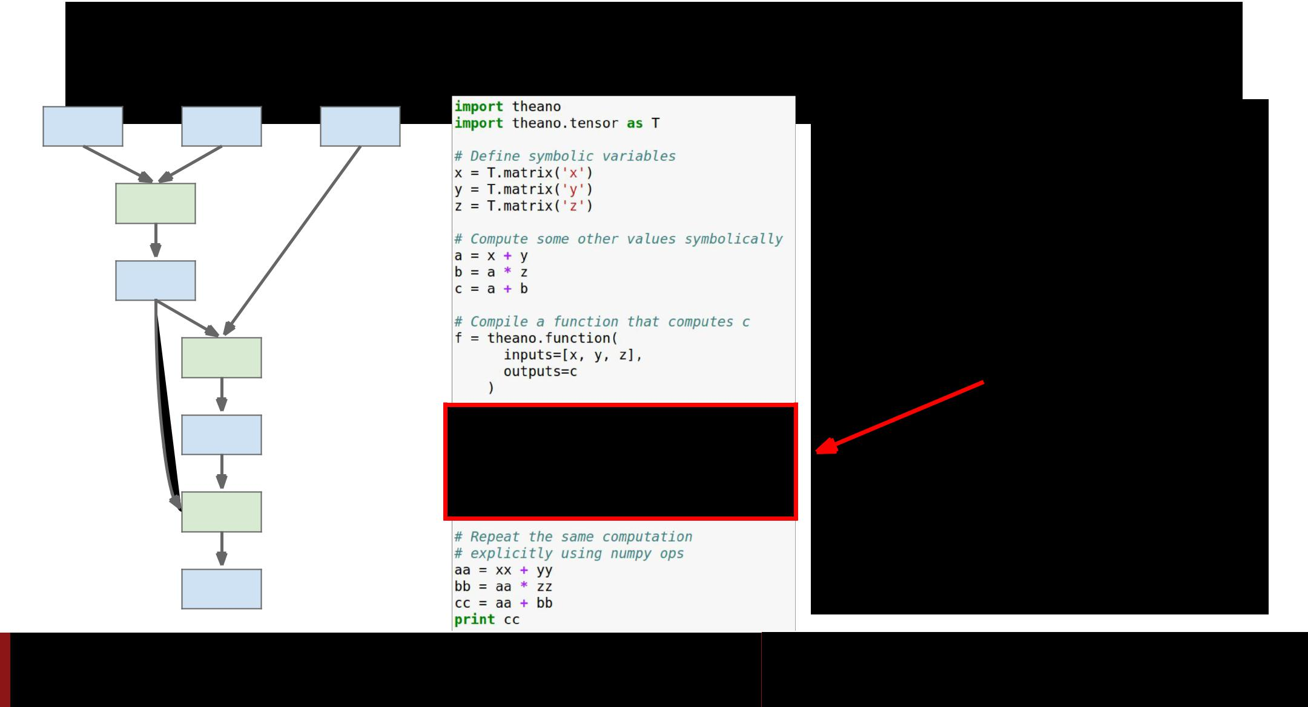Theano: Computational Graphs

x y z

+



a

☉



b



+



c

Fei-Fei Li & Andrej Karpathy & Justin Johnson

Run the function, passing some numpy arrays (may run on GPU)

Lecture 12 84 22 Feb 2016

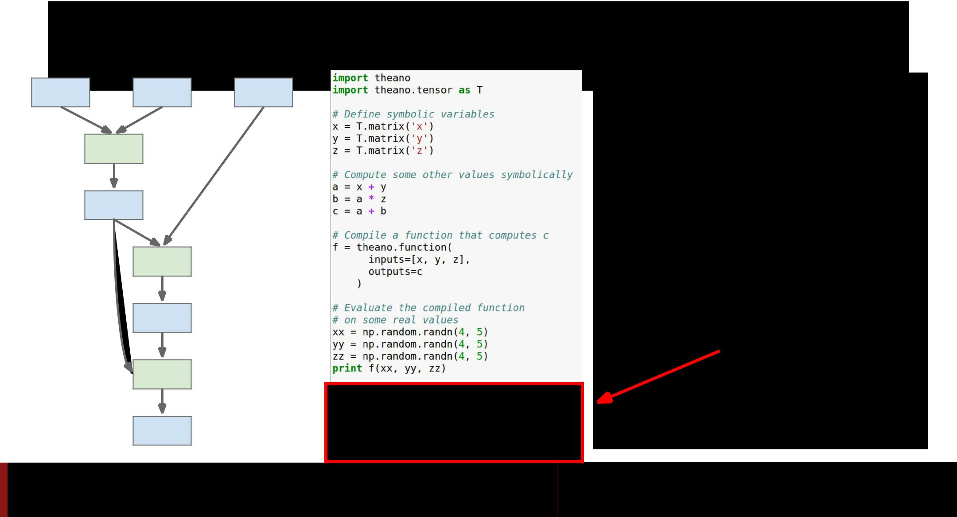Theano: Computational Graphs

x y z

+



a

☉



b



+



c

Fei-Fei Li & Andrej Karpathy & Justin Johnson

Repeat the same computation using numpy operations (runs on CPU)

Lecture 12 85 22 Feb 2016

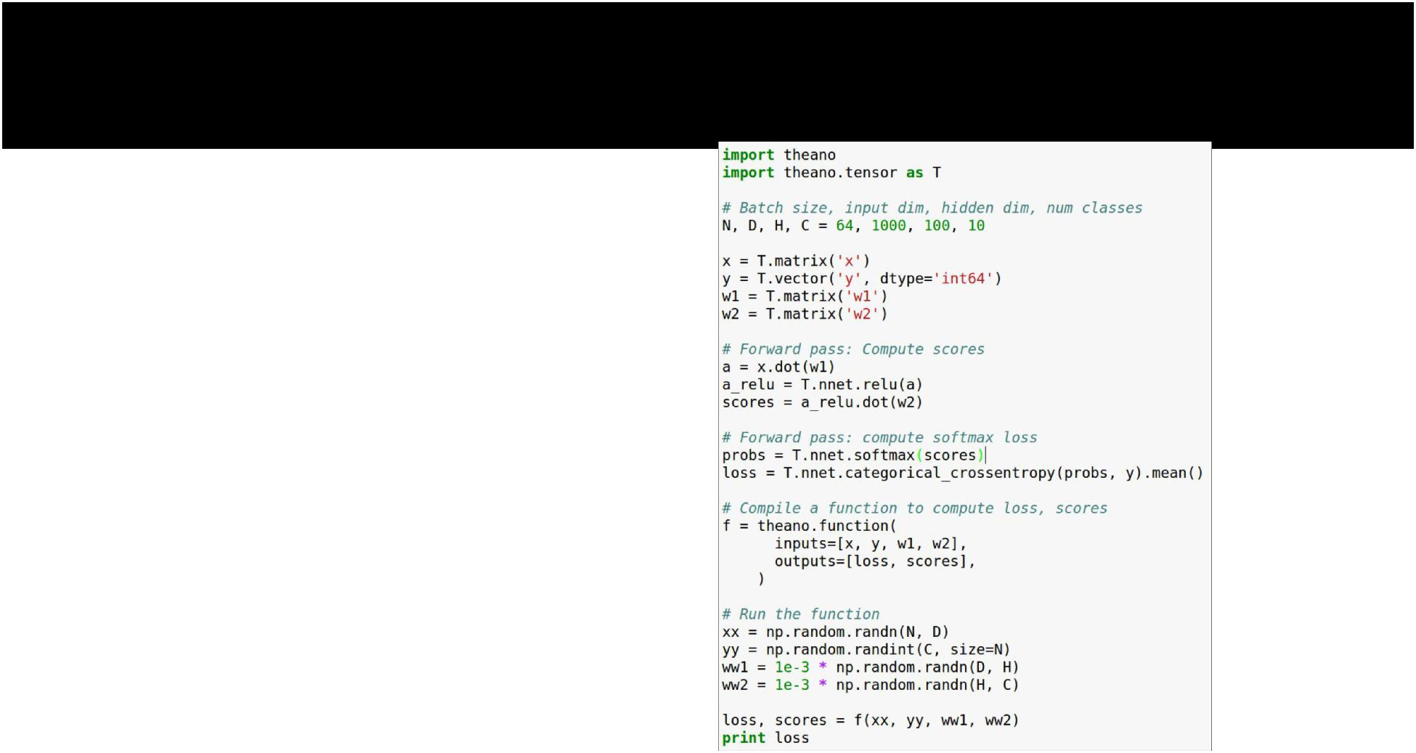Theano: Simple Neural Net



Fei-Fei Li & Andrej Karpathy & Justin Johnson Lecture 12 86 22 Feb 2016

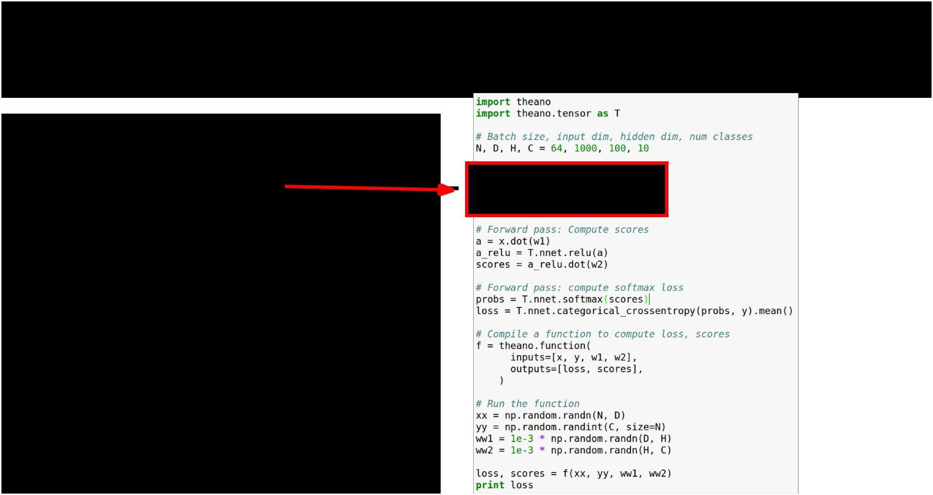Theano: Simple Neural Net

Define symbolic variables:

x = data

y = labels

w1 = first-layer weights

w2 = second-layer weights



Fei-Fei Li & Andrej Karpathy & Justin Johnson Lecture 12 87 22 Feb 2016

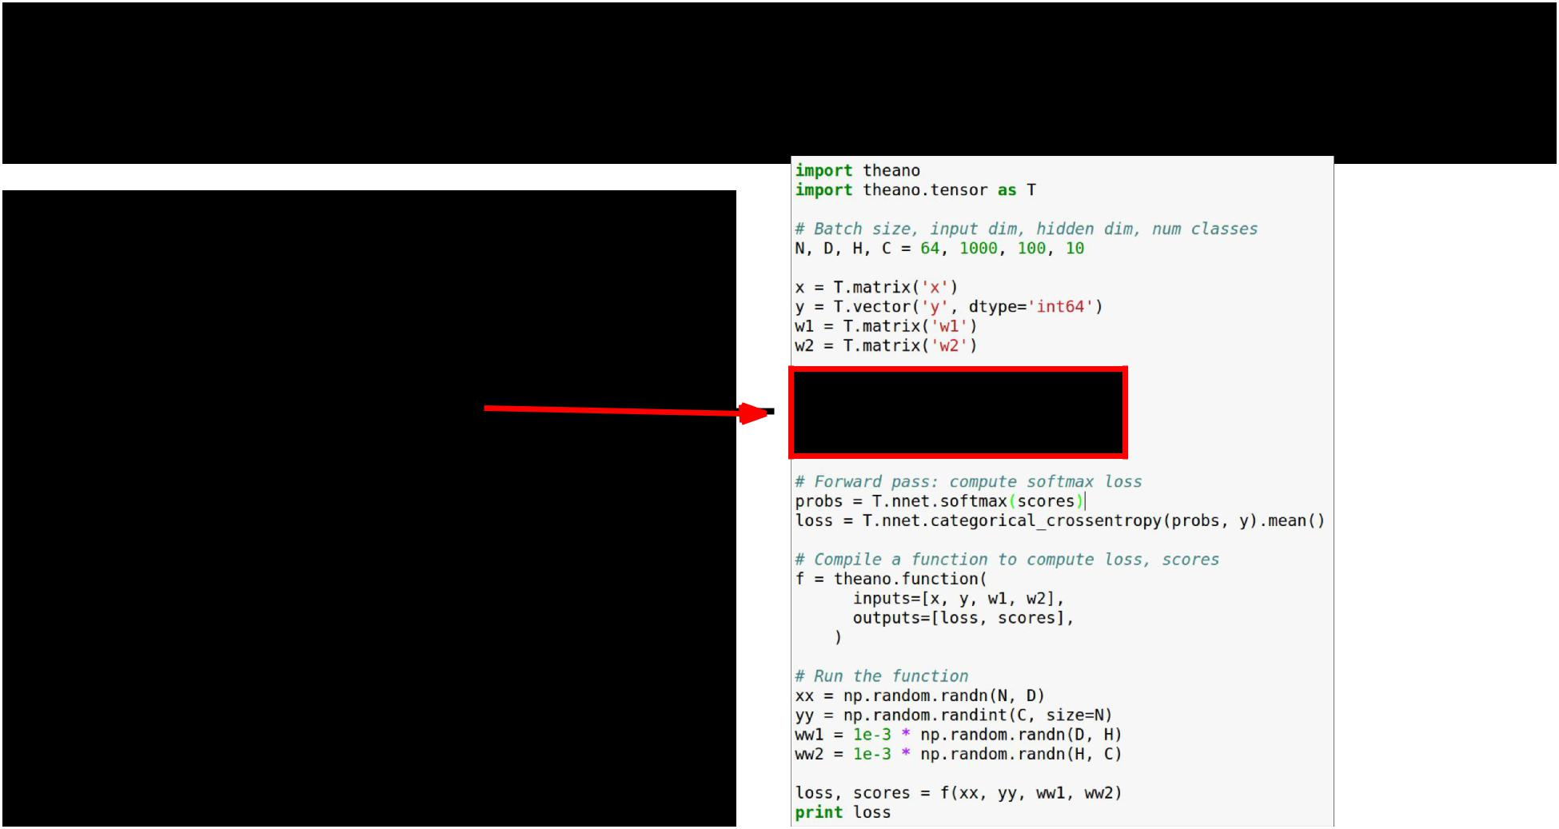Theano: Simple Neural Net

**Forward**: Compute scores(symbolically)



Fei-Fei Li & Andrej Karpathy & Justin Johnson Lecture 12 88 22 Feb 2016

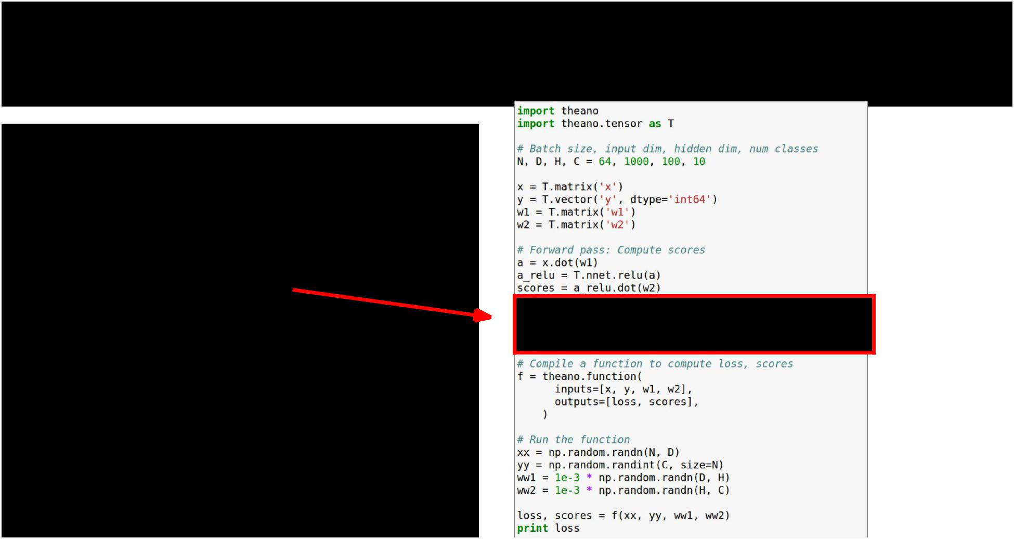Theano: Simple Neural Net

**Forward**: Compute probs, loss(symbolically)



Fei-Fei Li & Andrej Karpathy & Justin Johnson Lecture 12 89 22 Feb 2016

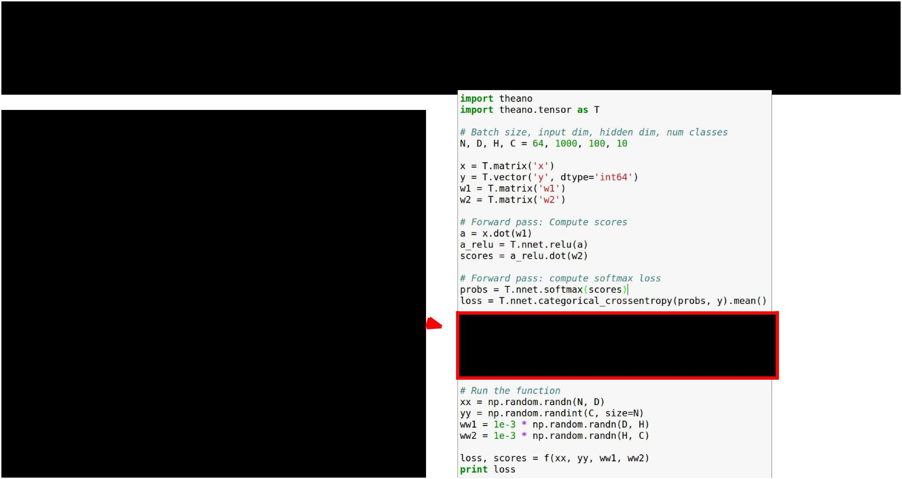Theano: Simple Neural Net

Compile a function that

computes loss, scores



Fei-Fei Li & Andrej Karpathy & Justin Johnson Lecture 12 90 22 Feb 2016

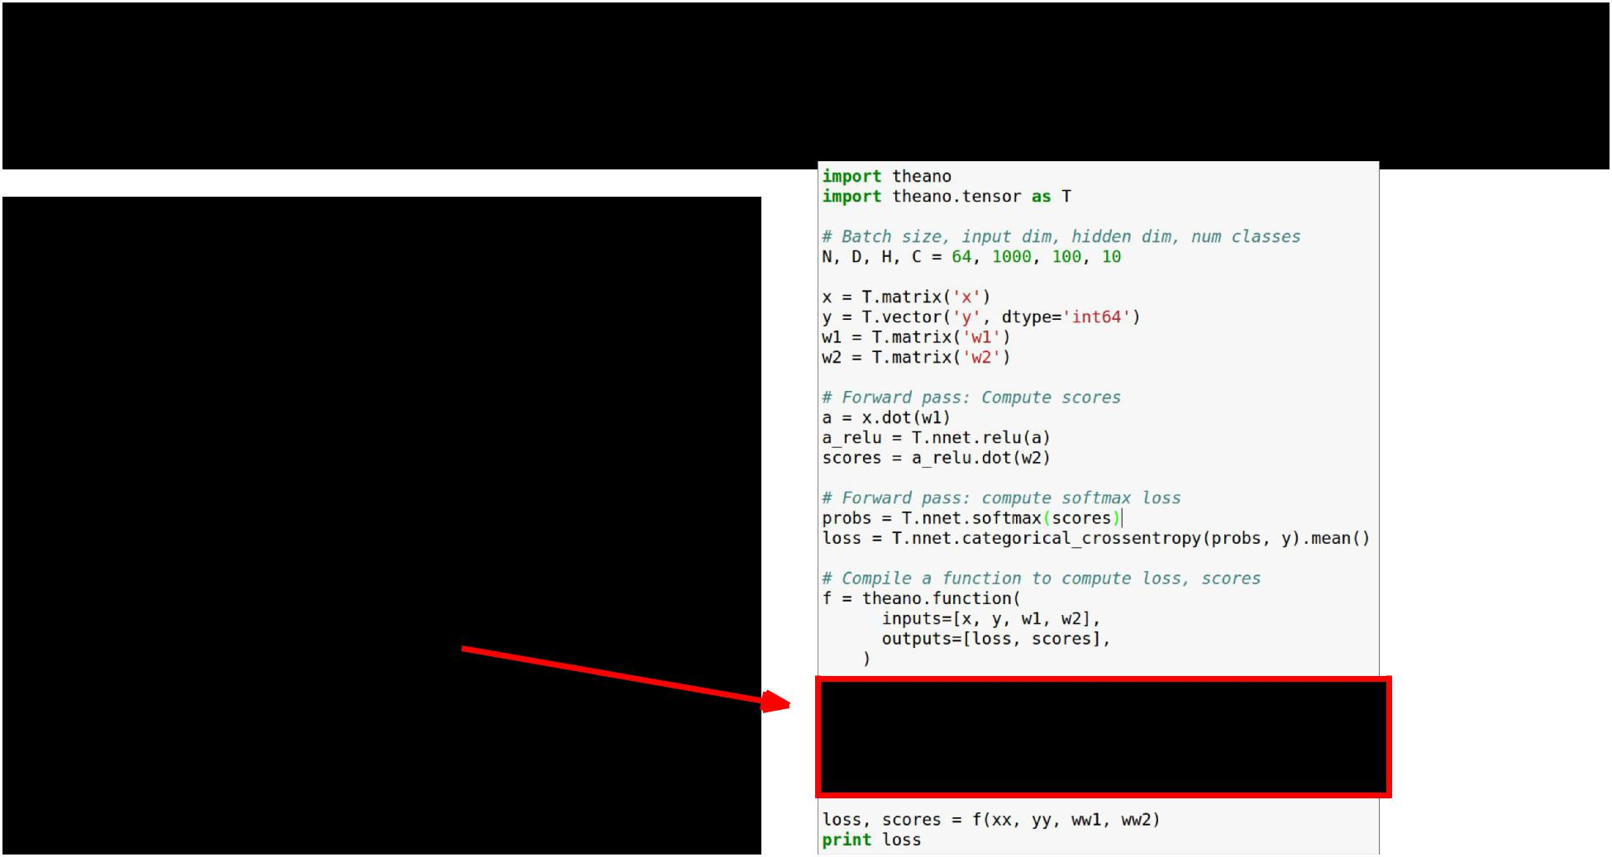Theano: Simple Neural Net

Stuff actual numpy arrays into the function



Fei-Fei Li & Andrej Karpathy & Justin Johnson Lecture 12 91 22 Feb 2016

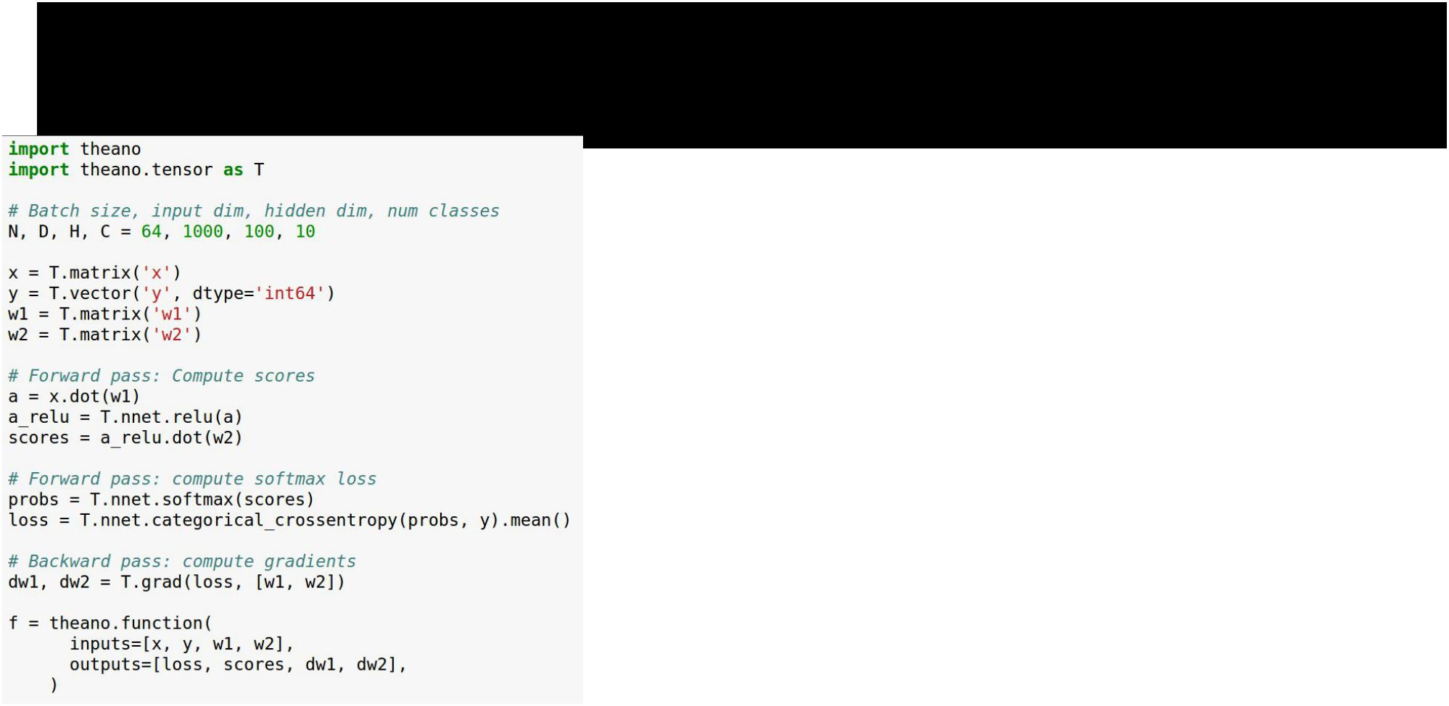Theano: Computing Gradients



Fei-Fei Li & Andrej Karpathy & Justin Johnson Lecture 12 92 22 Feb 2016

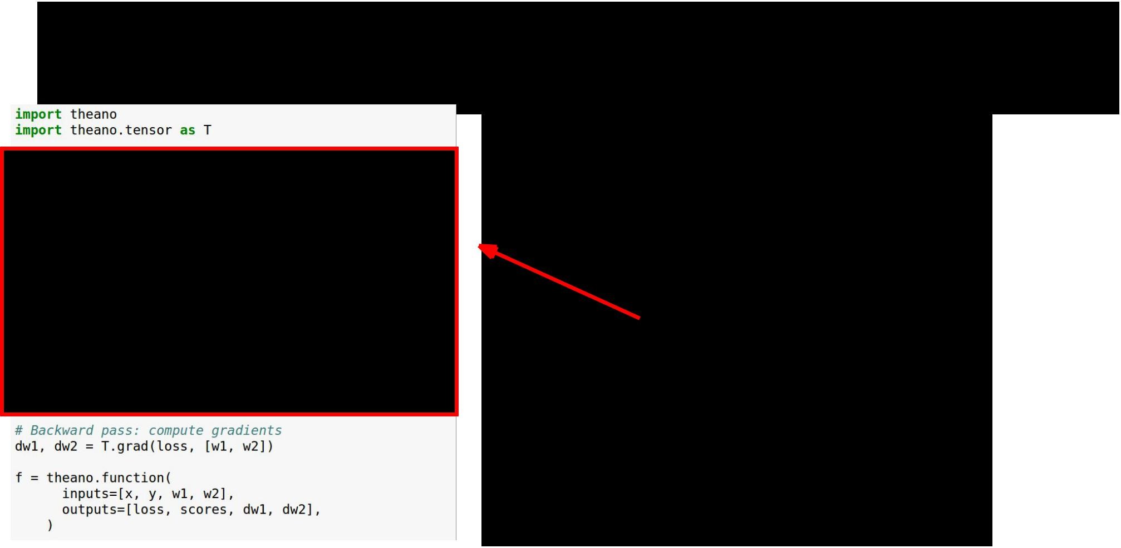Theano: Computing Gradients

Same as before: define variables, compute scores and loss symbolically



Fei-Fei Li & Andrej Karpathy & Justin Johnson Lecture 12 93 22 Feb 2016

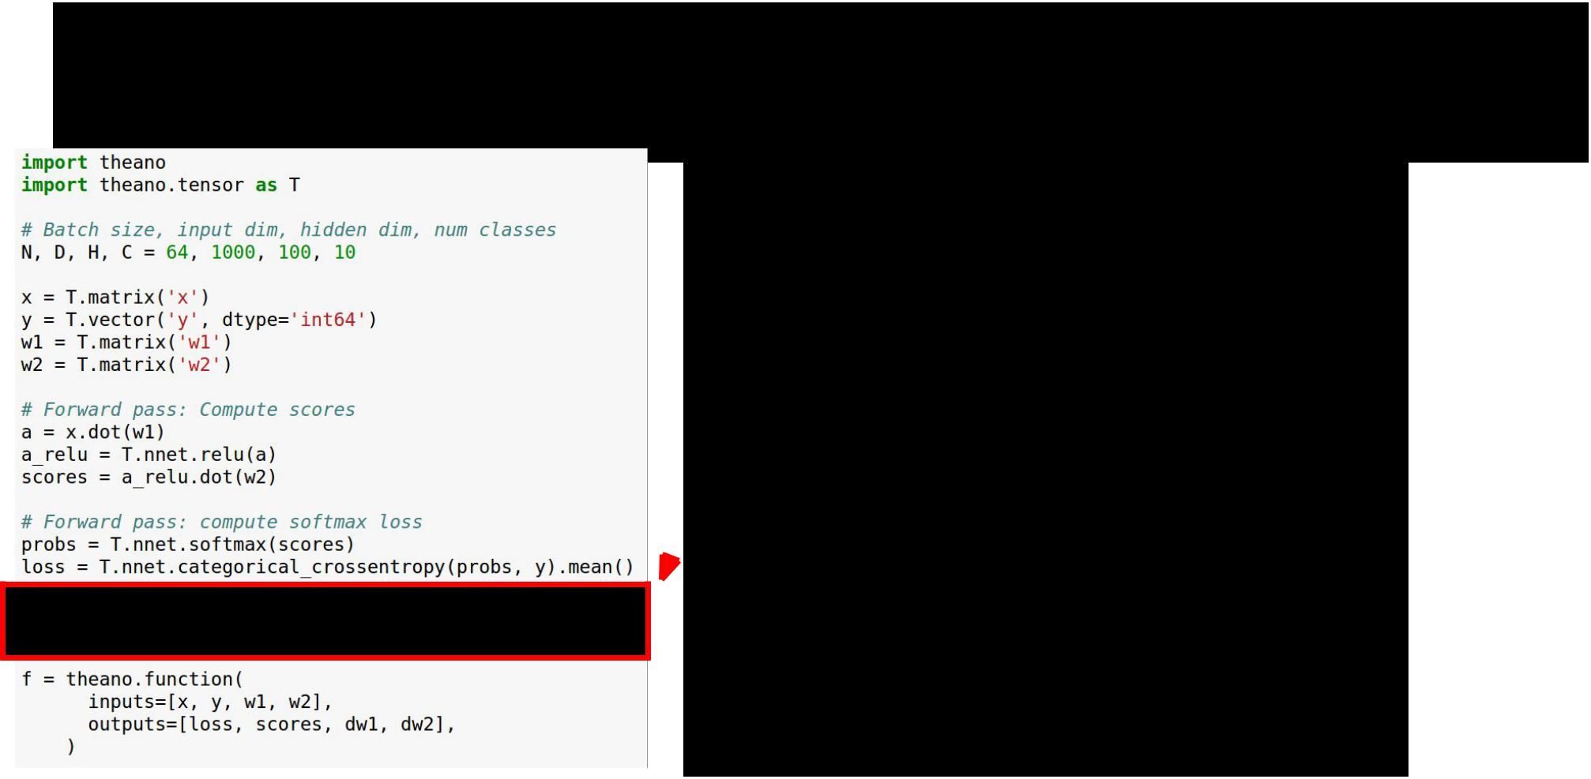Theano: Computing Gradients

Theano computes gradients for  us symbolically!



Fei-Fei Li & Andrej Karpathy & Justin Johnson Lecture 12 94 22 Feb 2016

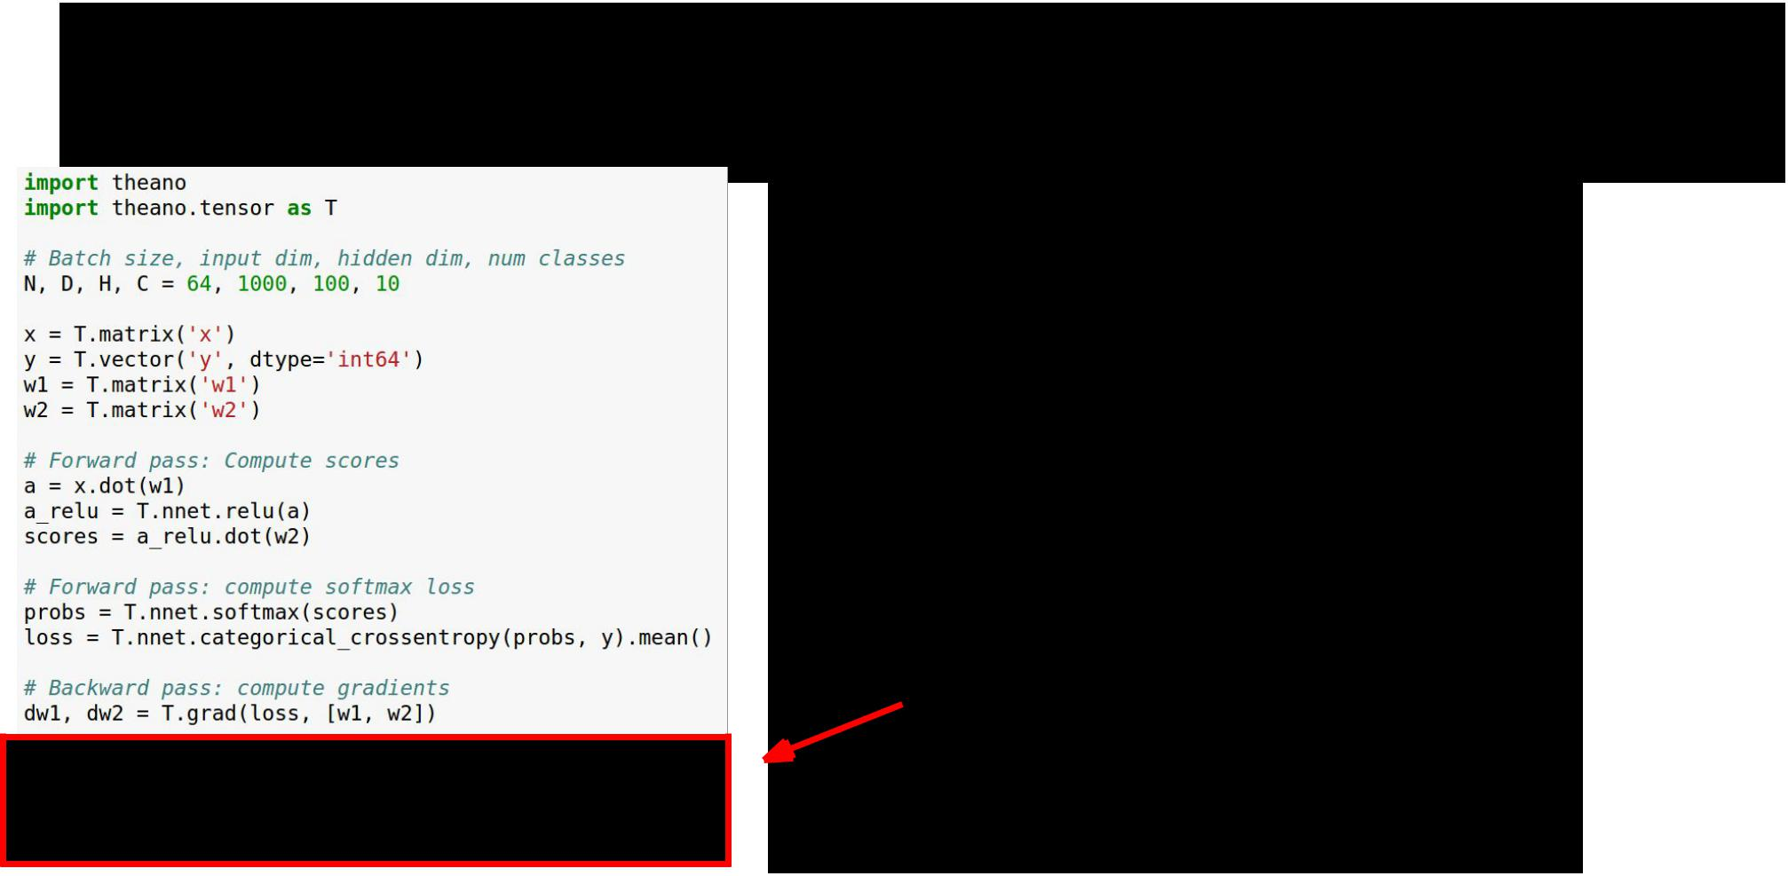Theano: Computing Gradients

Now the function returns loss, scores, and gradients



Fei-Fei Li & Andrej Karpathy & Justin Johnson Lecture 12 95 22 Feb 2016

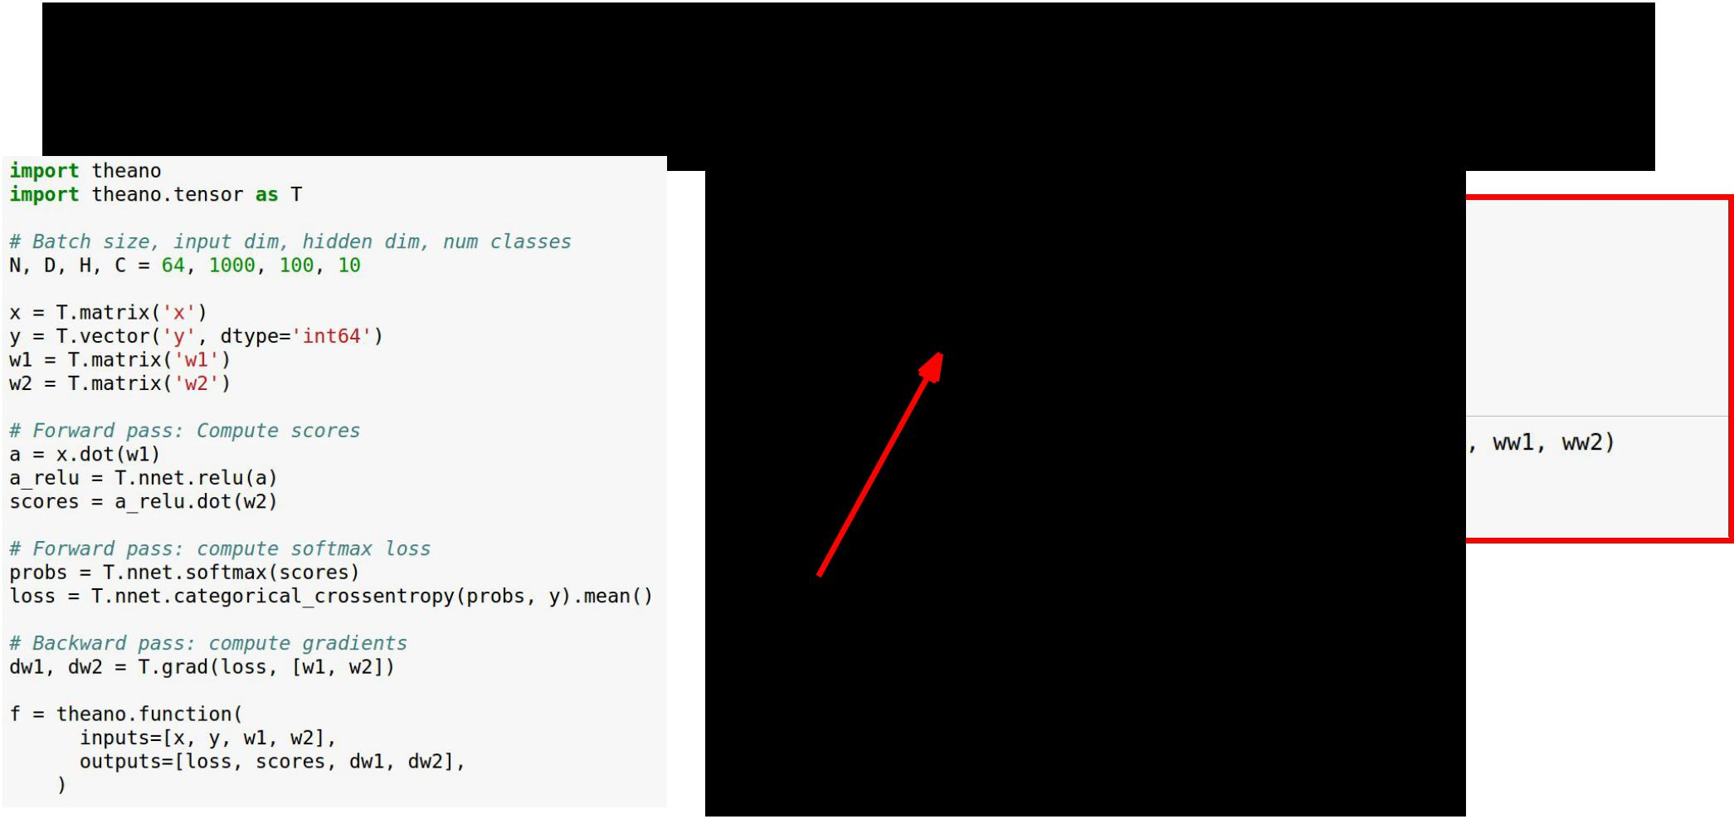Theano: Computing Gradients

Use the function to perform gradient descent!



Fei-Fei Li & Andrej Karpathy & Justin Johnson Lecture 12 96 22 Feb 2016

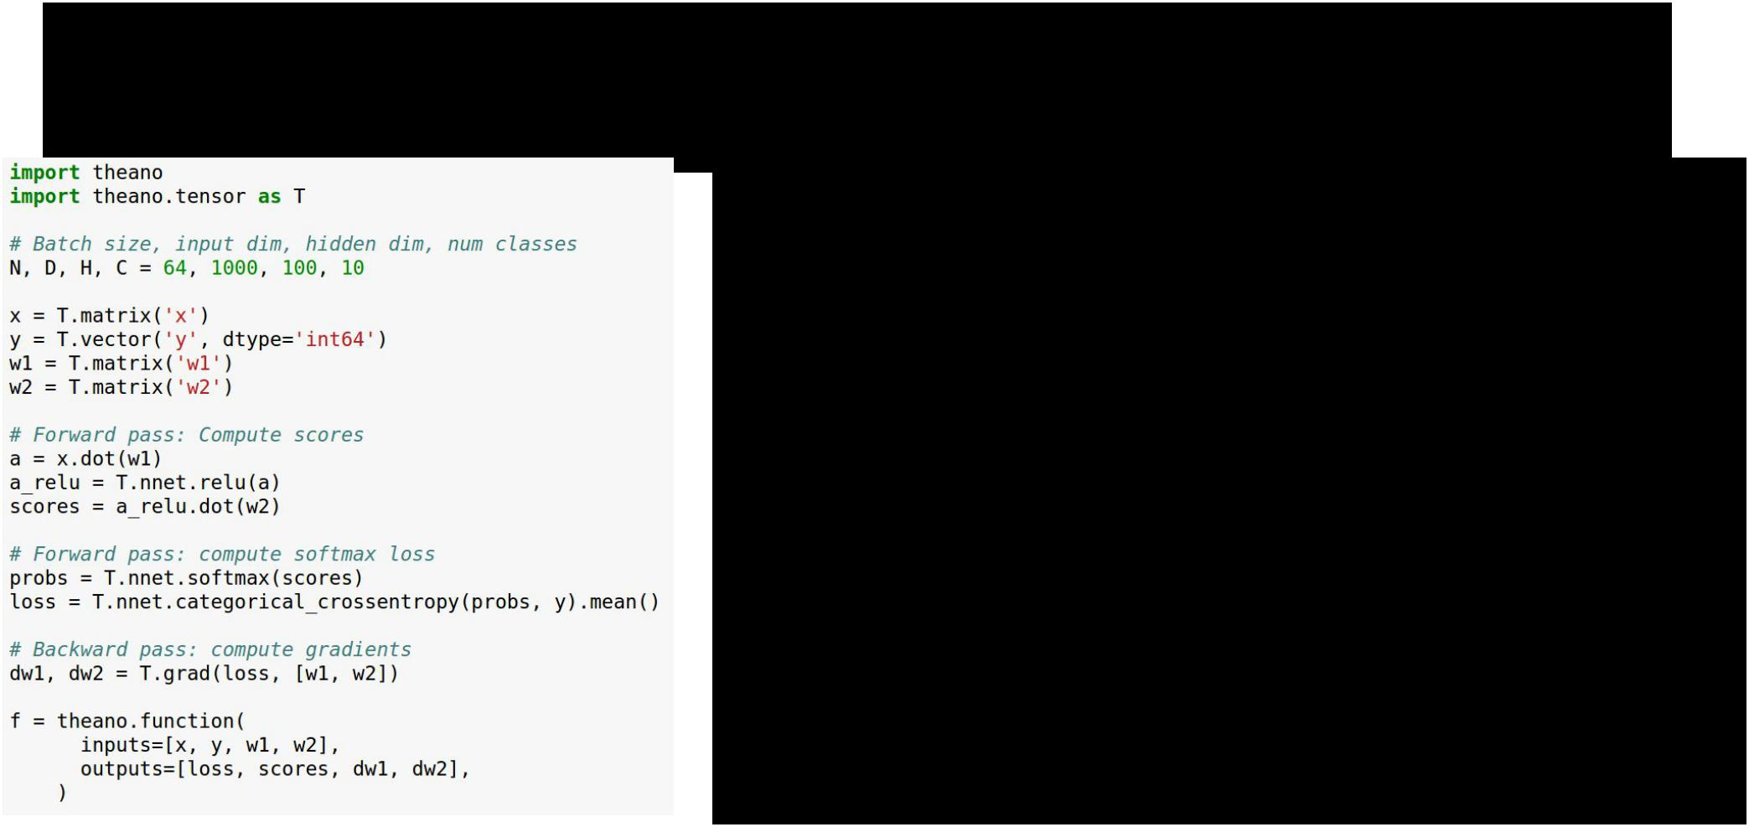Theano: Computing Gradients

**Problem**: Shipping weights and gradients toCPU on every iteration to update...



Fei-Fei Li & Andrej Karpathy & Justin Johnson Lecture 12 97 22 Feb 2016

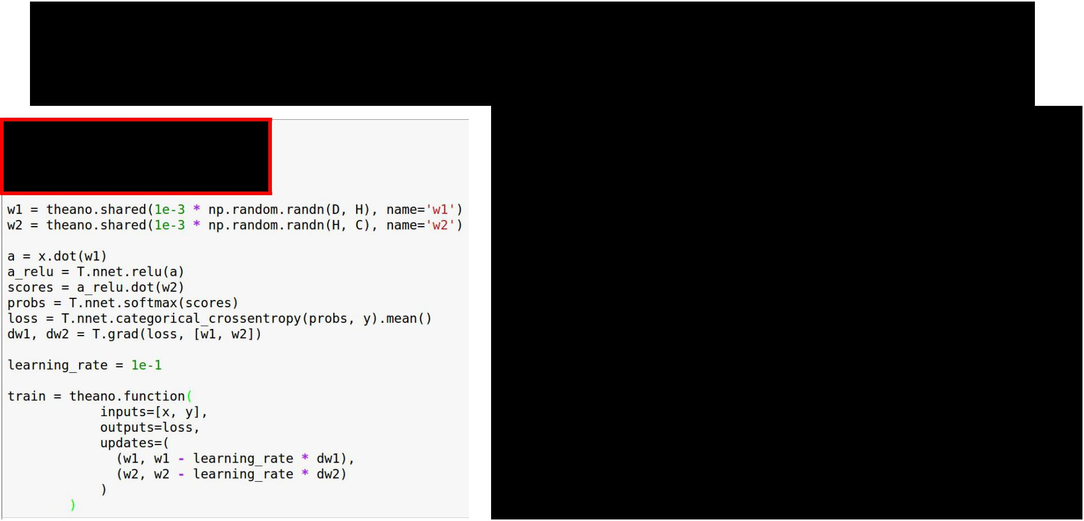Theano: Shared Variables

Same as before: Define dimensions,  define symbolic variables for x, y



Fei-Fei Li & Andrej Karpathy & Justin Johnson Lecture 12 98 22 Feb 2016

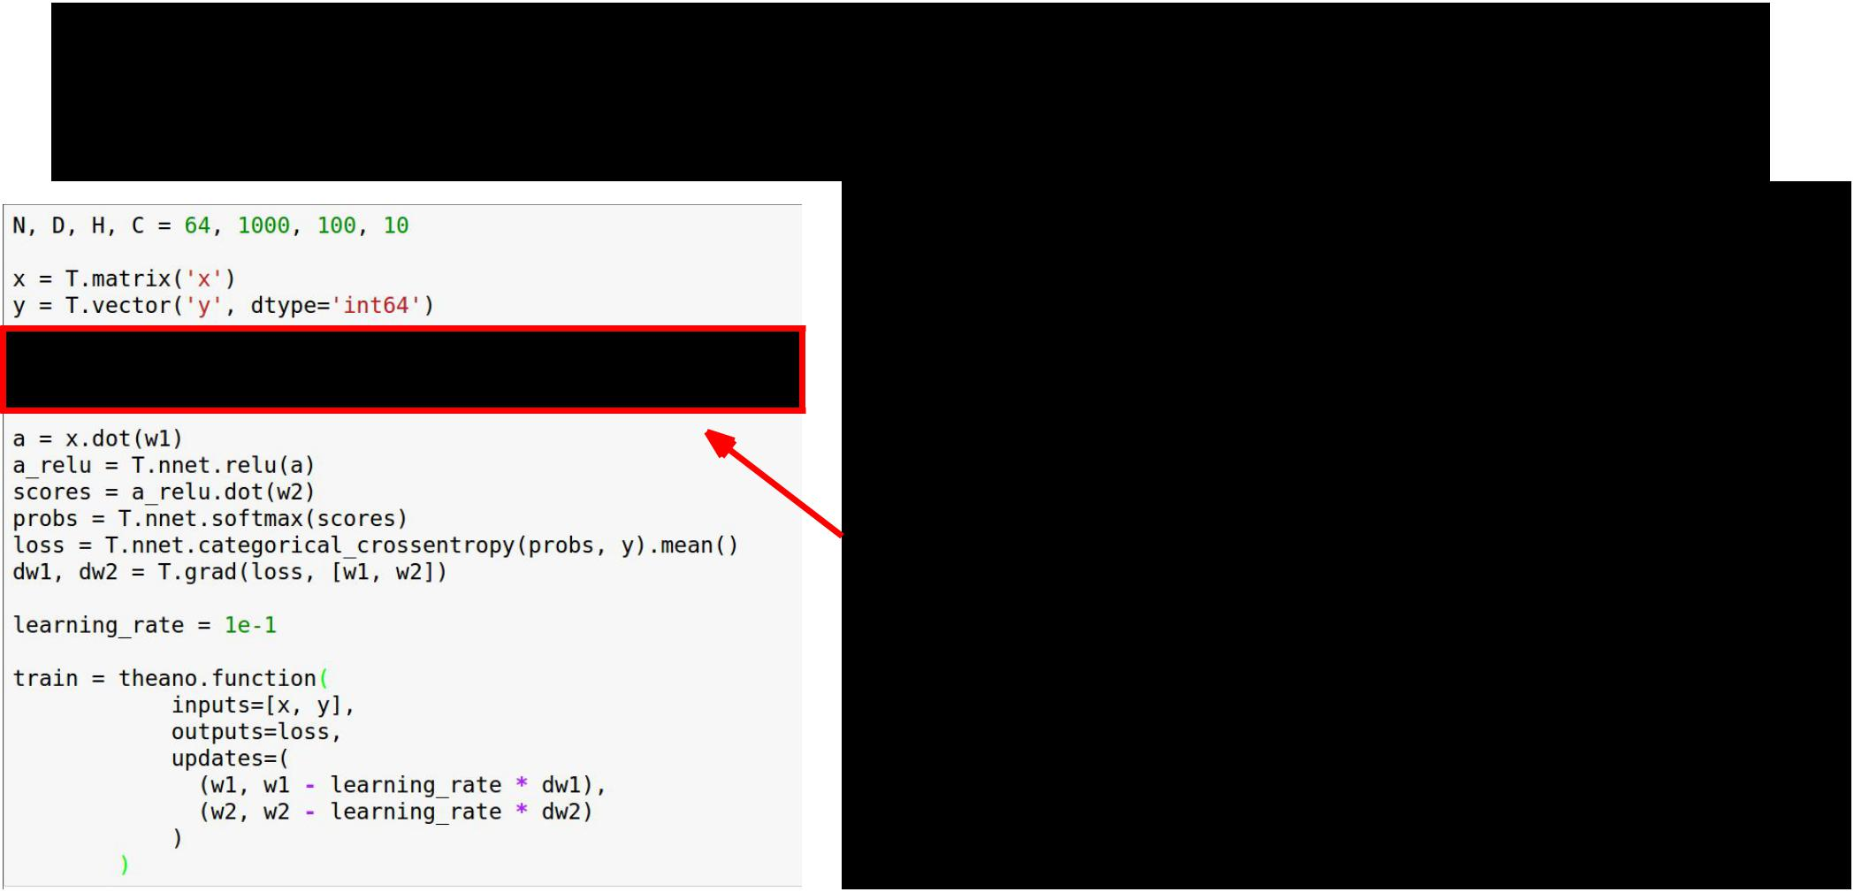Theano: Shared Variables

Define weights as **shared variables** that persist in the graph between calls; initialize with numpy arrays



Fei-Fei Li & Andrej Karpathy & Justin Johnson Lecture 12 99 22 Feb 2016

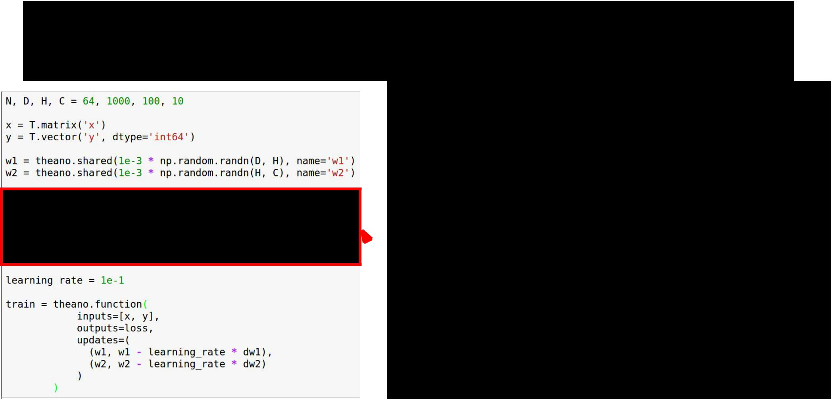Theano: Shared Variables

Same as before: Compute scores, loss, gradients symbolically



Fei-Fei Li & Andrej Karpathy & Justin Johnson Lecture 12 100 22 Feb 2016

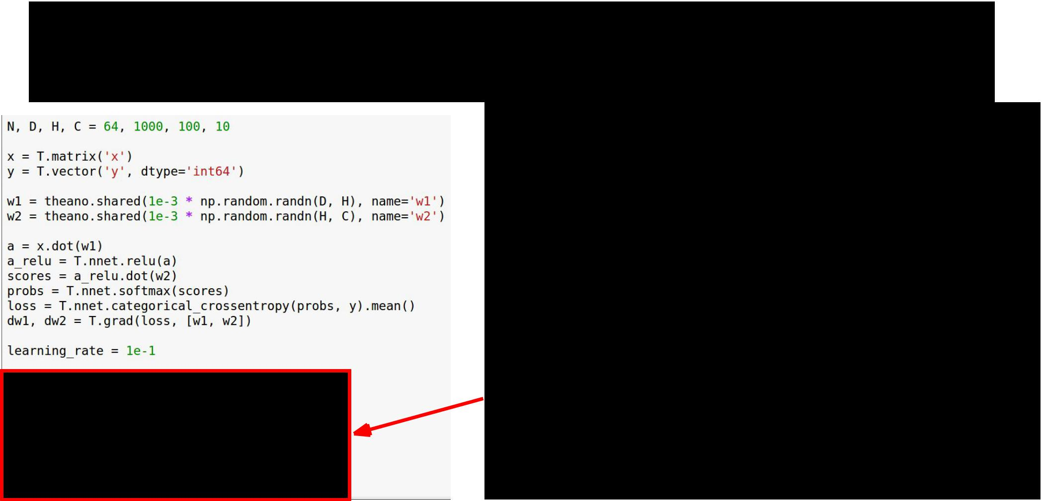Theano: Shared Variables

Compiled function inputs are x and y; weights live in the graph



Fei-Fei Li & Andrej Karpathy & Justin Johnson Lecture 12 101 22 Feb 2016

Theano: Shared Variables

Function includes an **update** that updates weights on every call



Fei-Fei Li & Andrej Karpathy & Justin Johnson Lecture 12 102 22 Feb 2016

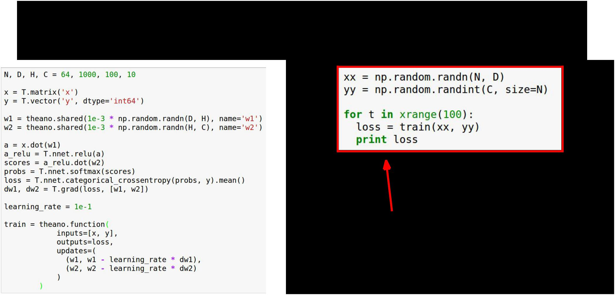Theano: Shared Variables

To train the net, just call function repeatedly!



Fei-Fei Li & Andrej Karpathy & Justin Johnson Lecture 12 103 22 Feb 2016

Theano: Other Topics



**Conditionals**: The **ifelse** and **switch** functions allow conditionalcontrol flow in the graph

**Loops**: The **scan** function allows for (some types) of loops in thecomputational graph; good for RNNs

**Derivatives**: Efficient Jacobian / vector products with R and Loperators, symbolic hessians (gradient of gradient)

**Sparse matrices, optimizations, etc**



Fei-Fei Li & Andrej Karpathy & Justin Johnson Lecture 12 104 22 Feb 2016

Theano: Multi-GPU



Experimental model parallelism:

<http://deeplearning.net/software/theano/tutorial/using_multi_gpu.html>

Data parallelism using platoon:

<https://github.com/mila-udem/platoon>



Fei-Fei Li & Andrej Karpathy & Justin Johnson Lecture 12 105 22 Feb 2016

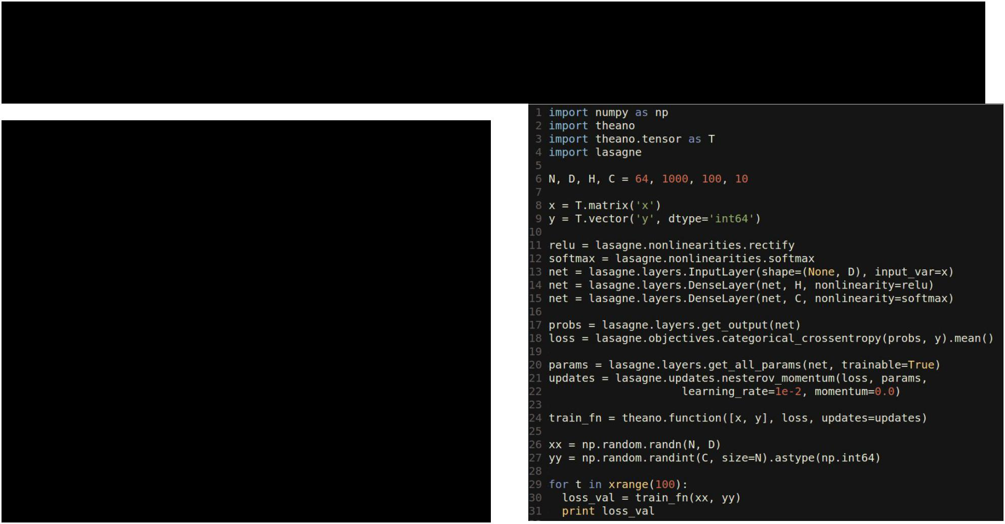Lasagne: High Level Wrapper

Lasagne gives layer abstractions, sets up weights for you, writes update rules for you



Fei-Fei Li & Andrej Karpathy & Justin Johnson Lecture 12 106 22 Feb 2016

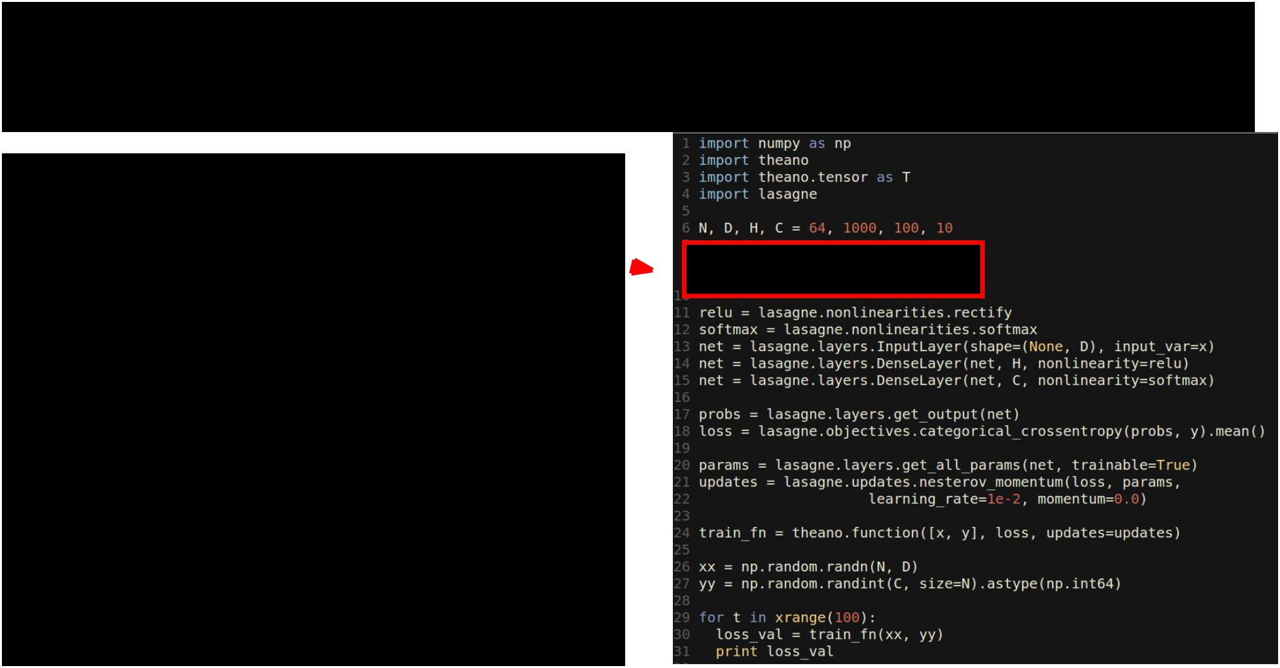Lasagne: High Level Wrapper

Set up symbolic Theano variables for data, labels 



Fei-Fei Li & Andrej Karpathy & Justin Johnson Lecture 12 107 22 Feb 2016

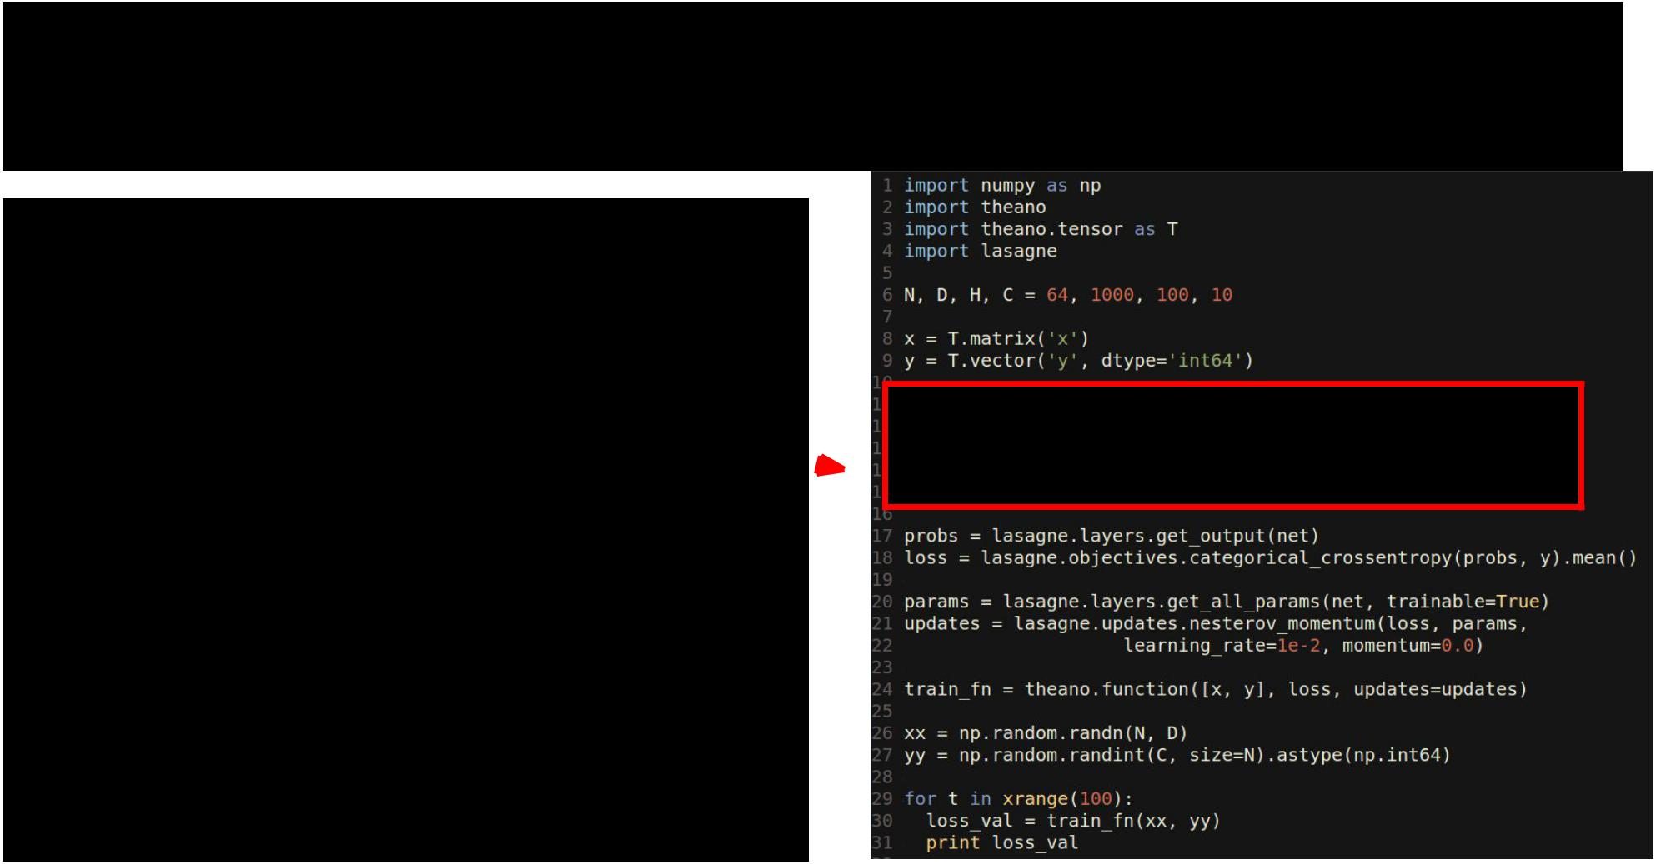Lasagne: High Level Wrapper

**Forward**: Use Lasagne layers toset up layers; don’t set up weights explicitly 



Fei-Fei Li & Andrej Karpathy & Justin Johnson Lecture 12 108 22 Feb 2016

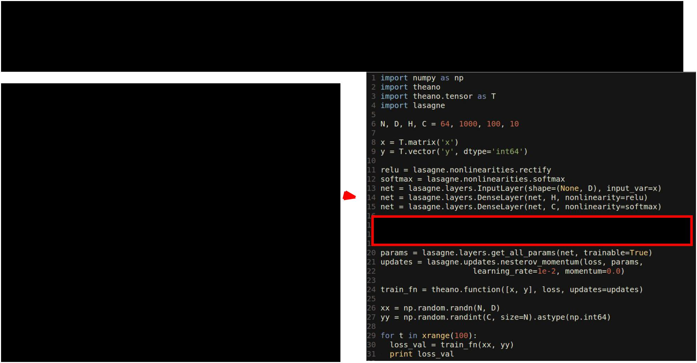Lasagne: High Level Wrapper

**Forward**: Use Lasagne layers tocompute loss 



Fei-Fei Li & Andrej Karpathy & Justin Johnson Lecture 12 109 22 Feb 2016

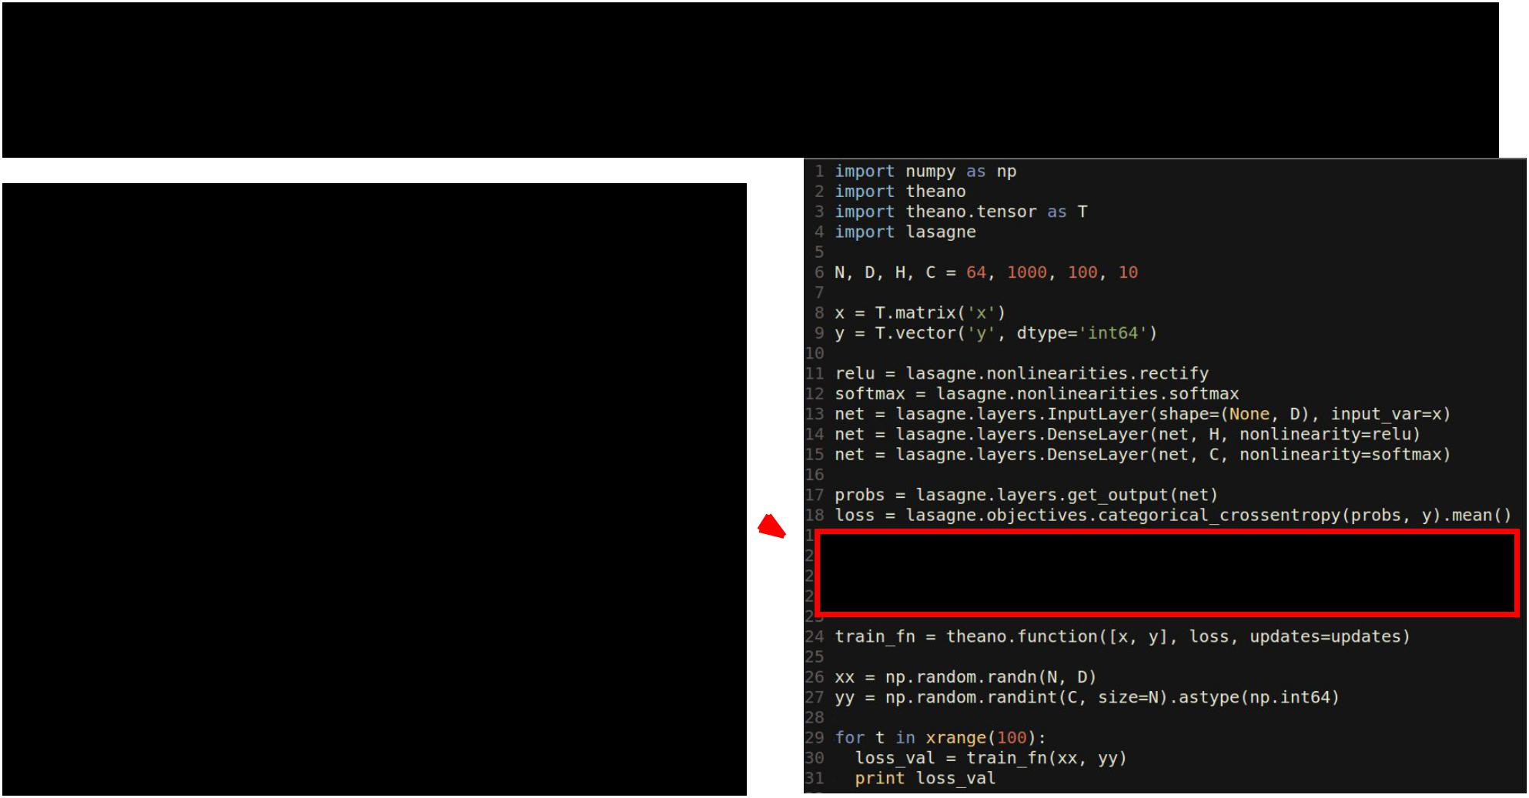Lasagne: High Level Wrapper

Lasagne gets parameters, and

writes the update rule for you 



Fei-Fei Li & Andrej Karpathy & Justin Johnson Lecture 12 110 22 Feb 2016

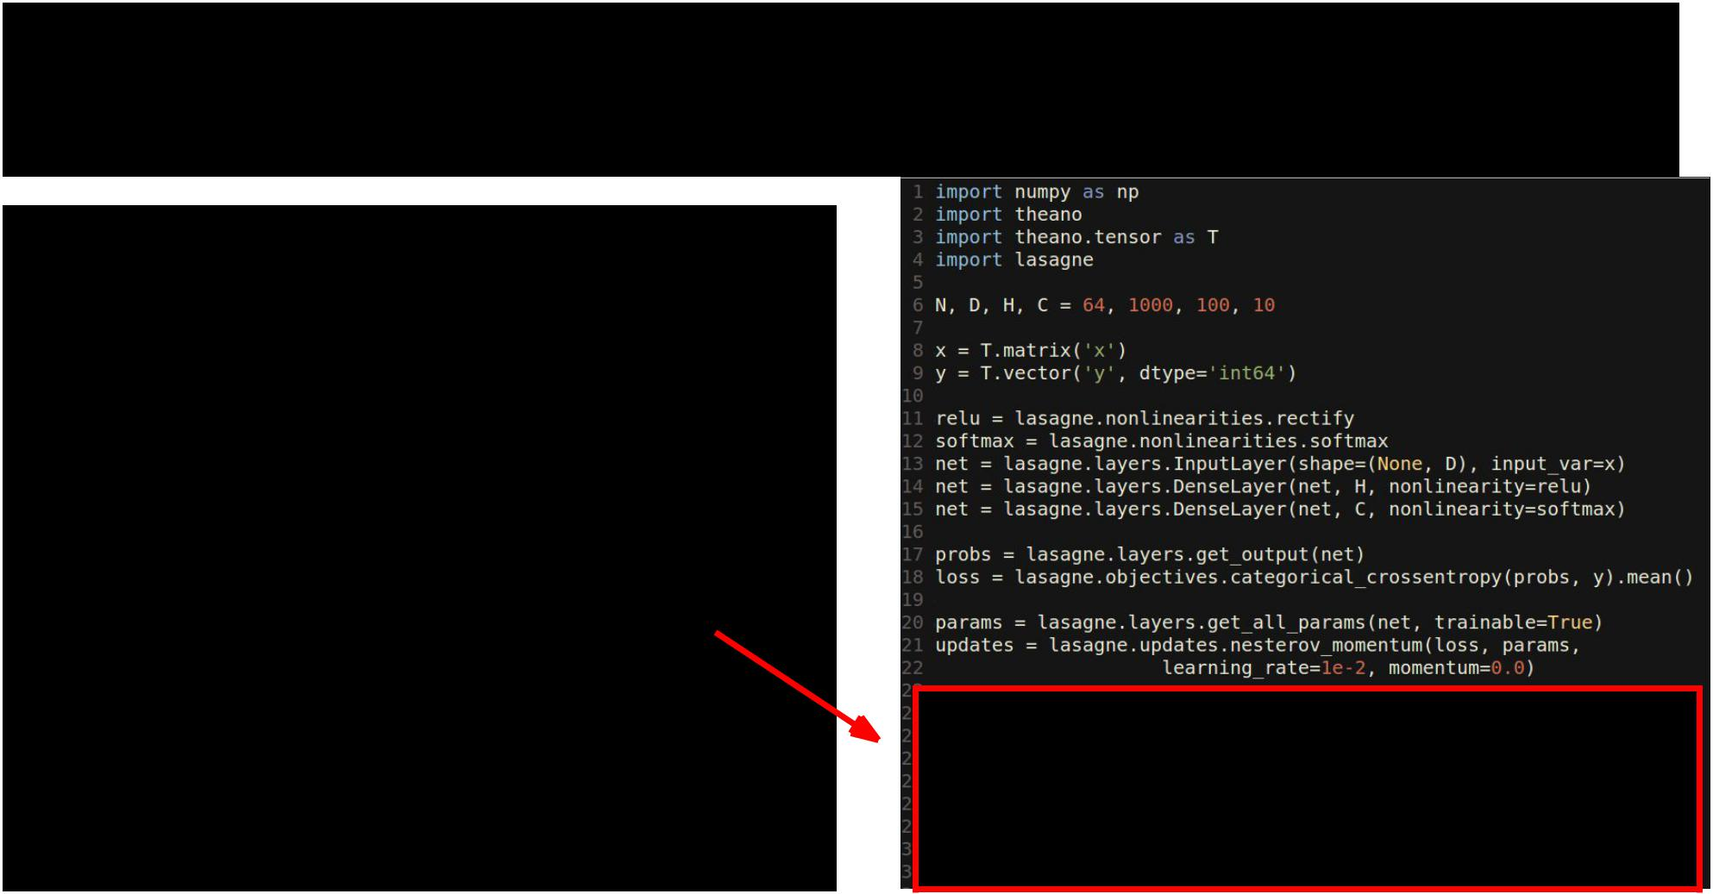Lasagne: High Level Wrapper

Same as Theano: compile a function with updates, train model by calling function with arrays



Fei-Fei Li & Andrej Karpathy & Justin Johnson Lecture 12 111 22 Feb 2016

Keras: High level wrapper



keras is a layer on top of Theano; makes common things easy to do

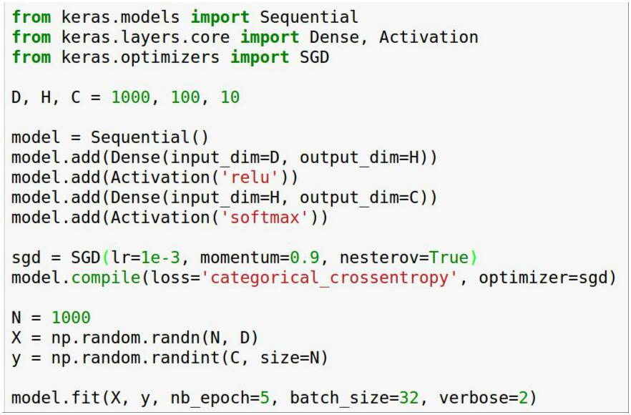

(Also supports TensorFlow backend)



Fei-Fei Li & Andrej Karpathy & Justin Johnson Lecture 12 112 22 Feb 2016

Keras: High level wrapper

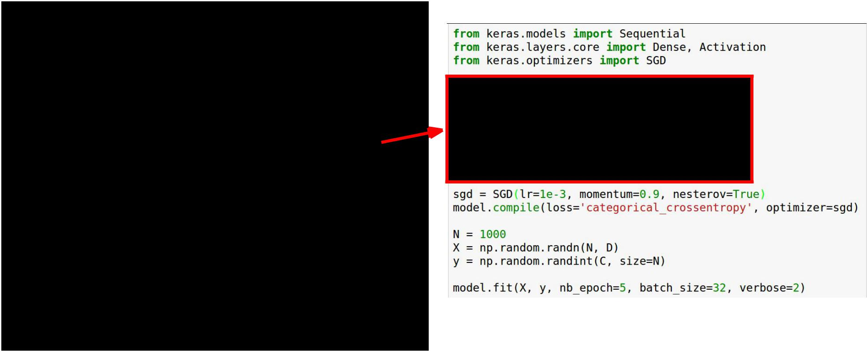

keras is a layer on top of Theano; makes common things easy to do

Set up a two-layer ReLU net with softmax



Fei-Fei Li & Andrej Karpathy & Justin Johnson Lecture 12 113 22 Feb 2016

Keras: High level wrapper

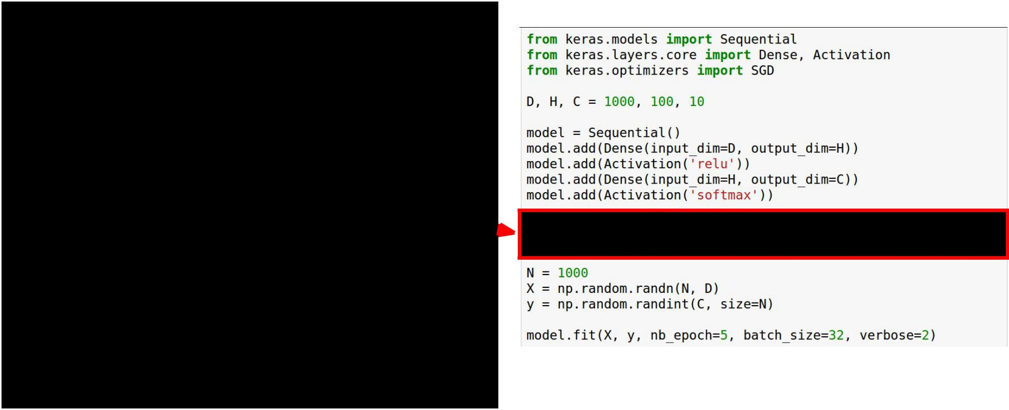

keras is a layer on top of Theano; makes common things easy to do

We will optimize the model using SGD with Nesterov momentum 



Fei-Fei Li & Andrej Karpathy & Justin Johnson Lecture 12 114 22 Feb 2016

Keras: High level wrapper



keras is a layer on top of Theano; makes common things easy to do

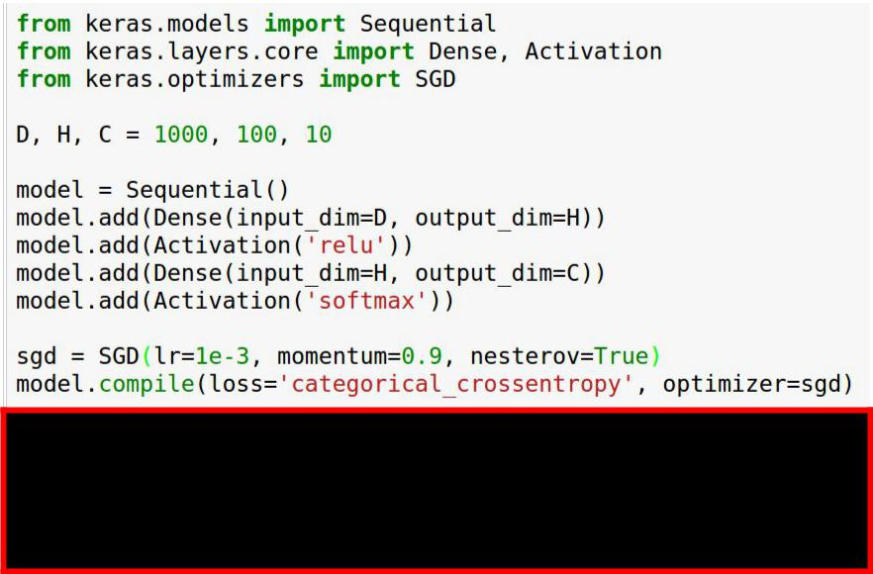

Generate some random data and

train the model



Fei-Fei Li & Andrej Karpathy & Justin Johnson Lecture 12 115 22 Feb 2016

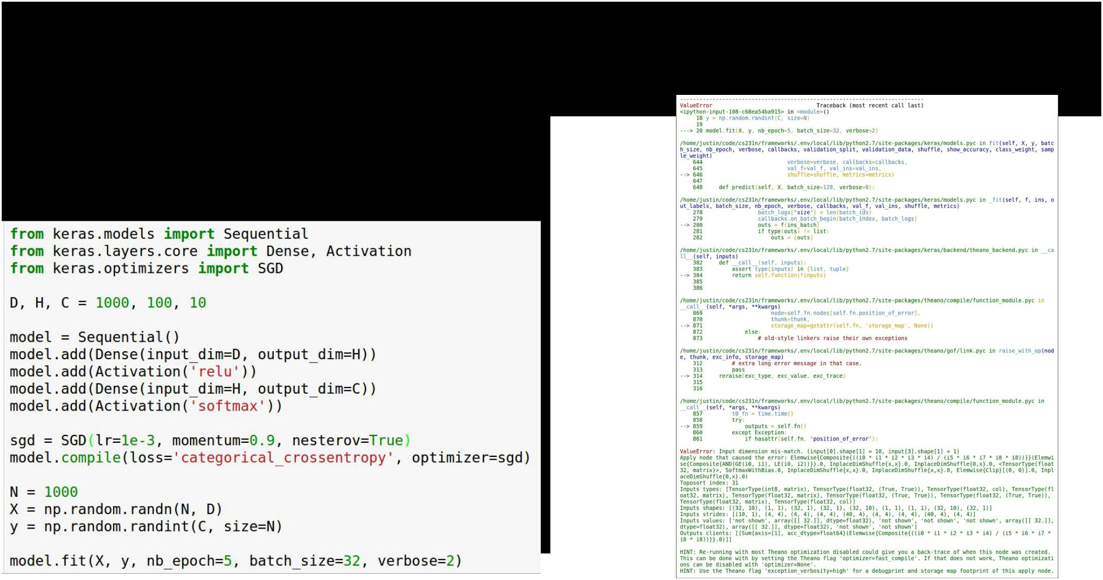Keras: High level wrapper

**Problem**: It crashes, stack traceand error message not useful :(



Fei-Fei Li & Andrej Karpathy & Justin Johnson Lecture 12 116 22 Feb 2016

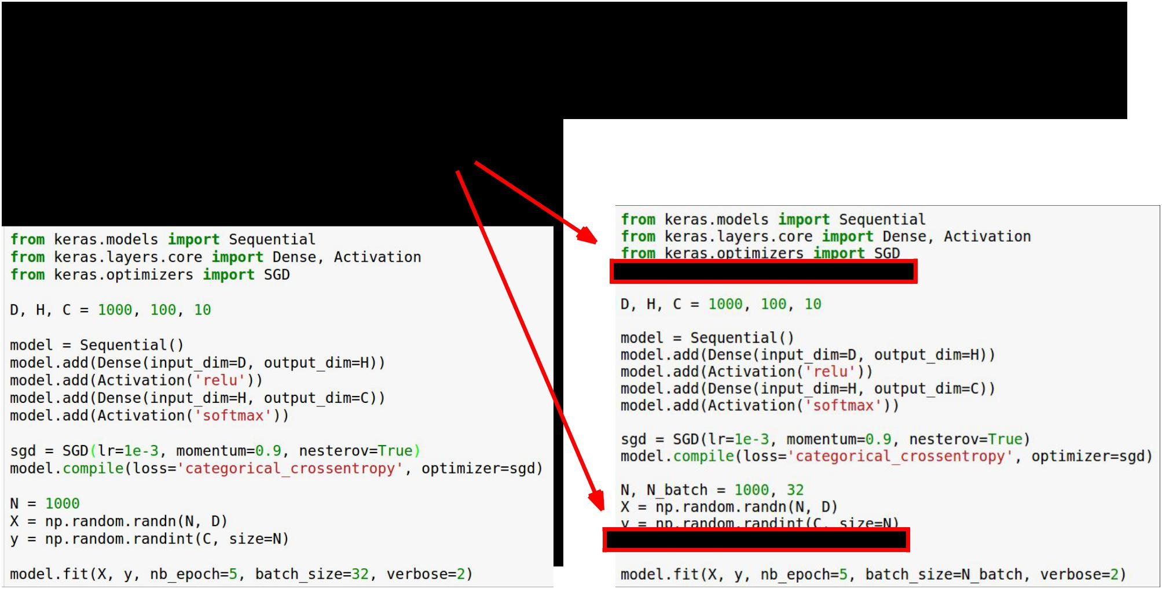Keras: High level wrapper

**Solution**: y should be one-hot

(too much API for me … )



Fei-Fei Li & Andrej Karpathy & Justin Johnson Lecture 12 117 22 Feb 2016

<https://github.com/kitofans/caffe-theano-conversion>

<http://sklearn-theano.github.io>



Theano: Pretrained Models



**Lasagne Model Zoo** has pretrained common architectures:

<https://github.com/Lasagne/Recipes/tree/master/modelzoo>

**AlexNet with weights**:<https://github.com/uoguelph-mlrg/theano_alexnet>

**sklearn-theano**: Run OverFeat and GoogLeNet forward, but no fine-tuning?

**caffe-theano-conversion**: CS 231n project from last year: load modelsand weights from caffe! Not sure if full-featured



Fei-Fei Li & Andrej Karpathy & Justin Johnson Lecture 12 118 22 Feb 2016

<https://github.com/kitofans/caffe-theano-conversion>

<http://sklearn-theano.github.io>



|  |  |  |  |  |  |
| --- | --- | --- | --- | --- | --- |
|  | Theano: Pretrained Models | | Best choice | |  |
|  |  |  |  |
|  |  |  |  |  |  |
|  |  |  |  |  |  |
|  |  |  |  |  |  |

**AlexNet with weights**:<https://github.com/uoguelph-mlrg/theano_alexnet>

**sklearn-theano**: Run OverFeat and GoogLeNet forward, but no fine-tuning?

**caffe-theano-conversion**: CS 231n project from last year: load modelsand weights from caffe! Not sure if full-featured



Fei-Fei Li & Andrej Karpathy & Justin Johnson Lecture 12 119 22 Feb 2016

Theano: Pros / Cons



* (+) Python + numpy
* (+) Computational graph is nice abstraction
* (+) RNNs fit nicely in computational graph
* (-) Raw Theano is somewhat low-level
* (+) High level wrappers (Keras, Lasagne) ease the pain
* (-) Error messages can be unhelpful
* (-) Large models can have long compile times
* (-) Much “fatter” than Torch; more magic
* (-) Patchy support for pretrained models



Fei-Fei Li & Andrej Karpathy & Justin Johnson Lecture 12 120 22 Feb 2016

TensorFlow



<https://www.tensorflow.org>



Fei-Fei Li & Andrej Karpathy & Justin Johnson Lecture 12 121 22 Feb 2016

TensorFlow



From Google

Very similar to Theano - all about computation graphs

Easy visualizations (TensorBoard)

Multi-GPU and multi-node training



Fei-Fei Li & Andrej Karpathy & Justin Johnson Lecture 12 122 22 Feb 2016

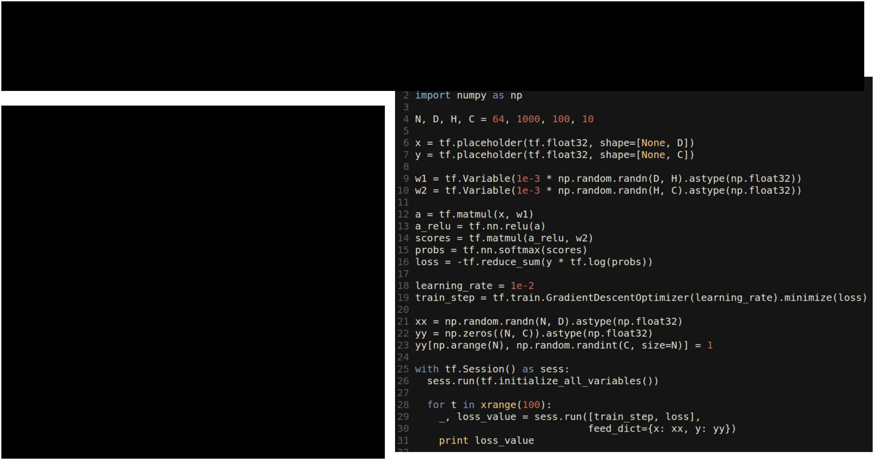TensorFlow: Two-Layer Net



Fei-Fei Li & Andrej Karpathy & Justin Johnson Lecture 12 123 22 Feb 2016

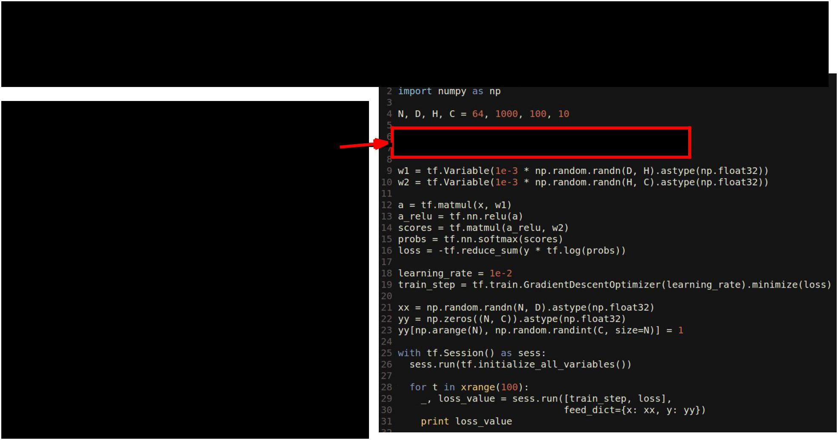TensorFlow: Two-Layer Net

Create placeholders for data and labels: These will be fed to the graph



Fei-Fei Li & Andrej Karpathy & Justin Johnson Lecture 12 124 22 Feb 2016

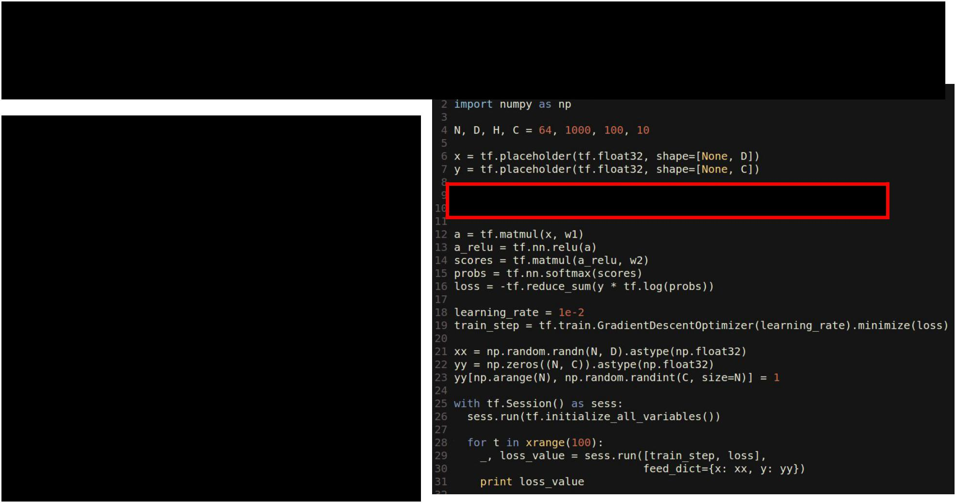TensorFlow: Two-Layer Net

Create Variables to hold

weights; similar to Theano

shared variables

Initialize variables with numpy arrays



Fei-Fei Li & Andrej Karpathy & Justin Johnson Lecture 12 125 22 Feb 2016

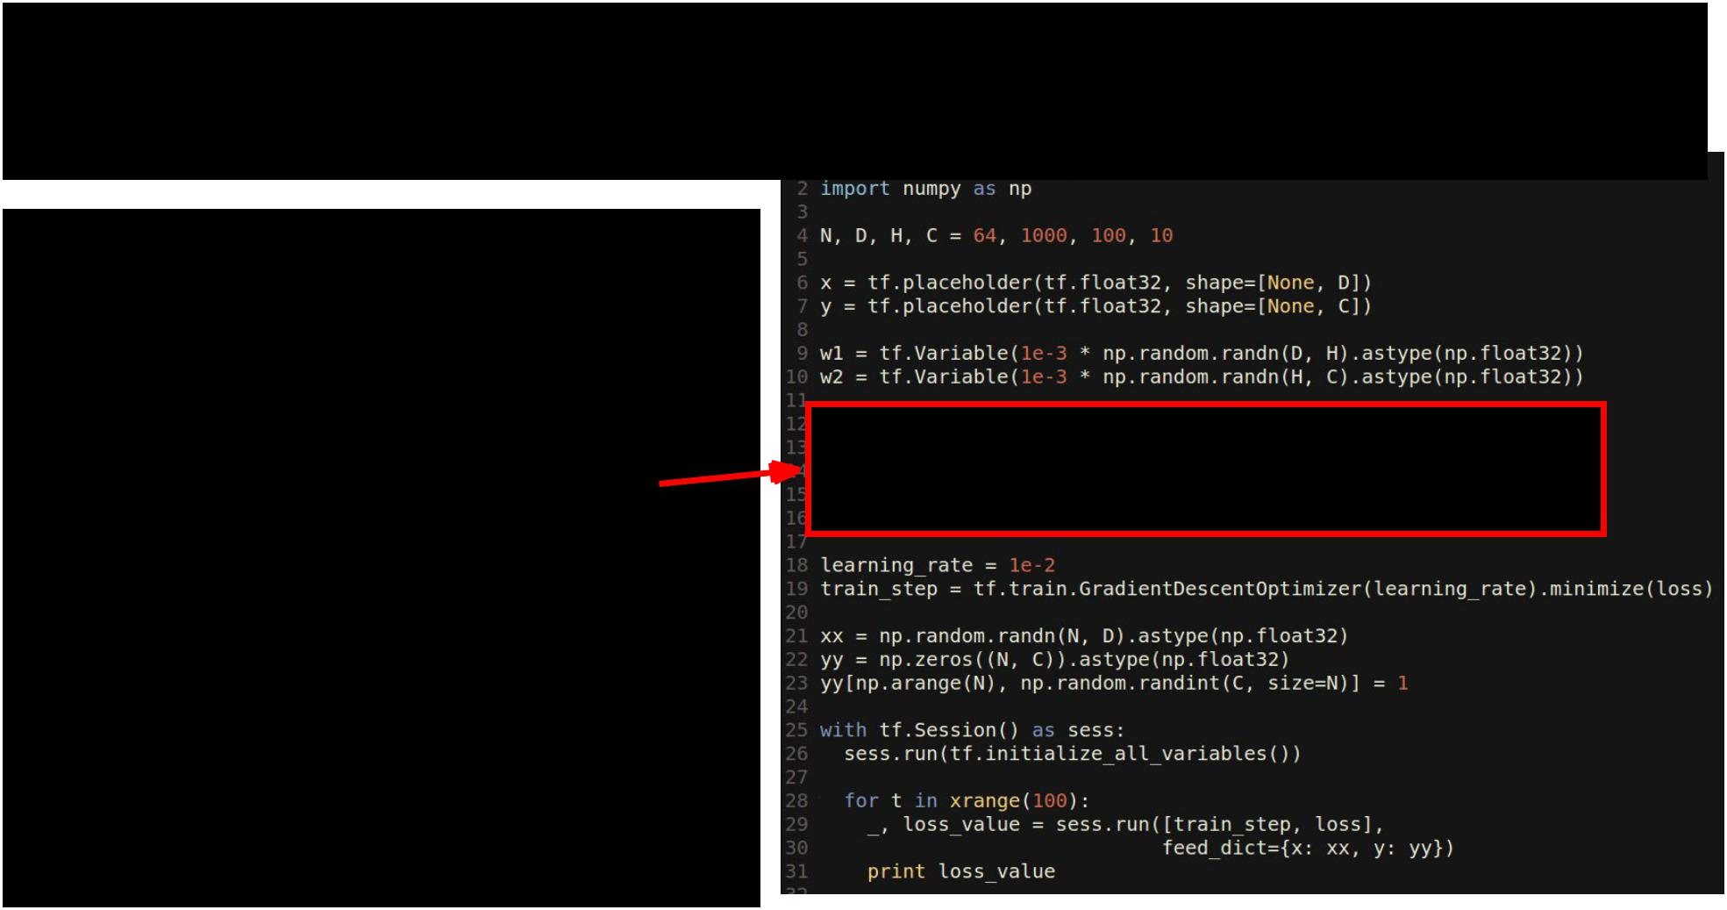TensorFlow: Two-Layer Net

**Forward**: Compute scores,probs, loss (symbolically)



Fei-Fei Li & Andrej Karpathy & Justin Johnson Lecture 12 126 22 Feb 2016

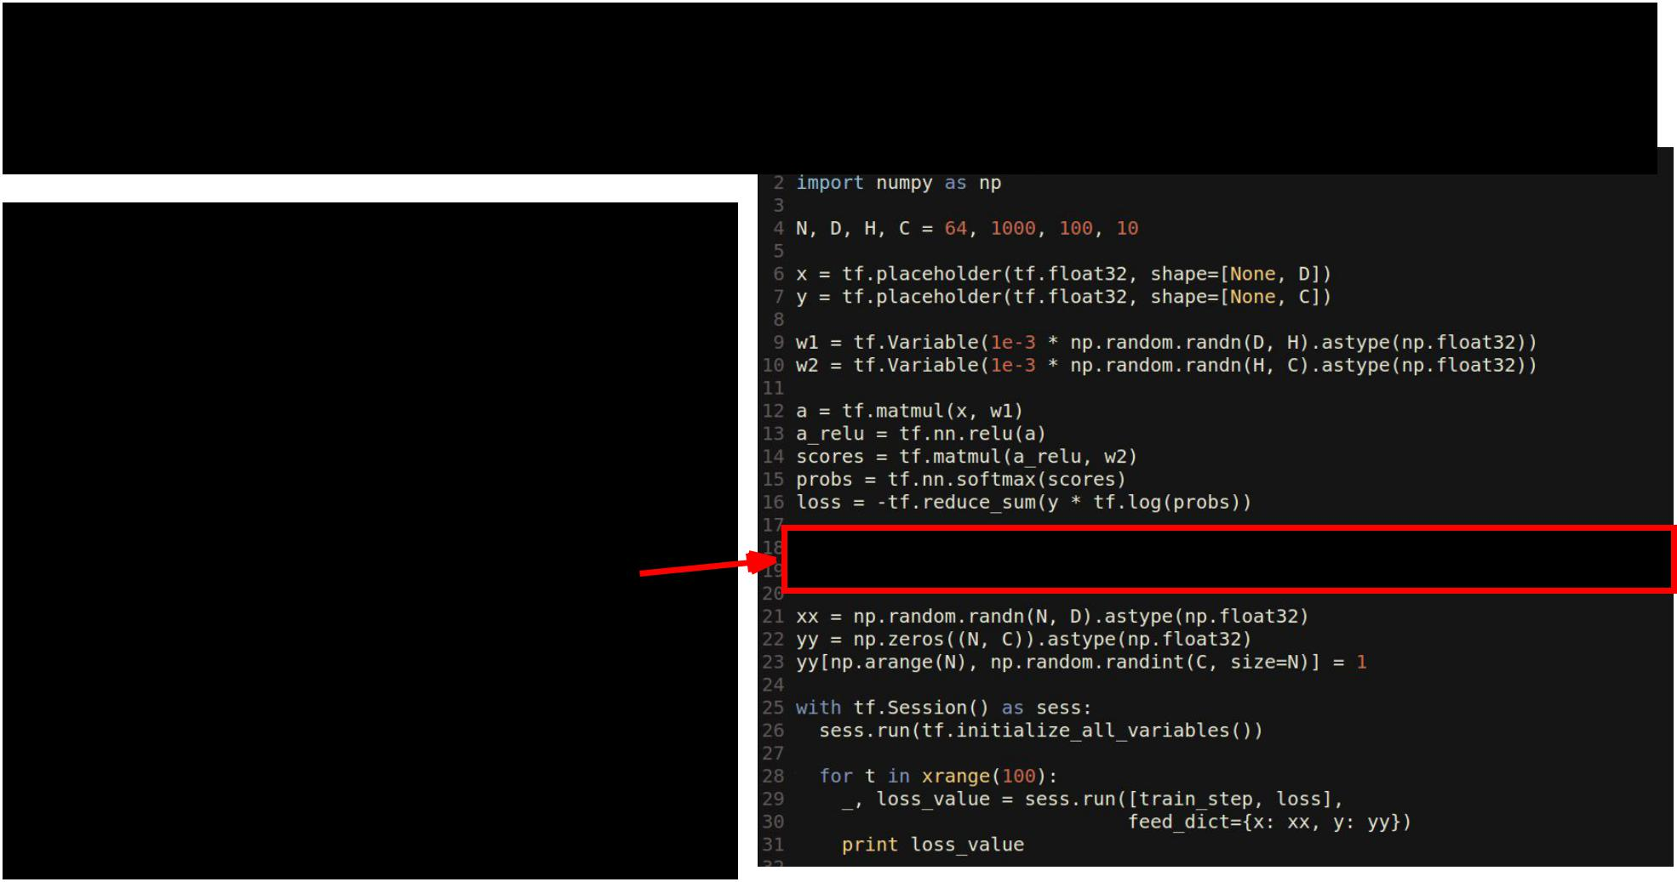TensorFlow: Two-Layer Net

Running train_step will use SGD to minimize loss



Fei-Fei Li & Andrej Karpathy & Justin Johnson Lecture 12 127 22 Feb 2016

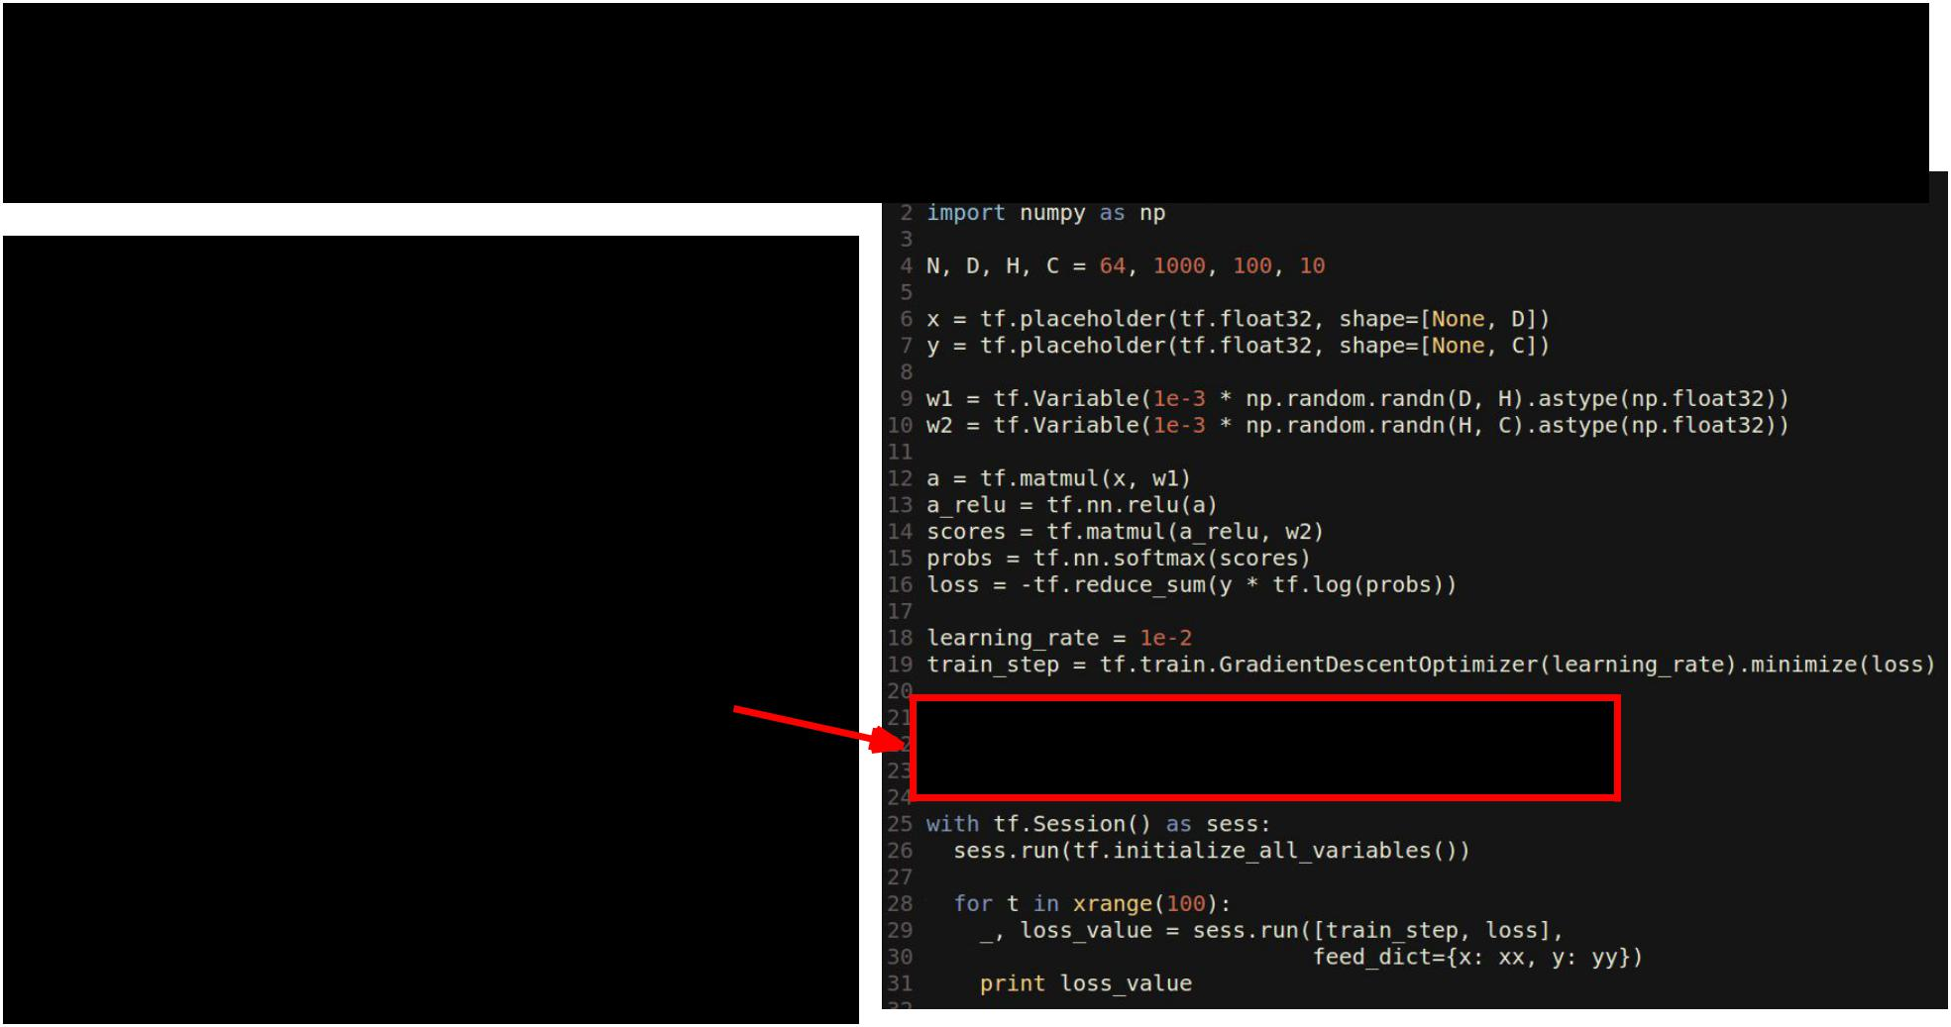TensorFlow: Two-Layer Net

Create an artificial dataset; y is one-hot like Keras



Fei-Fei Li & Andrej Karpathy & Justin Johnson Lecture 12 128 22 Feb 2016

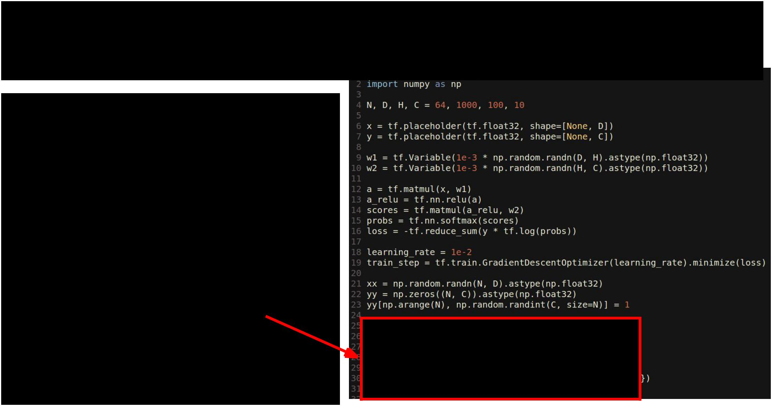TensorFlow: Two-Layer Net

Actually train the model



Fei-Fei Li & Andrej Karpathy & Justin Johnson Lecture 12 129 22 Feb 2016

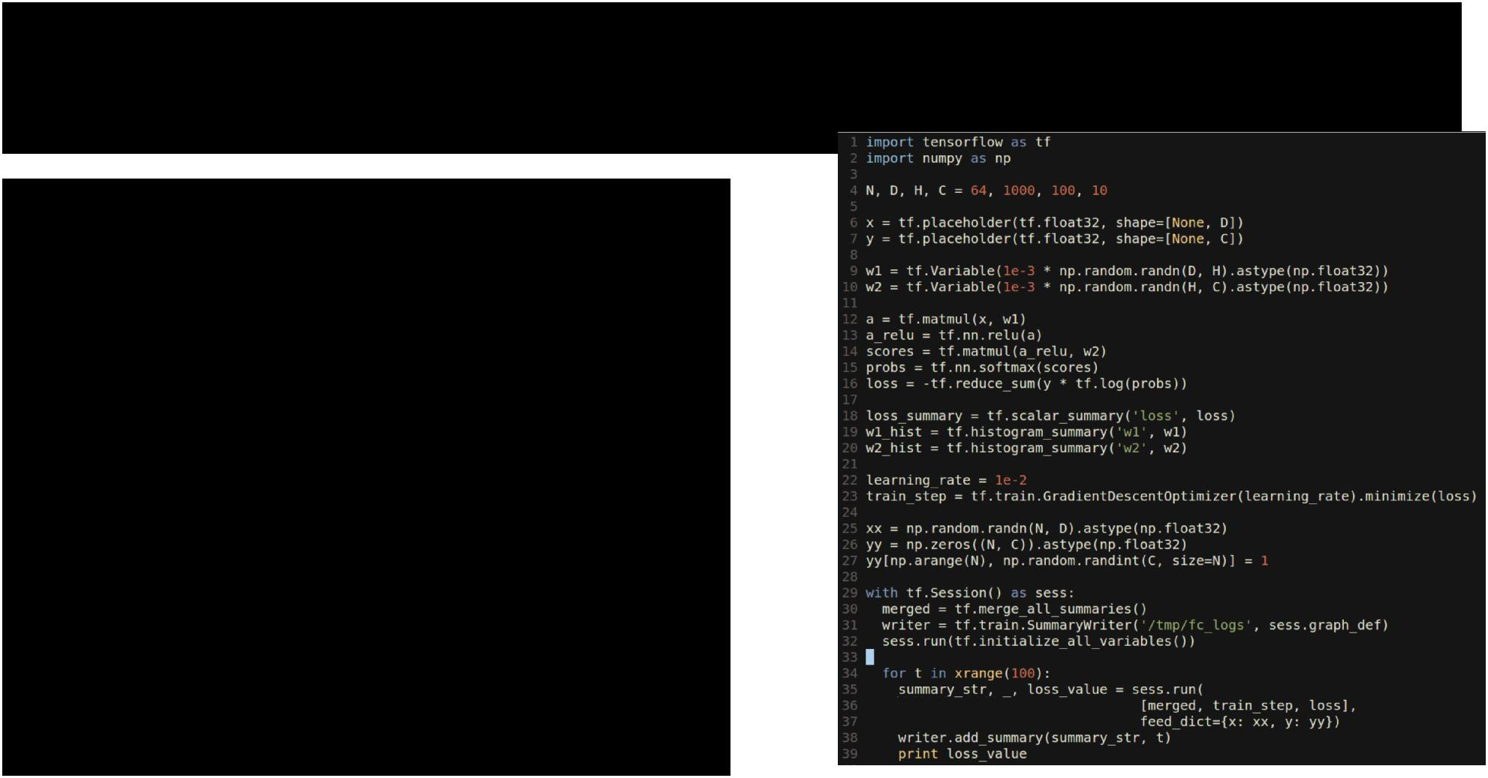TensorFlow: Tensorboard

Tensorboard makes it easy to visualize what’s happening inside your models



Fei-Fei Li & Andrej Karpathy & Justin Johnson Lecture 12 130 22 Feb 2016

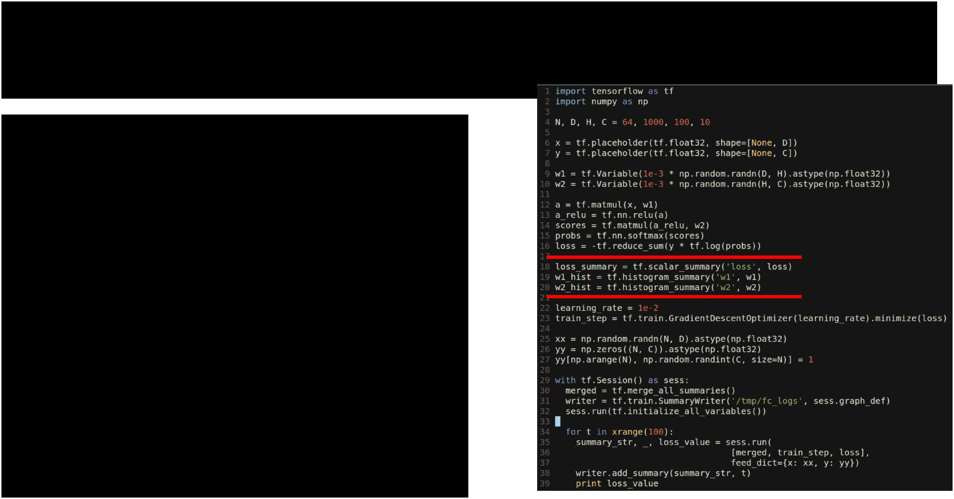TensorFlow: Tensorboard

Tensorboard makes it easy to visualize what’s happening inside your models

Same as before, but now we  create summaries for loss and

weights



Fei-Fei Li & Andrej Karpathy & Justin Johnson Lecture 12 131 22 Feb 2016

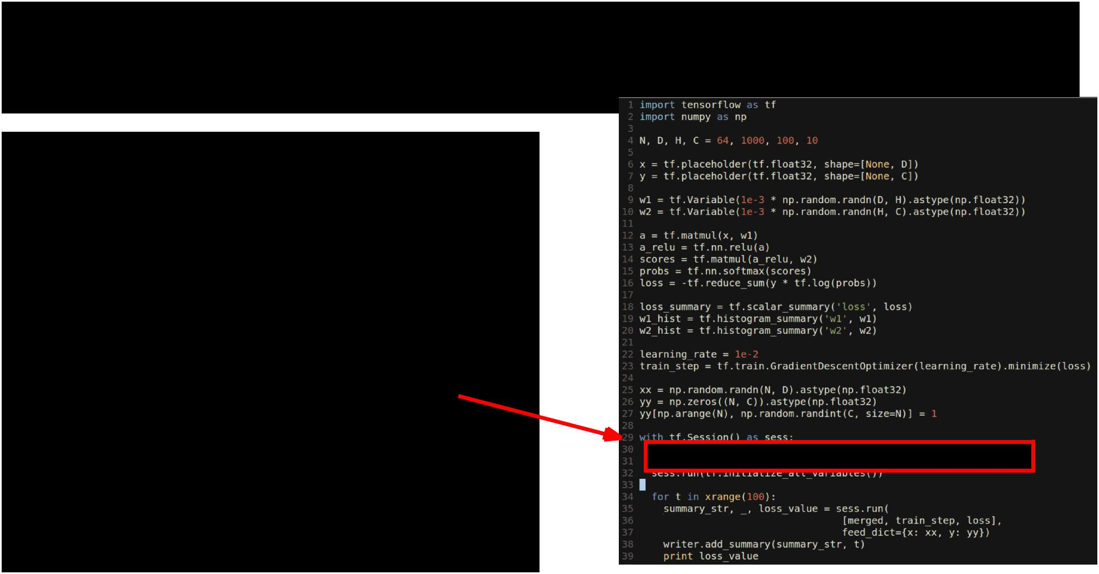TensorFlow: Tensorboard

Tensorboard makes it easy to visualize what’s happening inside your models

Create a special “merged” variable and a SummaryWriter object



Fei-Fei Li & Andrej Karpathy & Justin Johnson Lecture 12 132 22 Feb 2016

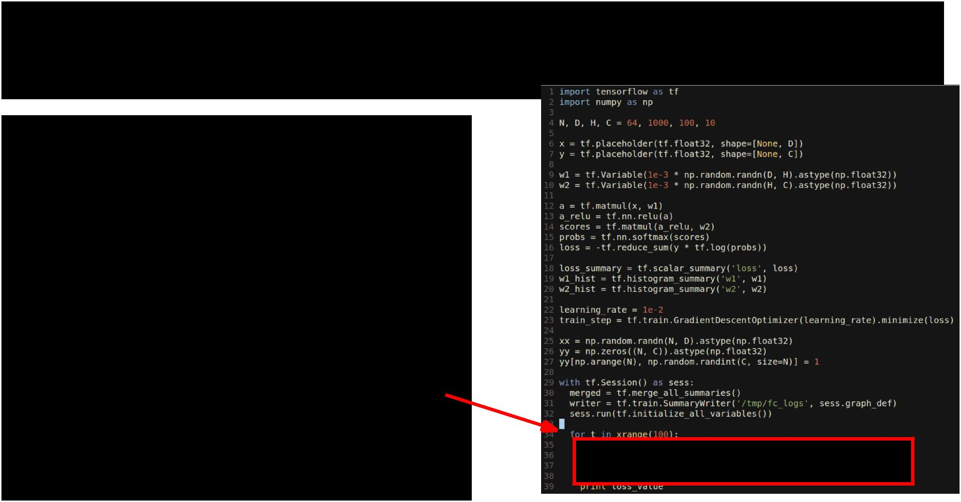TensorFlow: Tensorboard

Tensorboard makes it easy to visualize what’s happening inside your models

In the training loop, also run merged and pass its value to the writer



Fei-Fei Li & Andrej Karpathy & Justin Johnson Lecture 12 133 22 Feb 2016

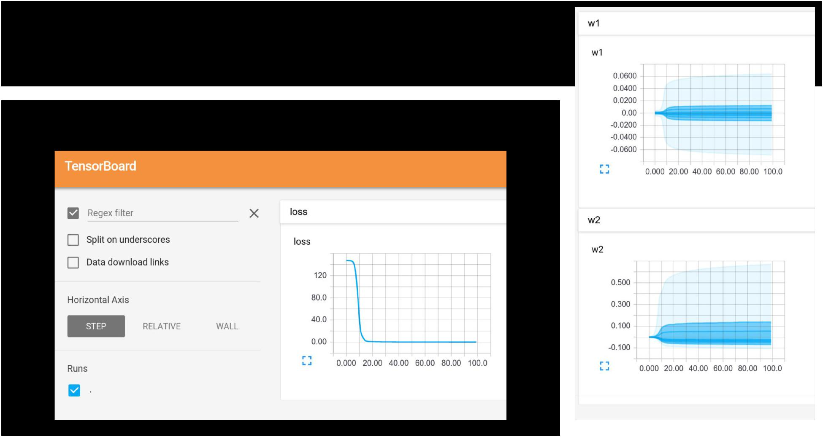TensorFlow: Tensorboard

Start Tensorboard server, and we get graphs!



Fei-Fei Li & Andrej Karpathy & Justin Johnson Lecture 12 134 22 Feb 2016

TensorFlow: TensorBoard

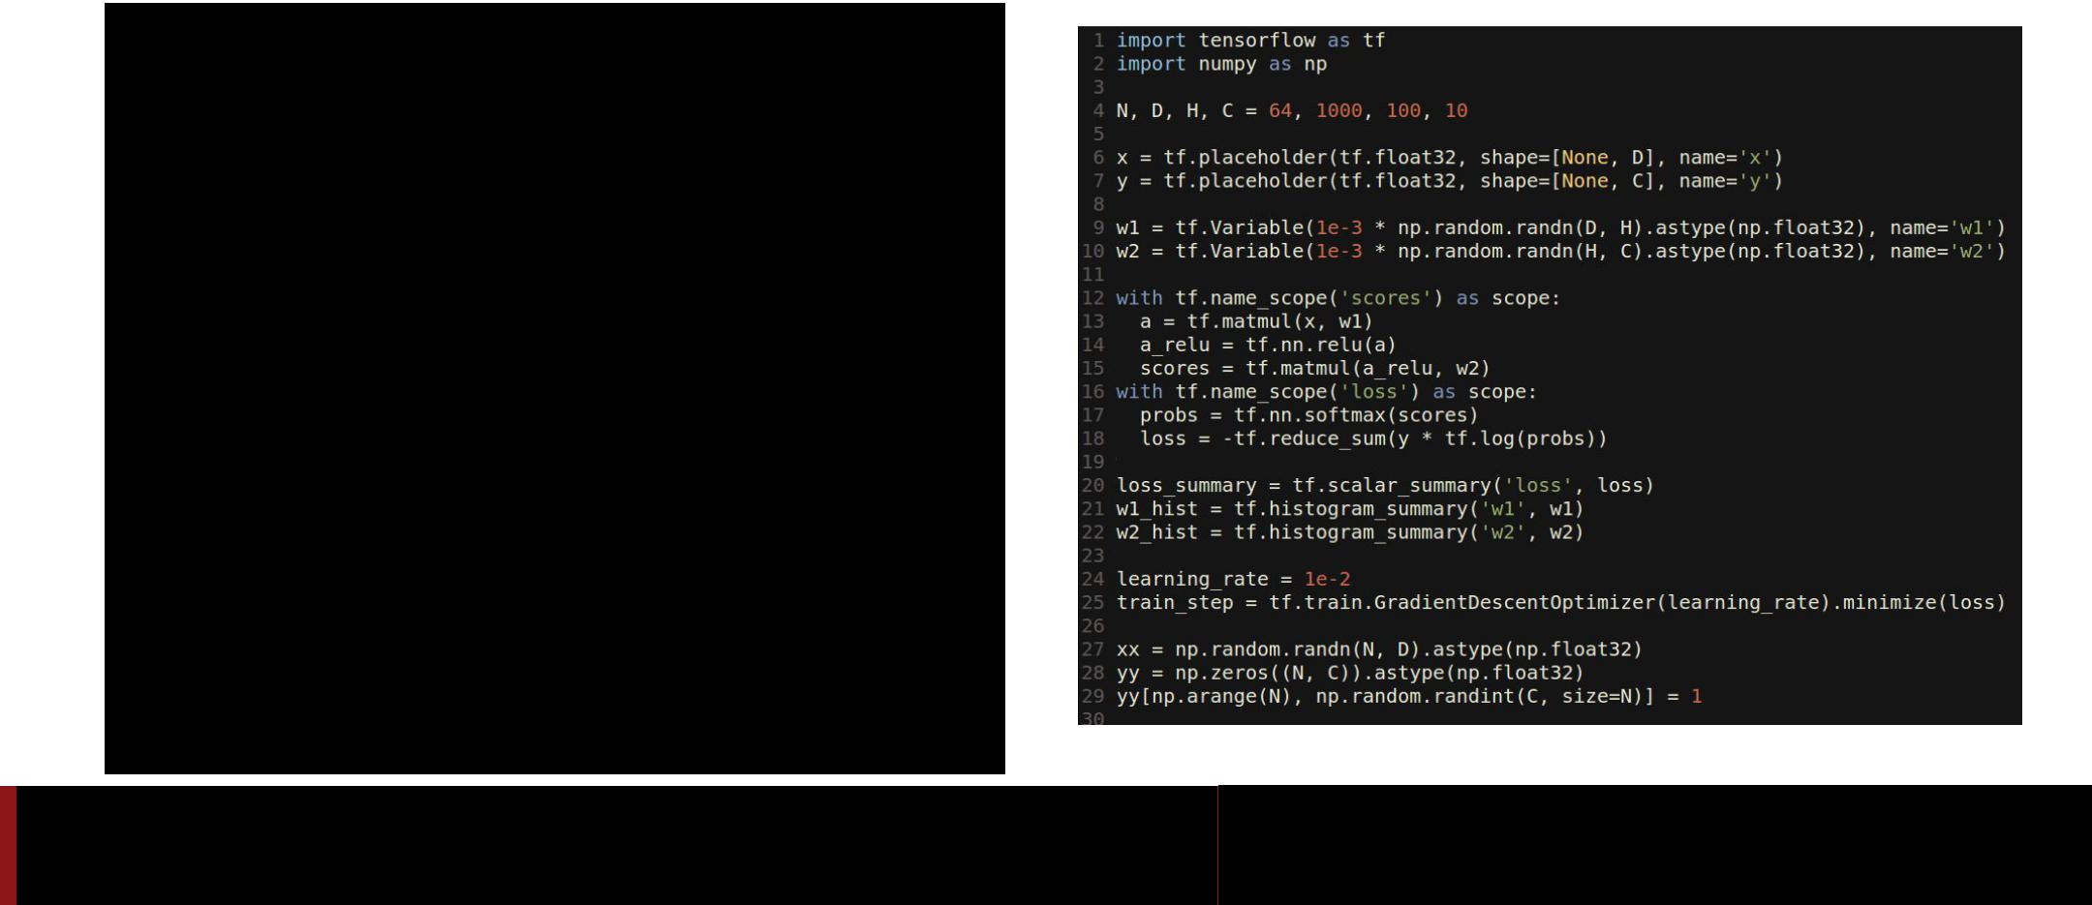

Fei-Fei Li & Andrej Karpathy & Justin Johnson Lecture 12 135 22 Feb 2016

TensorFlow: TensorBoard



Add names to placeholders and

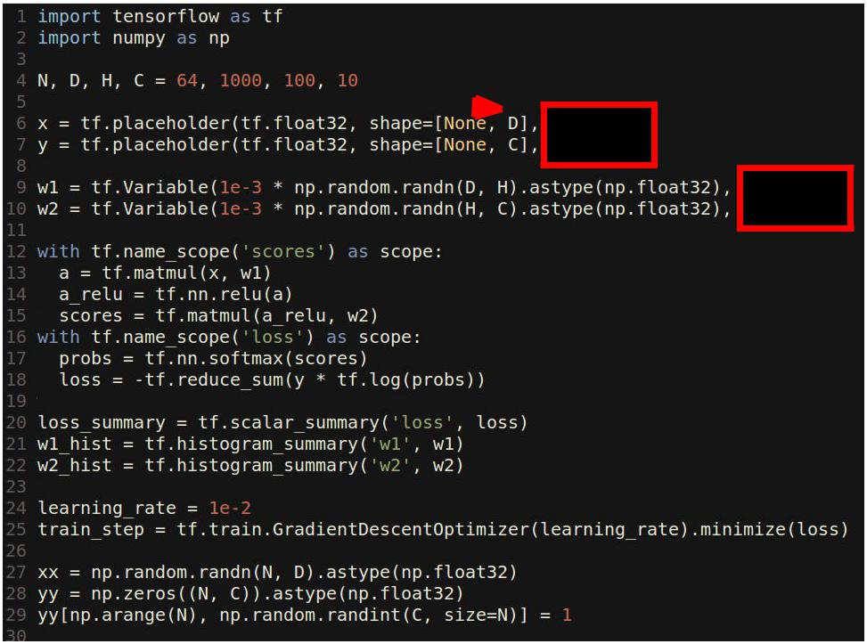

variables



Fei-Fei Li & Andrej Karpathy & Justin Johnson Lecture 12 136 22 Feb 2016

TensorFlow: TensorBoard



Add names to placeholders and variables

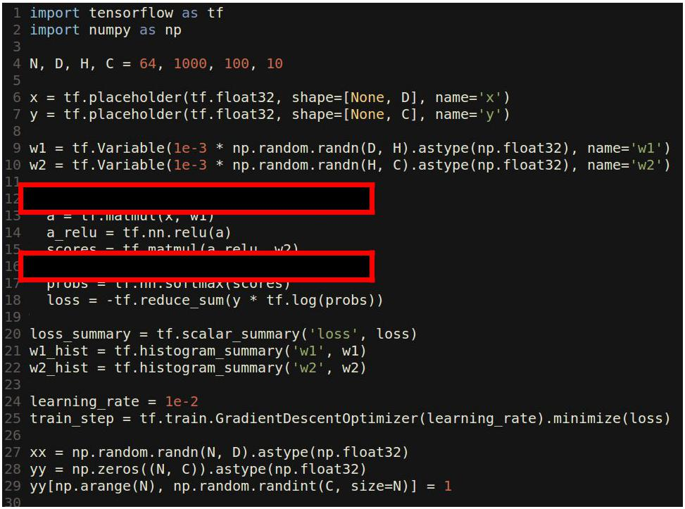

Break up the forward pass with name scoping 



Fei-Fei Li & Andrej Karpathy & Justin Johnson Lecture 12 137 22 Feb 2016

TensorFlow: TensorBoard

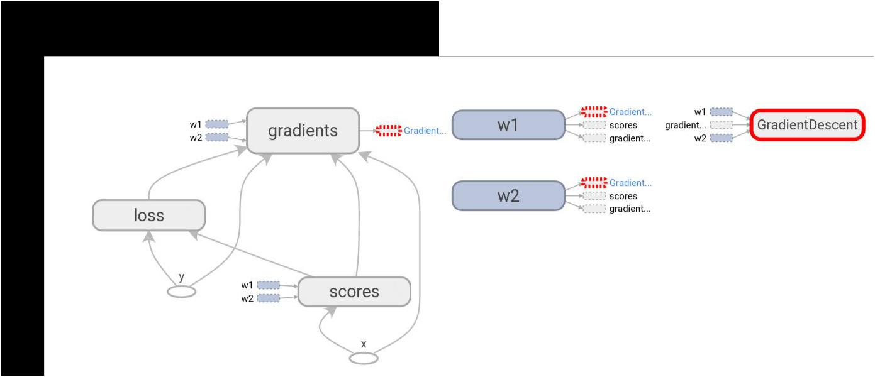

Tensorboard shows the graph!



Fei-Fei Li & Andrej Karpathy & Justin Johnson Lecture 12 138 22 Feb 2016

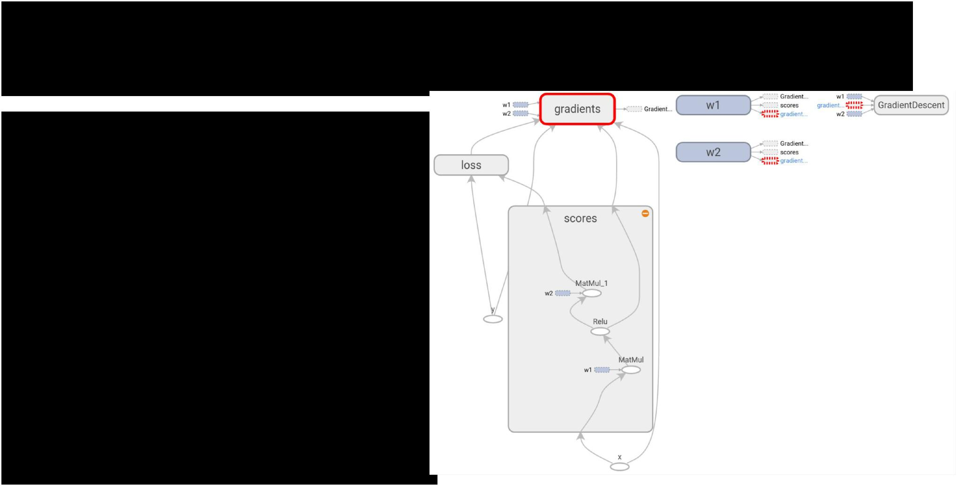TensorFlow: TensorBoard

Tensorboard shows the graph!

Name scopes expand to show individual operations



Fei-Fei Li & Andrej Karpathy & Justin Johnson Lecture 12 139 22 Feb 2016

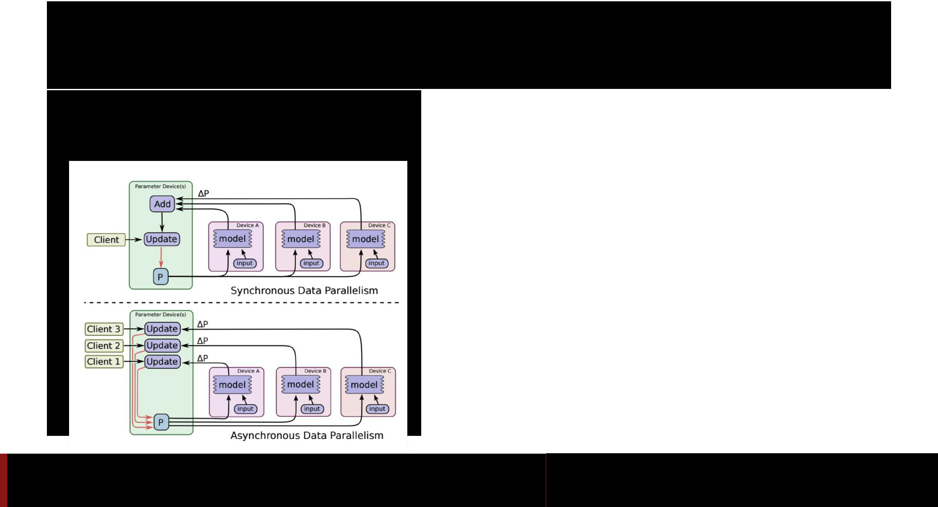TensorFlow: Multi-GPU

**Data parallelism**:

synchronous or asynchronous

Fei-Fei Li & Andrej Karpathy & Justin Johnson Lecture 12 140 22 Feb 2016

|  |  |  |
| --- | --- | --- |
| TensorFlow: Multi-GPU | |  |
| **Data parallelism**: | **Model parallelism**: |  |
| synchronous or asynchronous |  |
| Split model across GPUs |  |
|  |  |

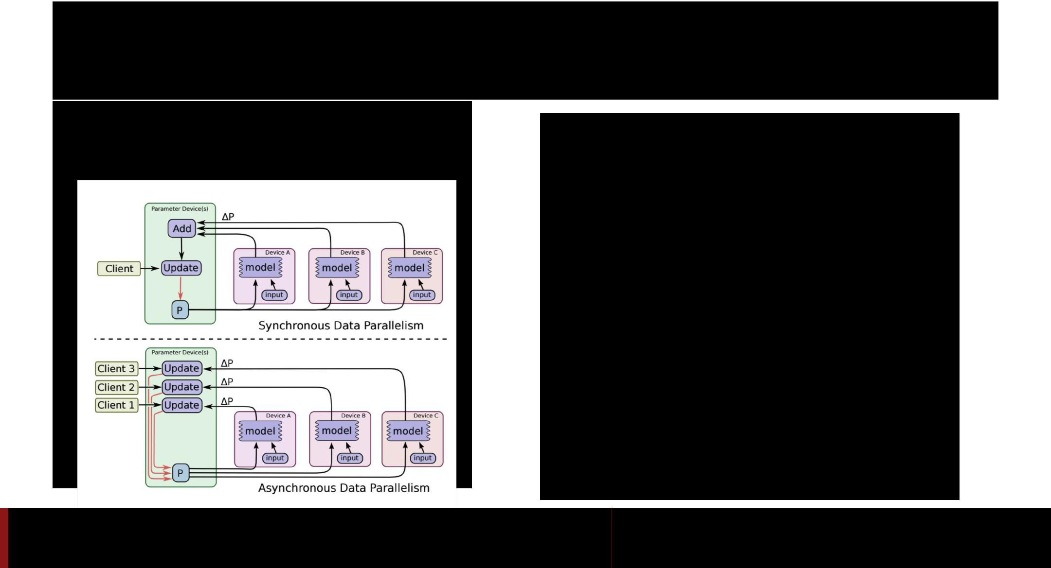

Fei-Fei Li & Andrej Karpathy & Justin Johnson Lecture 12 141 22 Feb 2016

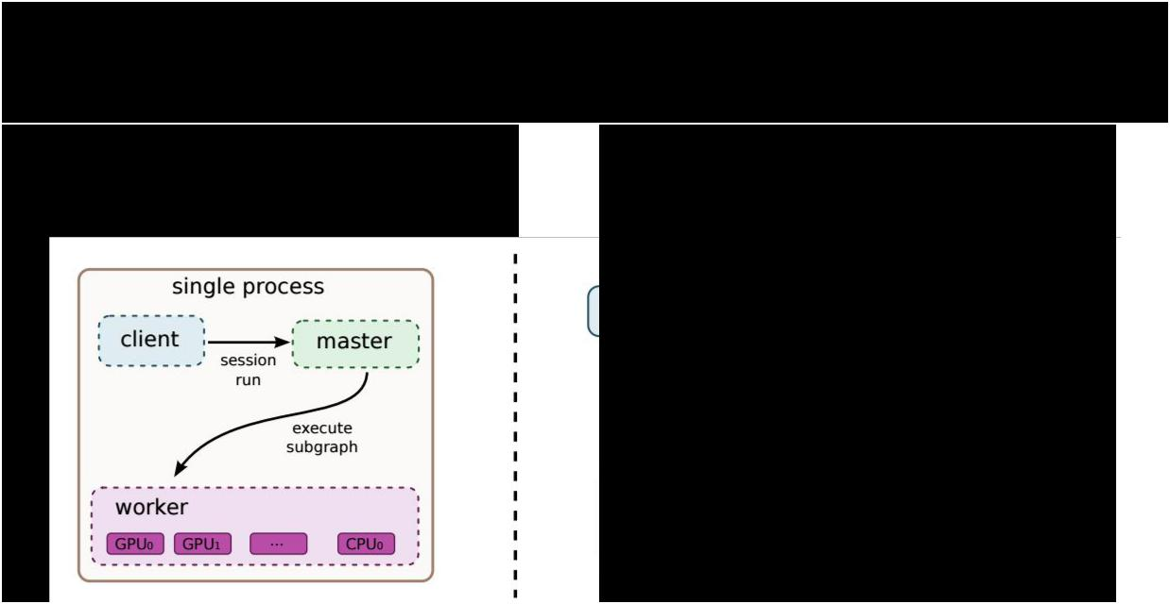TensorFlow: Distributed

**Single machine**: **Many machines**:

Like other frameworks Not open source (yet) =(



Fei-Fei Li & Andrej Karpathy & Justin Johnson Lecture 12 142 22 Feb 2016

TensorFlow: Pretrained Models



You can get a pretrained version of Inception here:

<https://github.com/tensorflow/tensorflow/blob/master/tensorflow/examples/android/README.md>

(In an Android example?? Very well-hidden)

The only one I could find =(



Fei-Fei Li & Andrej Karpathy & Justin Johnson Lecture 12 143 22 Feb 2016

TensorFlow: Pros / Cons



* (+) Python + numpy
* (+) Computational graph abstraction, like Theano; great for RNNs
* (+) Much faster compile times than Theano
* (+) Slightly more convenient than raw Theano?
* (+) TensorBoard for visualization
* (+) Data AND model parallelism; best of all frameworks
* (+/-) Distributed models, but not open-source yet
* (-) Slower than other frameworks right now
* (-) Much “fatter” than Torch; more magic
* (-) Not many pretrained models



Fei-Fei Li & Andrej Karpathy & Justin Johnson Lecture 12 144 22 Feb 2016

Overview

|  |  |  |  |  |
| --- | --- | --- | --- | --- |
|  | **Caffe** | **Torch** | **Theano** | **TensorFlow** |
|  |  |  |  |  |
| **Language** | C++, Python | Lua | Python | Python |
|  |  |  |  |  |
| **Pretrained** | Yes ++ | Yes ++ | Yes (Lasagne) | Inception |
|  |  |  |  |  |
| **Multi-GPU:** | Yes | Yes cunn. | Yes | Yes |
| **Data parallel** |  | DataParallelTable | platoon |  |
|  |  |  |  |  |
| **Multi-GPU:** | No | Yes | Experimental | Yes (best) |
| **Model parallel** |  | fbcunn.ModelParallel |  |  |
|  |  |  |  |  |
| **Readable** | Yes (C++) | Yes (Lua) | No | No |
| **source code** |  |  |  |  |
|  |  |  |  |  |
| **Good at RNN** | No | Mediocre | Yes | Yes (best) |
|  |  |  |  |  |



Fei-Fei Li & Andrej Karpathy & Justin Johnson Lecture 12 145 22 Feb 2016

Use Cases



Extract AlexNet or VGG features?



Fei-Fei Li & Andrej Karpathy & Justin Johnson Lecture 12 146 22 Feb 2016

Use Cases



Extract AlexNet or VGG features? **Use Caffe**



Fei-Fei Li & Andrej Karpathy & Justin Johnson Lecture 12 147 22 Feb 2016

Use Cases



Fine-tune AlexNet for new classes?



Fei-Fei Li & Andrej Karpathy & Justin Johnson Lecture 12 148 22 Feb 2016

Use Cases



Fine-tune AlexNet for new classes? **Use Caffe**



Fei-Fei Li & Andrej Karpathy & Justin Johnson Lecture 12 149 22 Feb 2016

Use Cases



Image Captioning with finetuning?



Fei-Fei Li & Andrej Karpathy & Justin Johnson Lecture 12 150 22 Feb 2016

Use Cases



Image Captioning with finetuning?

-> Need pretrained models (Caffe, Torch, Lasagne)

-> Need RNNs (Torch or Lasagne)

-> **Use Torch or Lasagna**



Fei-Fei Li & Andrej Karpathy & Justin Johnson Lecture 12 151 22 Feb 2016

Use Cases



Segmentation? (Classify every pixel)



Fei-Fei Li & Andrej Karpathy & Justin Johnson Lecture 12 152 22 Feb 2016

Use Cases



Segmentation? (Classify every pixel)

-> Need pretrained model (Caffe, Torch, Lasagna)

-> Need funny loss function

-> If loss function exists in Caffe: **Use Caffe**

-> If you want to write your own loss: **Use Torch**



Fei-Fei Li & Andrej Karpathy & Justin Johnson Lecture 12 153 22 Feb 2016

Use Cases



Object Detection?



Fei-Fei Li & Andrej Karpathy & Justin Johnson Lecture 12 154 22 Feb 2016

Use Cases



Object Detection?

-> Need pretrained model (Torch, Caffe, Lasagne)

-> Need lots of custom imperative code (NOT Lasagne) -> Use **Caffe + Python** or **Torch**



Fei-Fei Li & Andrej Karpathy & Justin Johnson Lecture 12 155 22 Feb 2016

Use Cases



Language modeling with new RNN structure?



Fei-Fei Li & Andrej Karpathy & Justin Johnson Lecture 12 156 22 Feb 2016

Use Cases



Language modeling with new RNN structure?

-> Need easy recurrent nets (NOT Caffe, Torch)

-> No need for pretrained models

-> **Use Theano or TensorFlow**



Fei-Fei Li & Andrej Karpathy & Justin Johnson Lecture 12 157 22 Feb 2016

Use Cases



Implement BatchNorm?

-> Don’t want to derive gradient? **Theano** or **TensorFlow** -> Implement efficient backward pass? **Use Torch**



Fei-Fei Li & Andrej Karpathy & Justin Johnson Lecture 12 158 22 Feb 2016

My Recommendation



Feature extraction / finetuning existing models: Use Caffe

Complex uses of pretrained models: Use Lasagne or Torch

Write your own layers: Use Torch

Crazy RNNs: Use Theano or Tensorflow

Huge model, need model parallelism: Use TensorFlow



Fei-Fei Li & Andrej Karpathy & Justin Johnson Lecture 12 159 22 Feb 2016



Fei-Fei Li & Andrej Karpathy & Justin Johnson Lecture 12 160 22 Feb 2016



Fei-Fei Li & Andrej Karpathy & Justin Johnson Lecture 12 161 22 Feb 2016

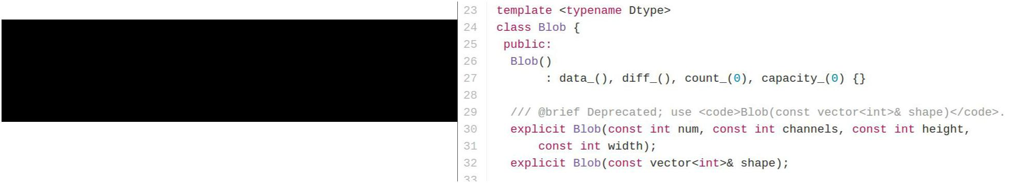**Caffe: Blobs**

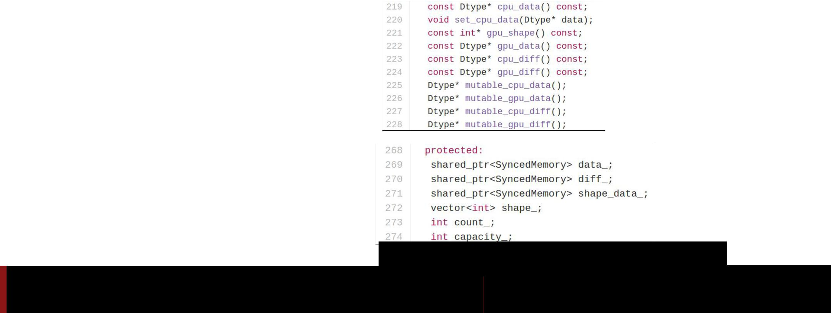

<https://github.com/BVLC/caffe/blob/master/include/caffe/blob.hpp>

Fei-Fei Li & Andrej Karpathy & Justin Johnson Lecture 12 162 22 Feb 2016

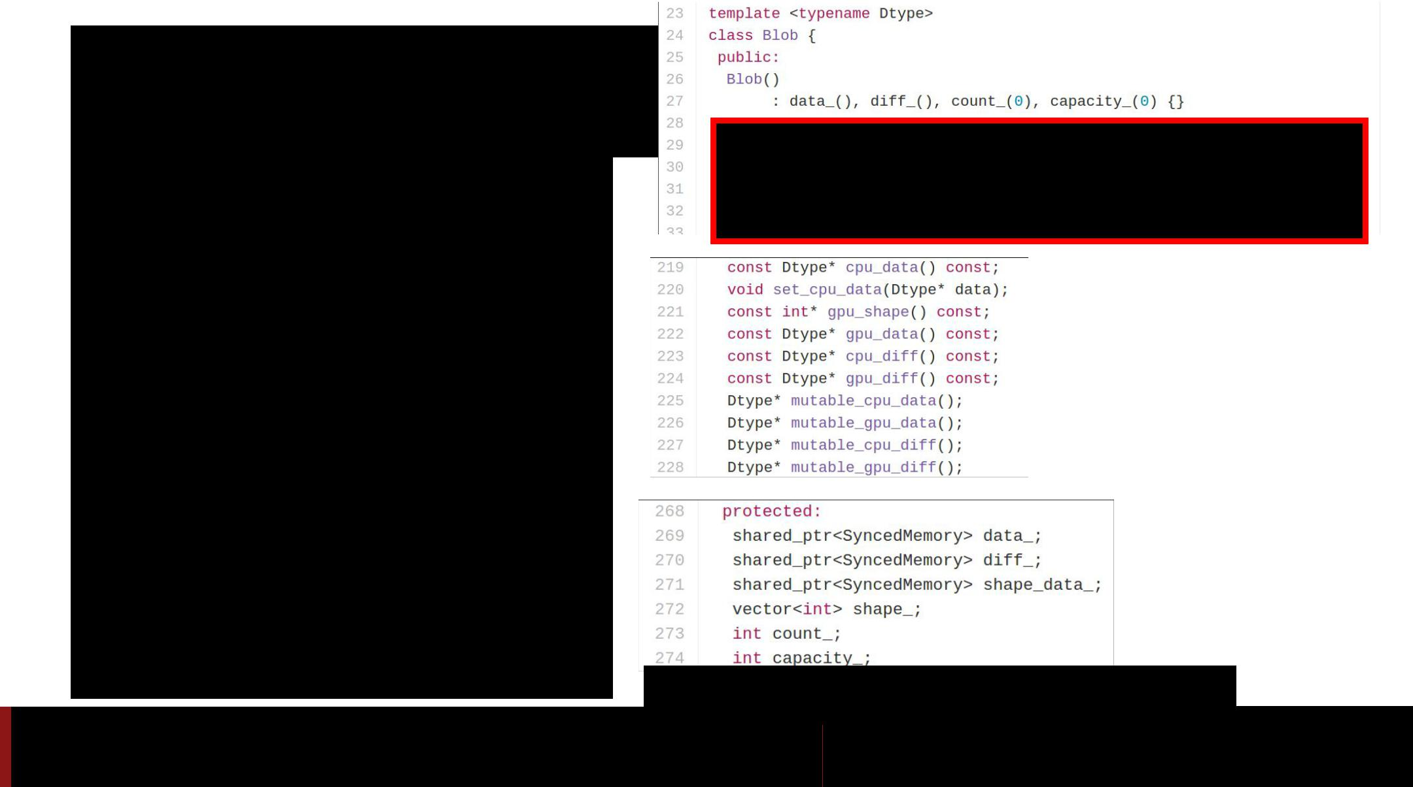**Caffe: Blobs**

● N-dimensional array for

storing activations and

weights

<https://github.com/BVLC/caffe/blob/master/include/caffe/blob.hpp>

Fei-Fei Li & Andrej Karpathy & Justin Johnson Lecture 12 163 22 Feb 2016

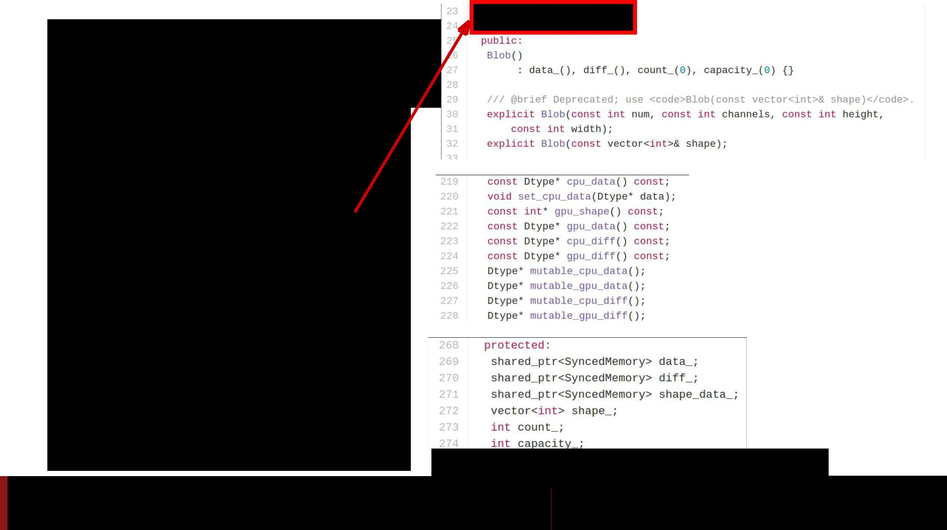**Caffe: Blobs**

* N-dimensional array for storing activations and weights
* Template over datatype

<https://github.com/BVLC/caffe/blob/master/include/caffe/blob.hpp>

Fei-Fei Li & Andrej Karpathy & Justin Johnson Lecture 12 164 22 Feb 2016

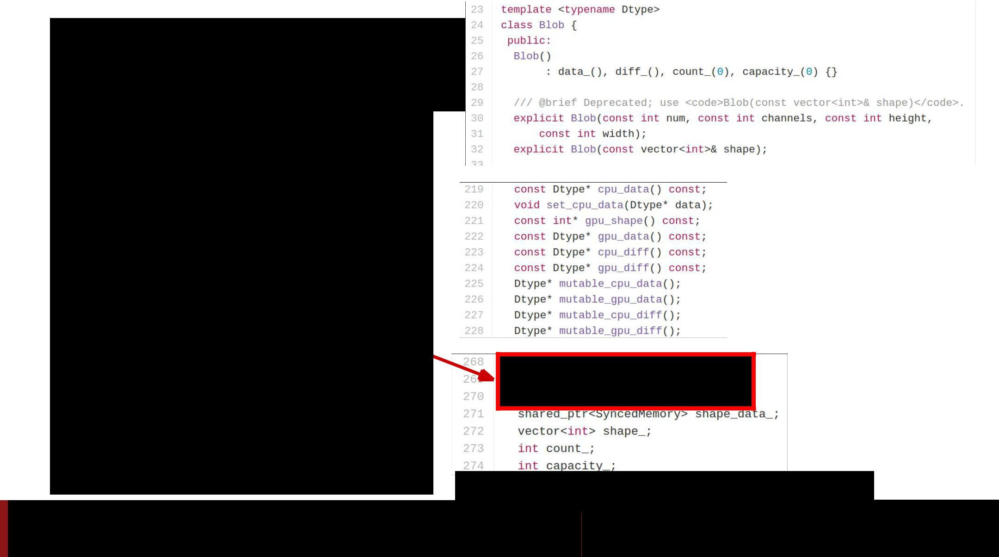**Caffe: Blobs**

* N-dimensional array for storing activations and weights
* Template over datatype
* Two parallel tensors:
  + **data**: values
  + **diffs**: gradients

<https://github.com/BVLC/caffe/blob/master/include/caffe/blob.hpp>

Fei-Fei Li & Andrej Karpathy & Justin Johnson Lecture 12 165 22 Feb 2016

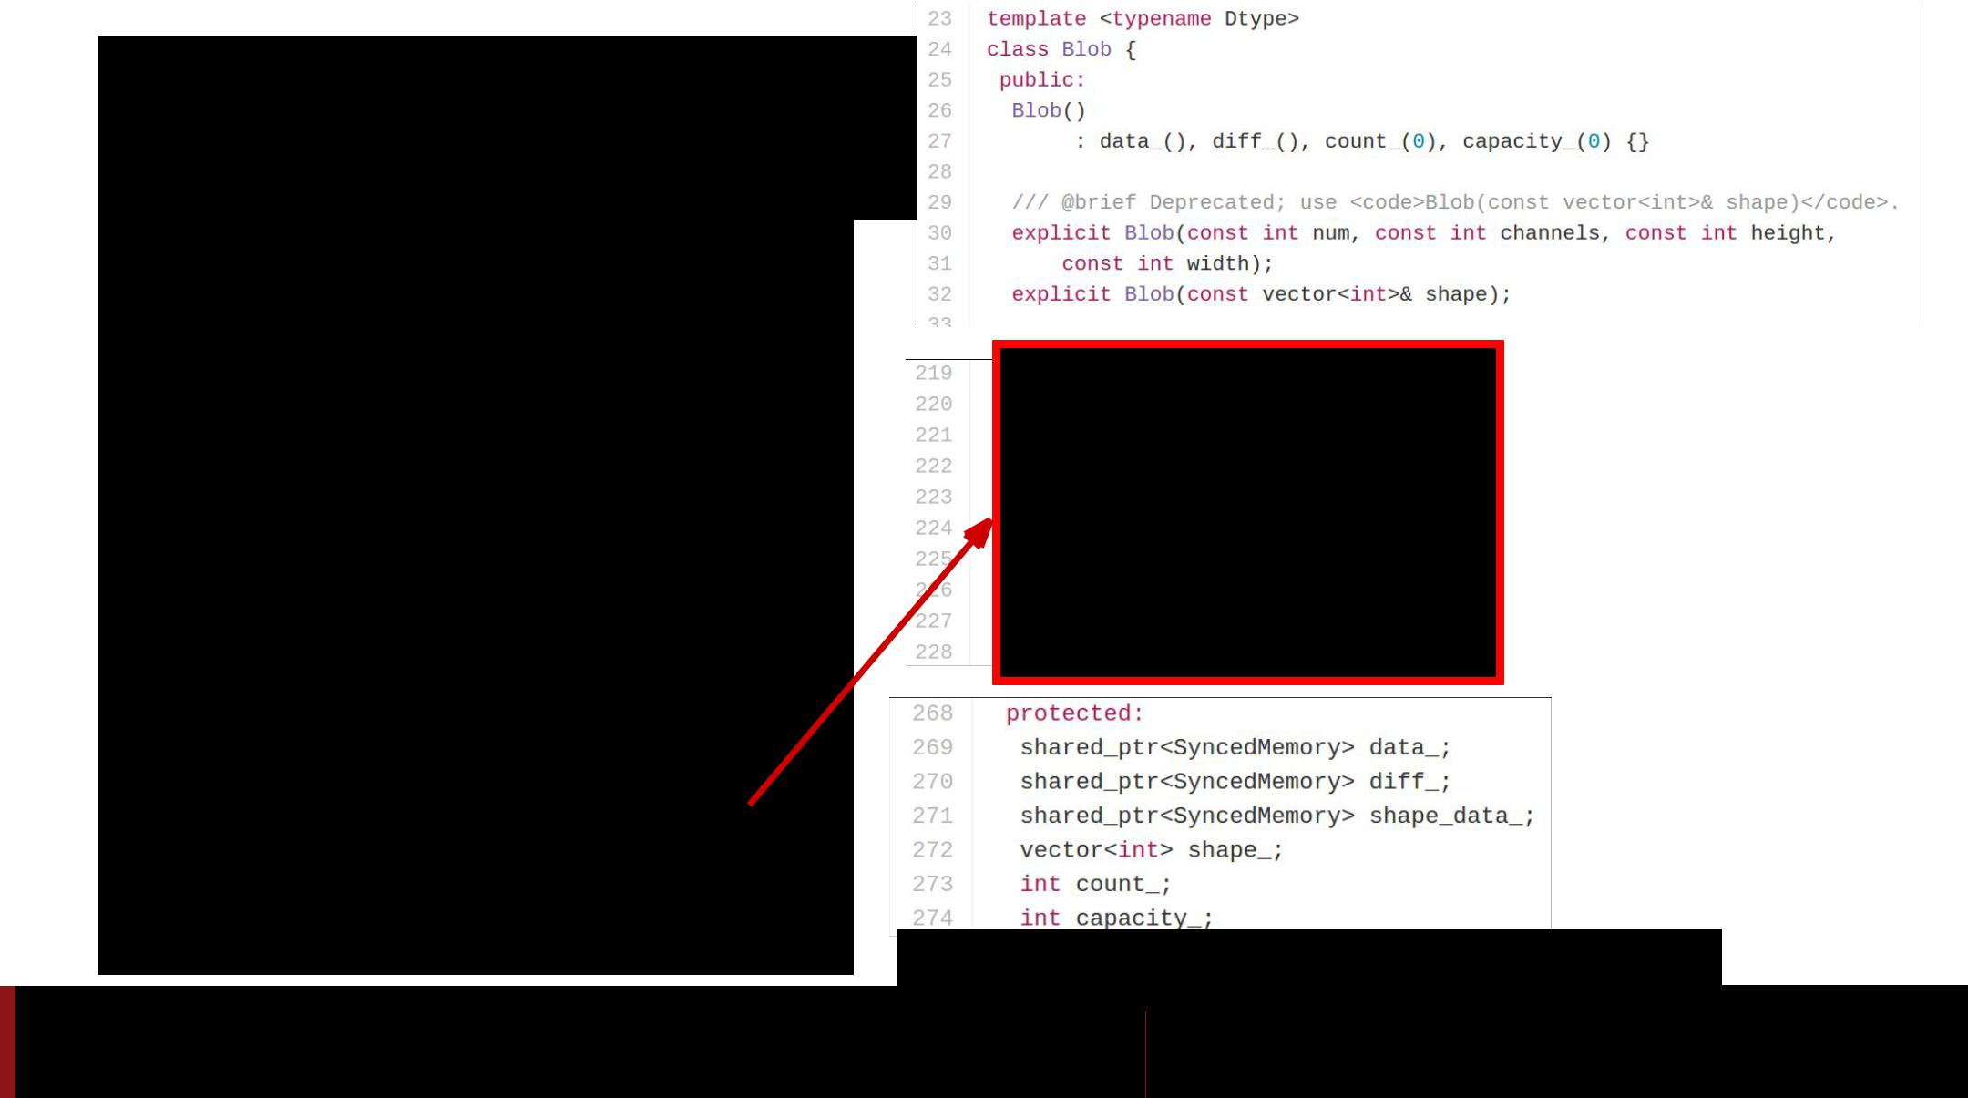**Caffe: Blobs**

* N-dimensional array for storing activations and weights
* Template over datatype
* Two parallel tensors:
  + **data**: values
  + **diffs**: gradients
* Stores CPU / GPU versions of each tensor

<https://github.com/BVLC/caffe/blob/master/include/caffe/blob.hpp>

Fei-Fei Li & Andrej Karpathy & Justin Johnson Lecture 12 166 22 Feb 2016

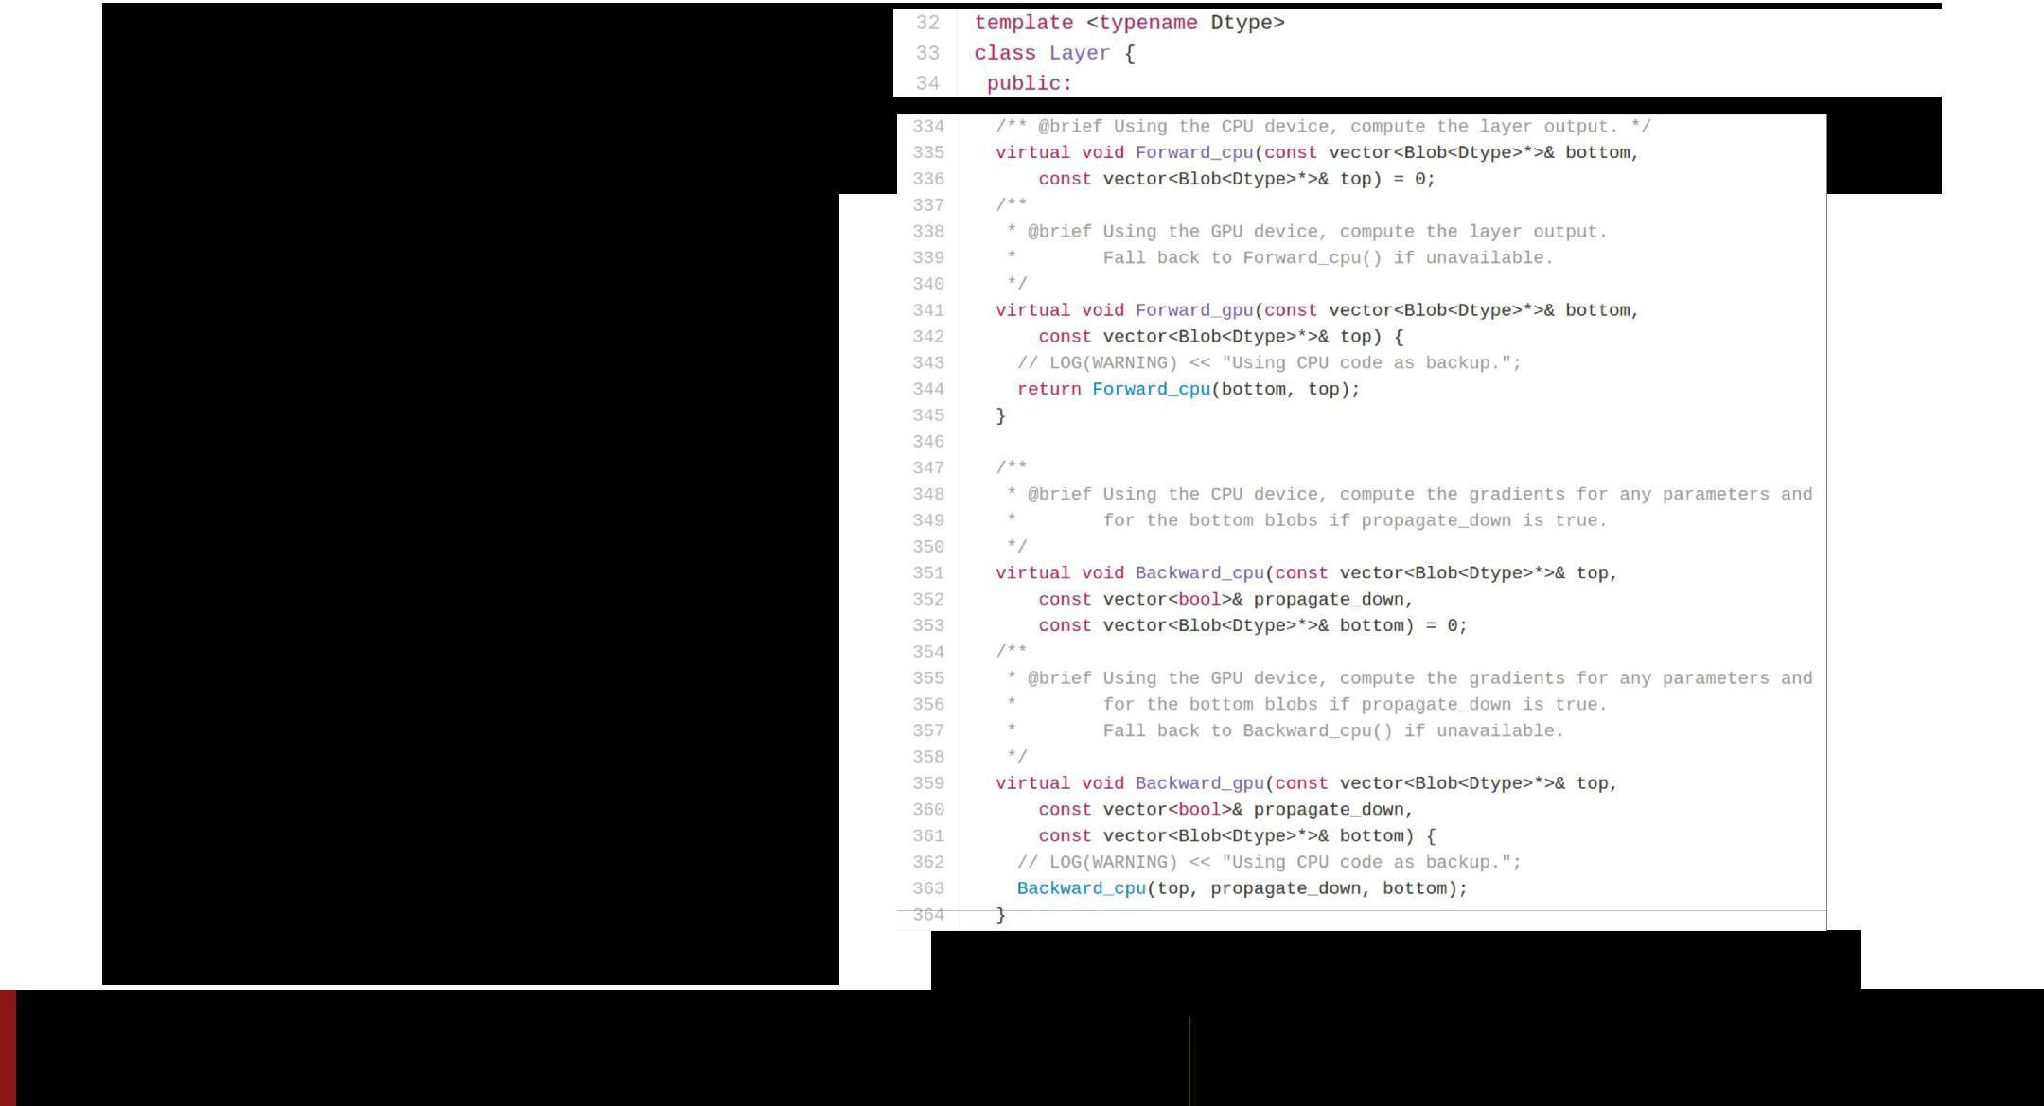**Caffe: Layer**

* A small unit of computation

<https://github.com/BVLC/caffe/blob/master/include/caffe/layer.hpp>

Fei-Fei Li & Andrej Karpathy & Justin Johnson Lecture 12 167 22 Feb 2016

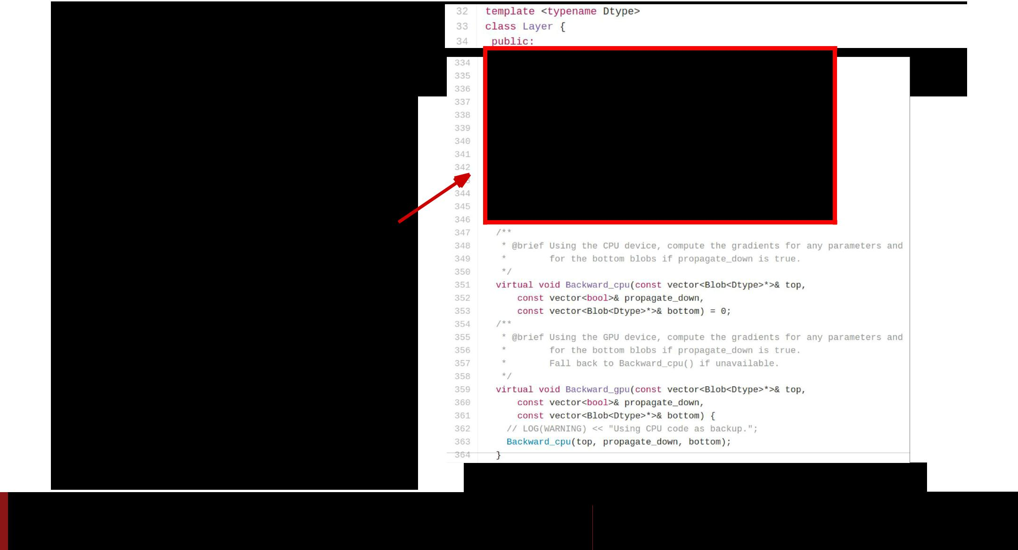**Caffe: Layer**

* A small unit of computation

● **Forward**: Use “bottom”data to compute “top” data

<https://github.com/BVLC/caffe/blob/master/include/caffe/layer.hpp>

Fei-Fei Li & Andrej Karpathy & Justin Johnson Lecture 12 168 22 Feb 2016

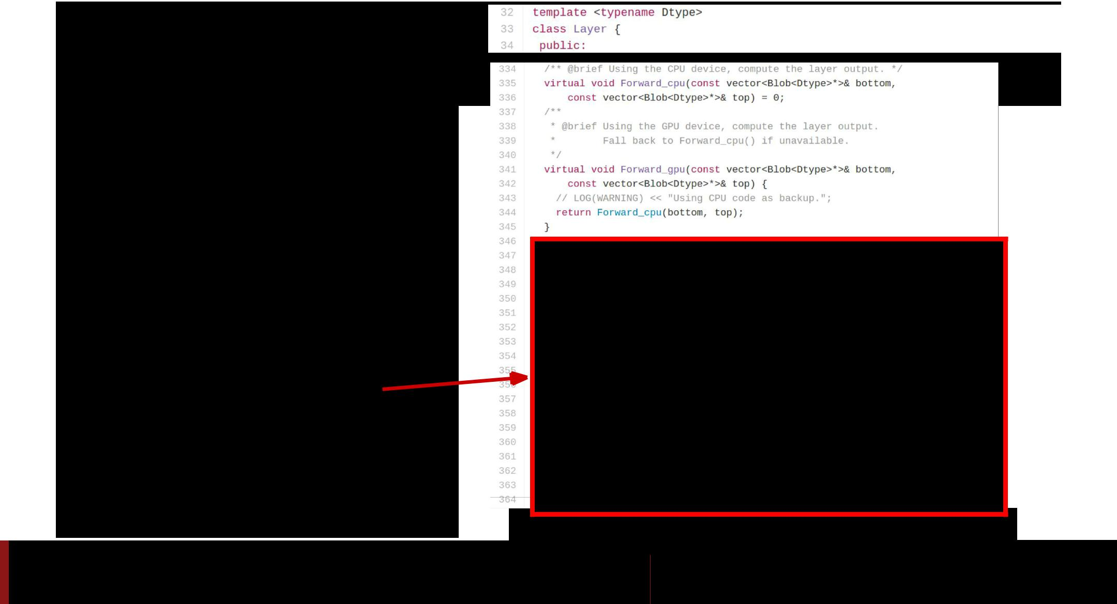**Caffe: Layer**

* A small unit of computation
* **Forward**: Use “bottom”data to compute “top” data
* **Backward**: Use “top”

diffs to compute

“bottom” diffs

<https://github.com/BVLC/caffe/blob/master/include/caffe/layer.hpp>

Fei-Fei Li & Andrej Karpathy & Justin Johnson Lecture 12 169 22 Feb 2016

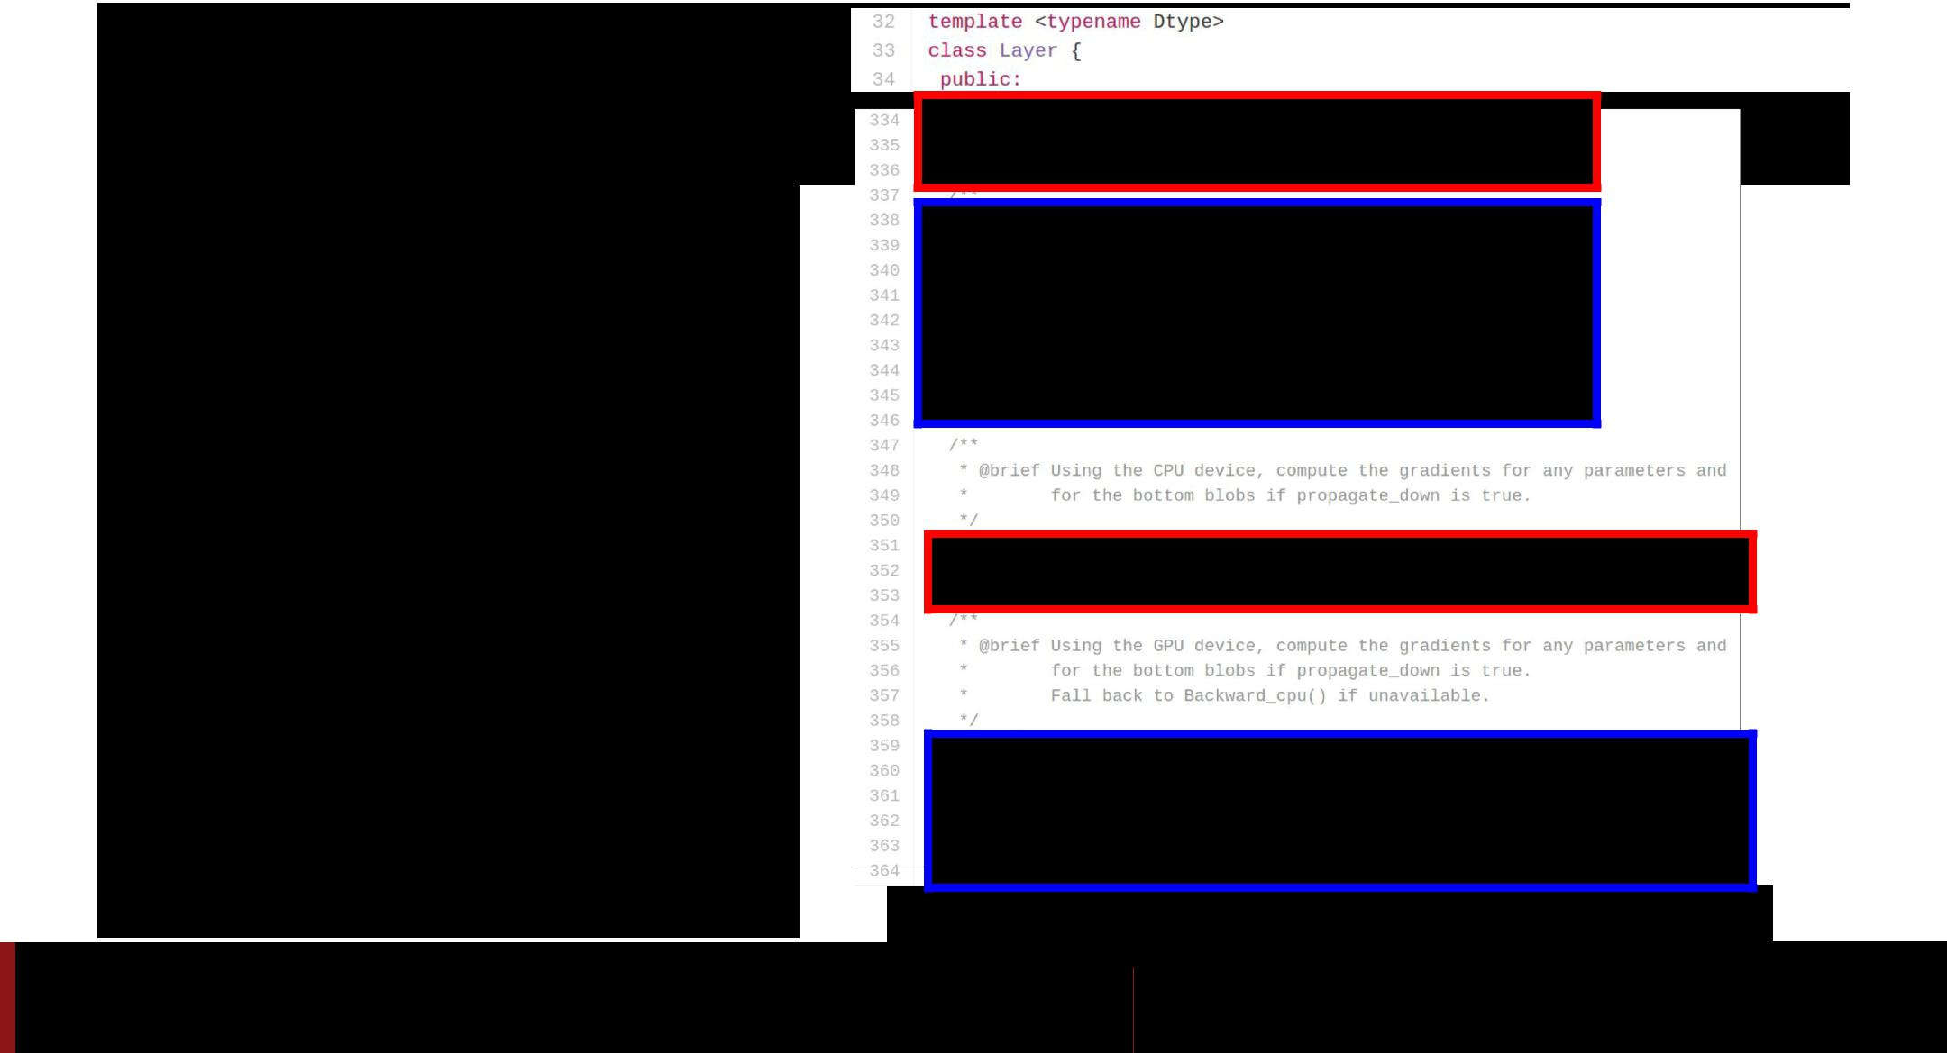**Caffe: Layer**

● A small unit of computation

* **Forward**: Use “bottom”data to compute “top” data

**● Backward**: Use “top”diffs to compute “bottom” diffs

* Separate **CPU** / **GPU** implementations

<https://github.com/BVLC/caffe/blob/master/include/caffe/layer.hpp>

Fei-Fei Li & Andrej Karpathy & Justin Johnson Lecture 12 170 22 Feb 2016

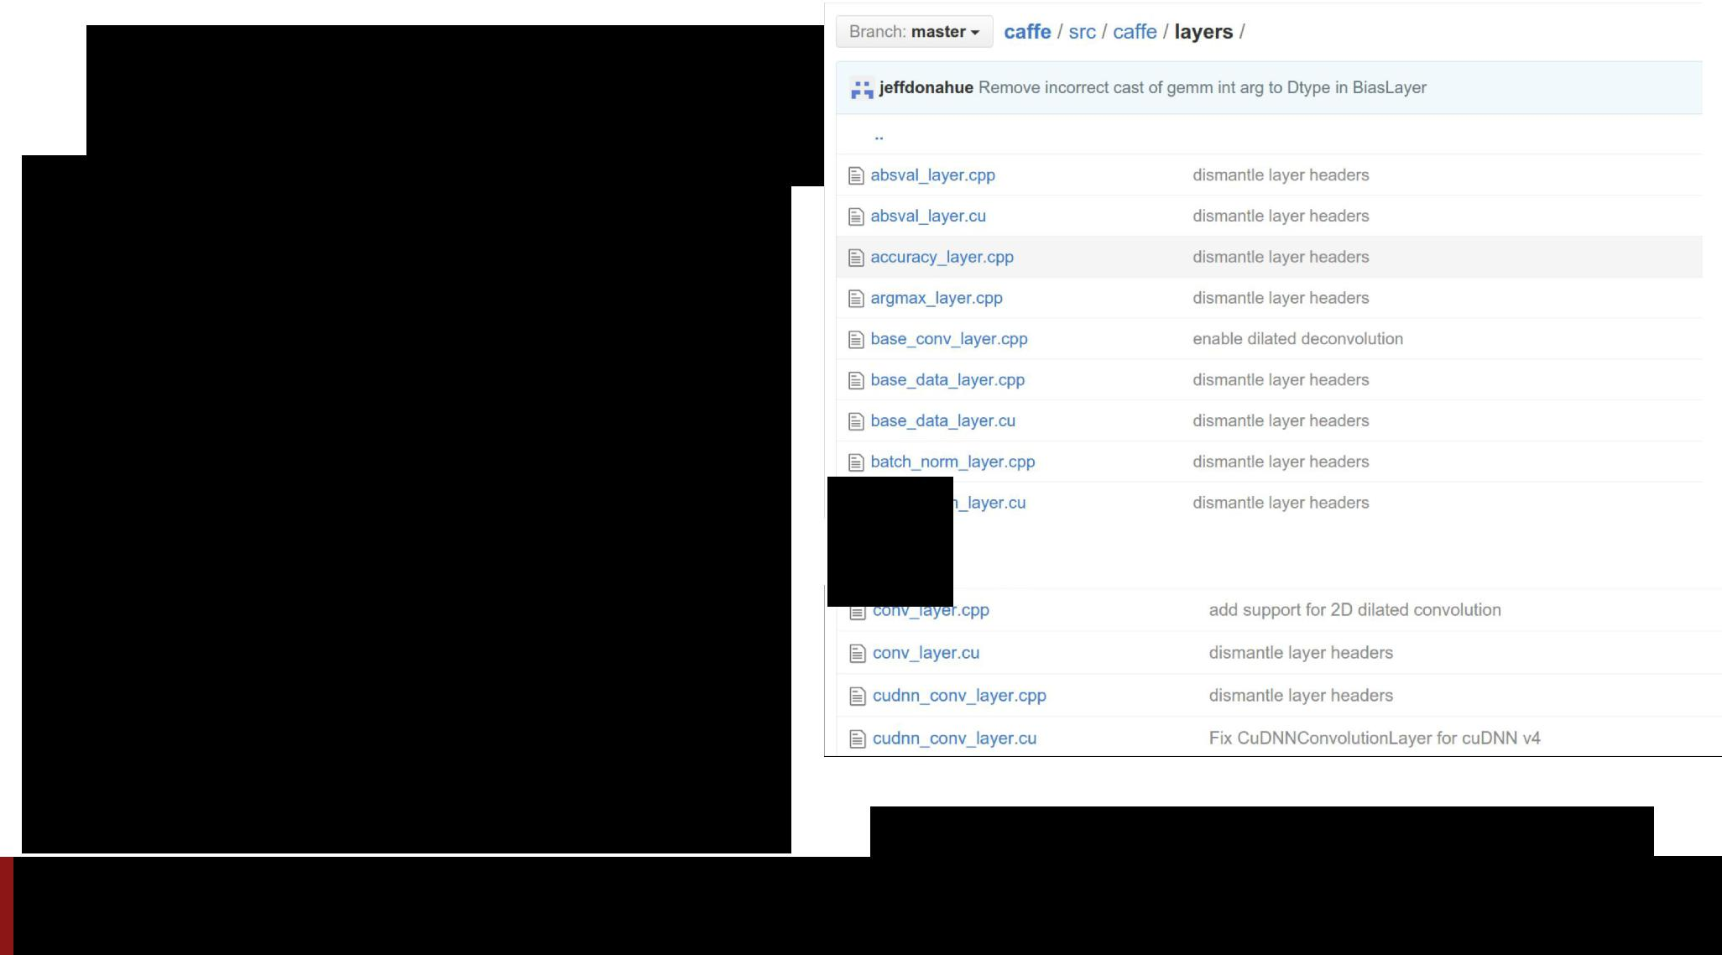**Caffe: Layer**

● Tons of different layer types:

...

<https://github.com/BVLC/caffe/tree/master/src/caffe/layers>

Fei-Fei Li & Andrej Karpathy & Justin Johnson Lecture 12 171 22 Feb 2016

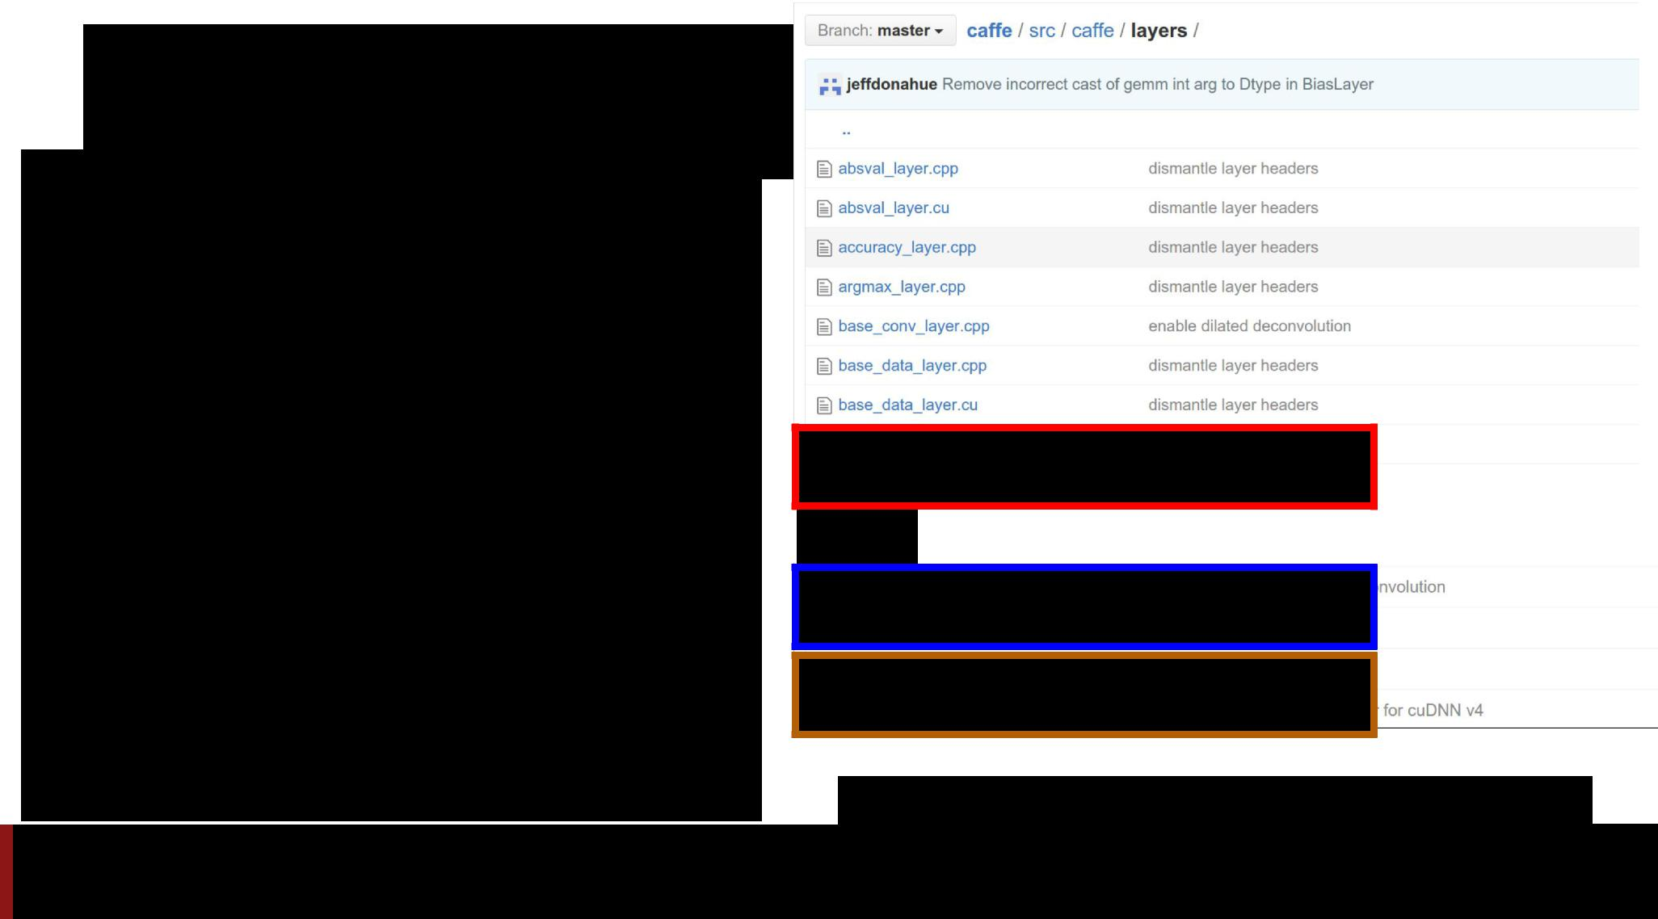**Caffe: Layer**

* Tons of different layer types:
  + **batch norm**
  + **convolution**
  + **cuDNN convolution**

...

* **.cpp:** CPU implementation
* **.cu**: GPU implementation

<https://github.com/BVLC/caffe/tree/master/src/caffe/layers>

Fei-Fei Li & Andrej Karpathy & Justin Johnson Lecture 12 172 22 Feb 2016

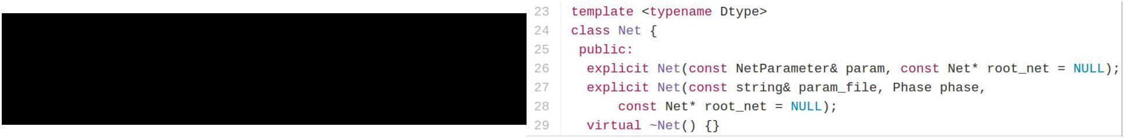**Caffe: Net**



* Collects layers into a DAG
* Run all or part of the net **forward** and **backward**

<https://github.com/BVLC/caffe/blob/master/include/caffe/net.hpp>

Fei-Fei Li & Andrej Karpathy & Justin Johnson Lecture 12 173 22 Feb 2016

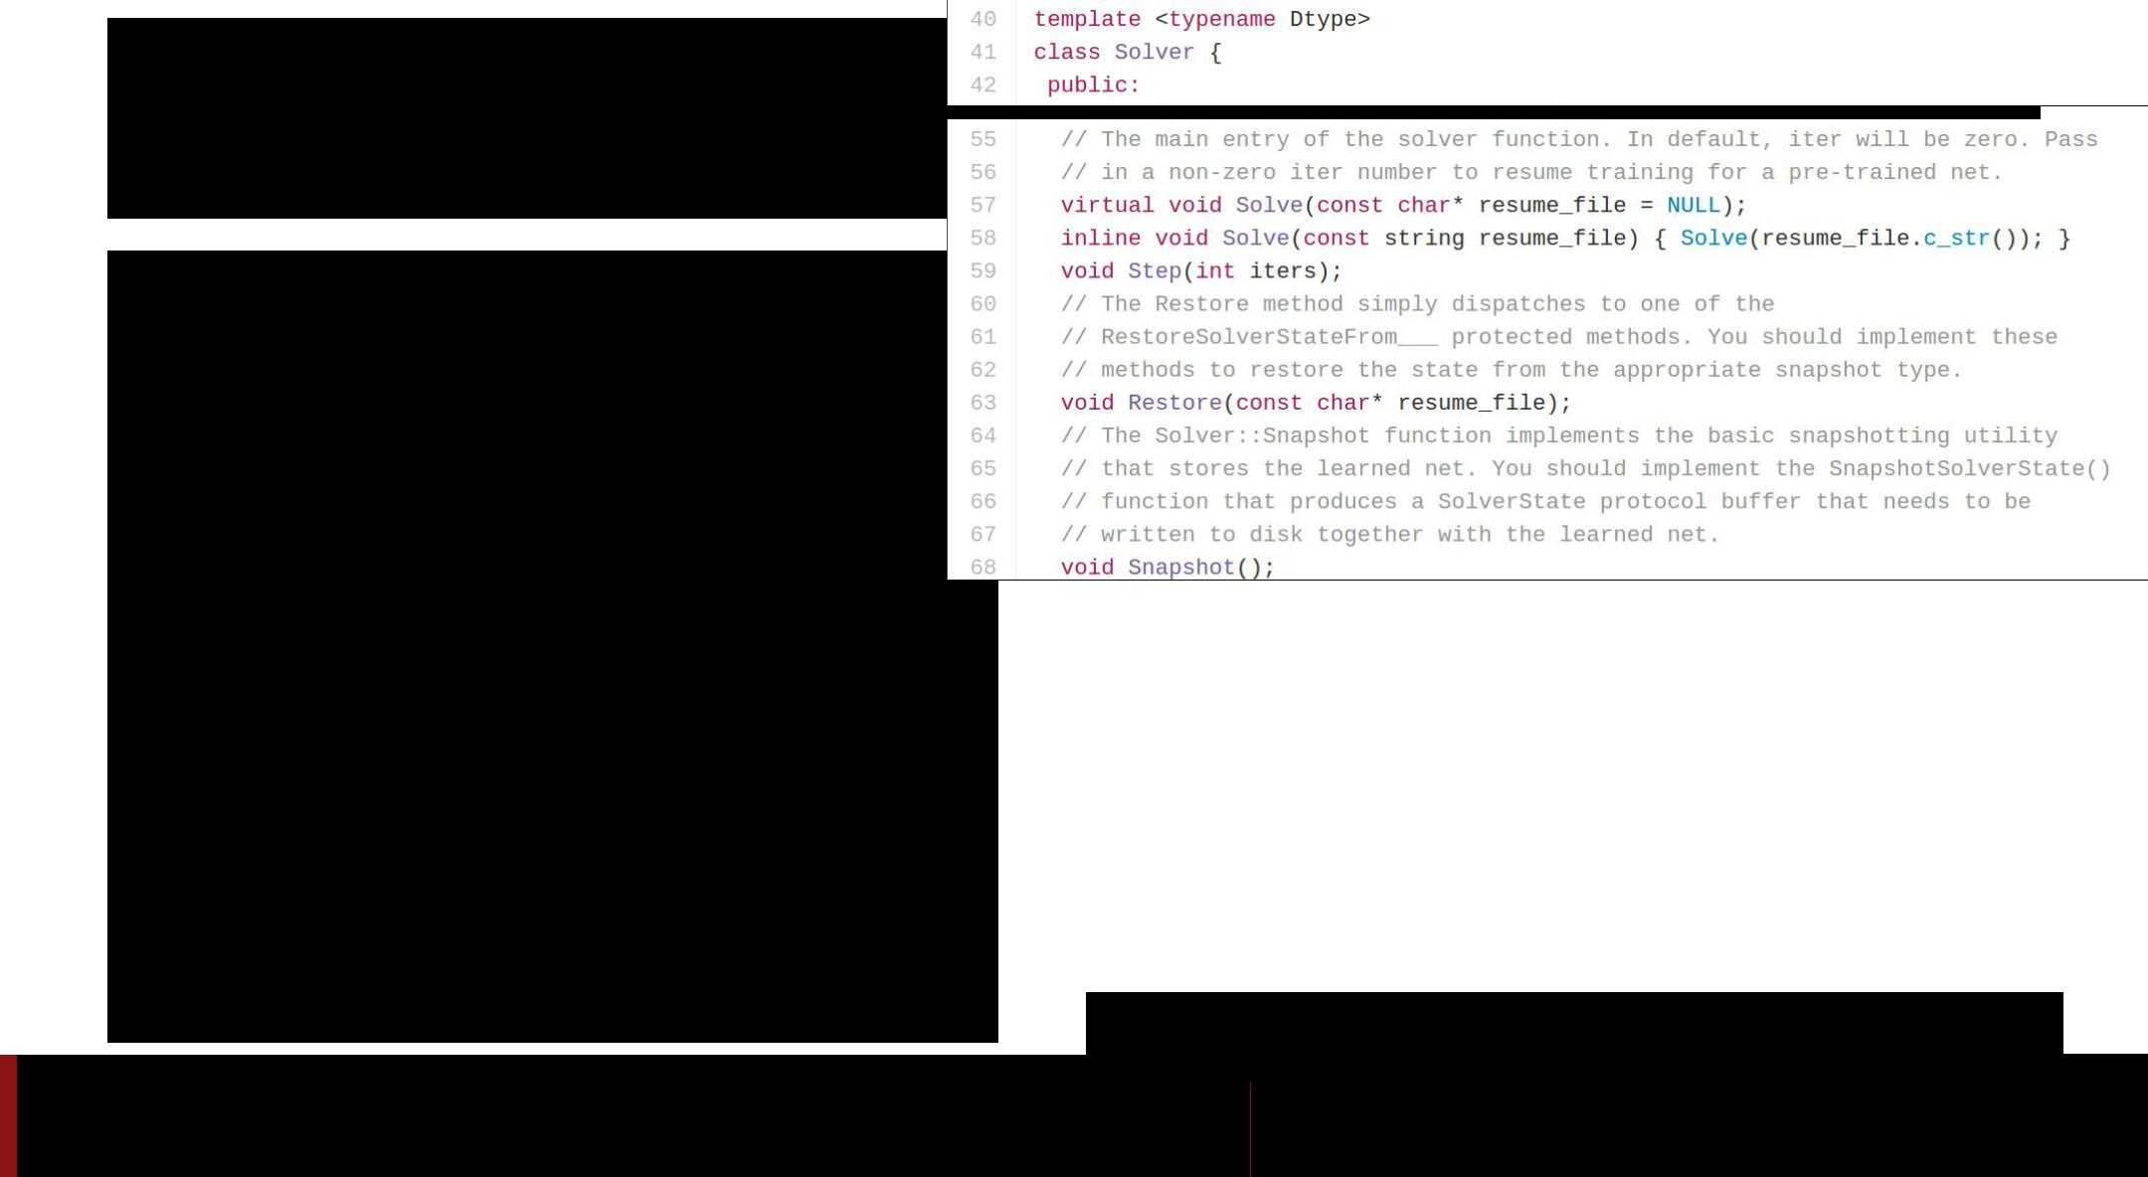**Caffe: Solver**

<https://github.com/BVLC/caffe/blob/master/include/caffe/solver.hpp>

Fei-Fei Li & Andrej Karpathy & Justin Johnson Lecture 12 174 22 Feb 2016

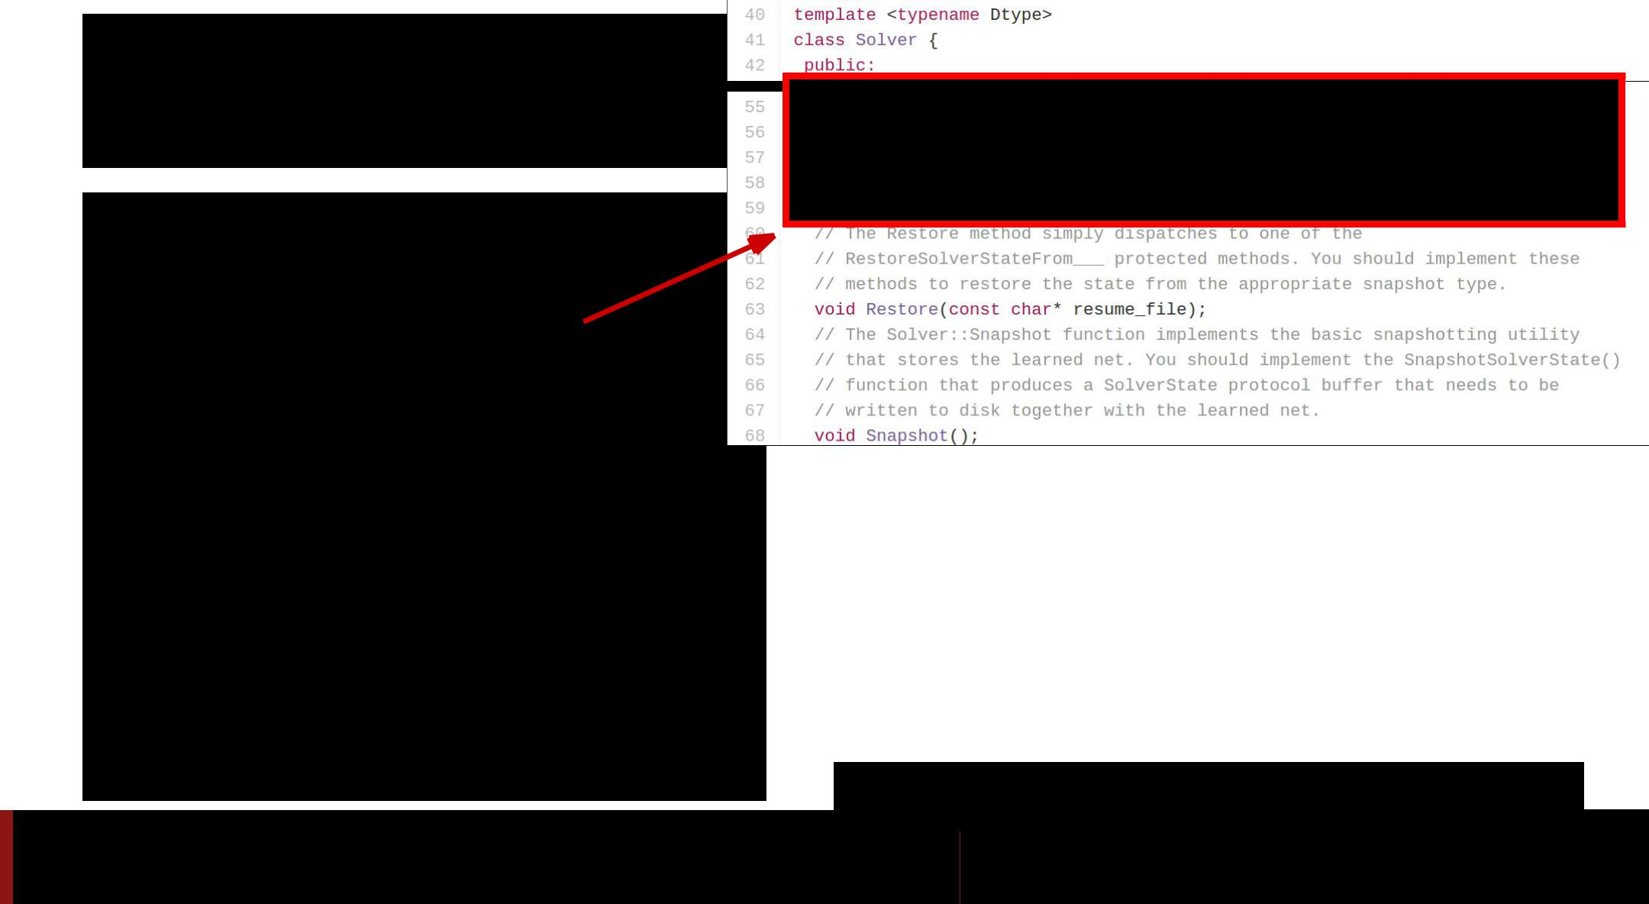**Caffe: Solver**

● Trains a Net by running it forward / backward, updating weights

<https://github.com/BVLC/caffe/blob/master/include/caffe/solver.hpp>

Fei-Fei Li & Andrej Karpathy & Justin Johnson Lecture 12 175 22 Feb 2016

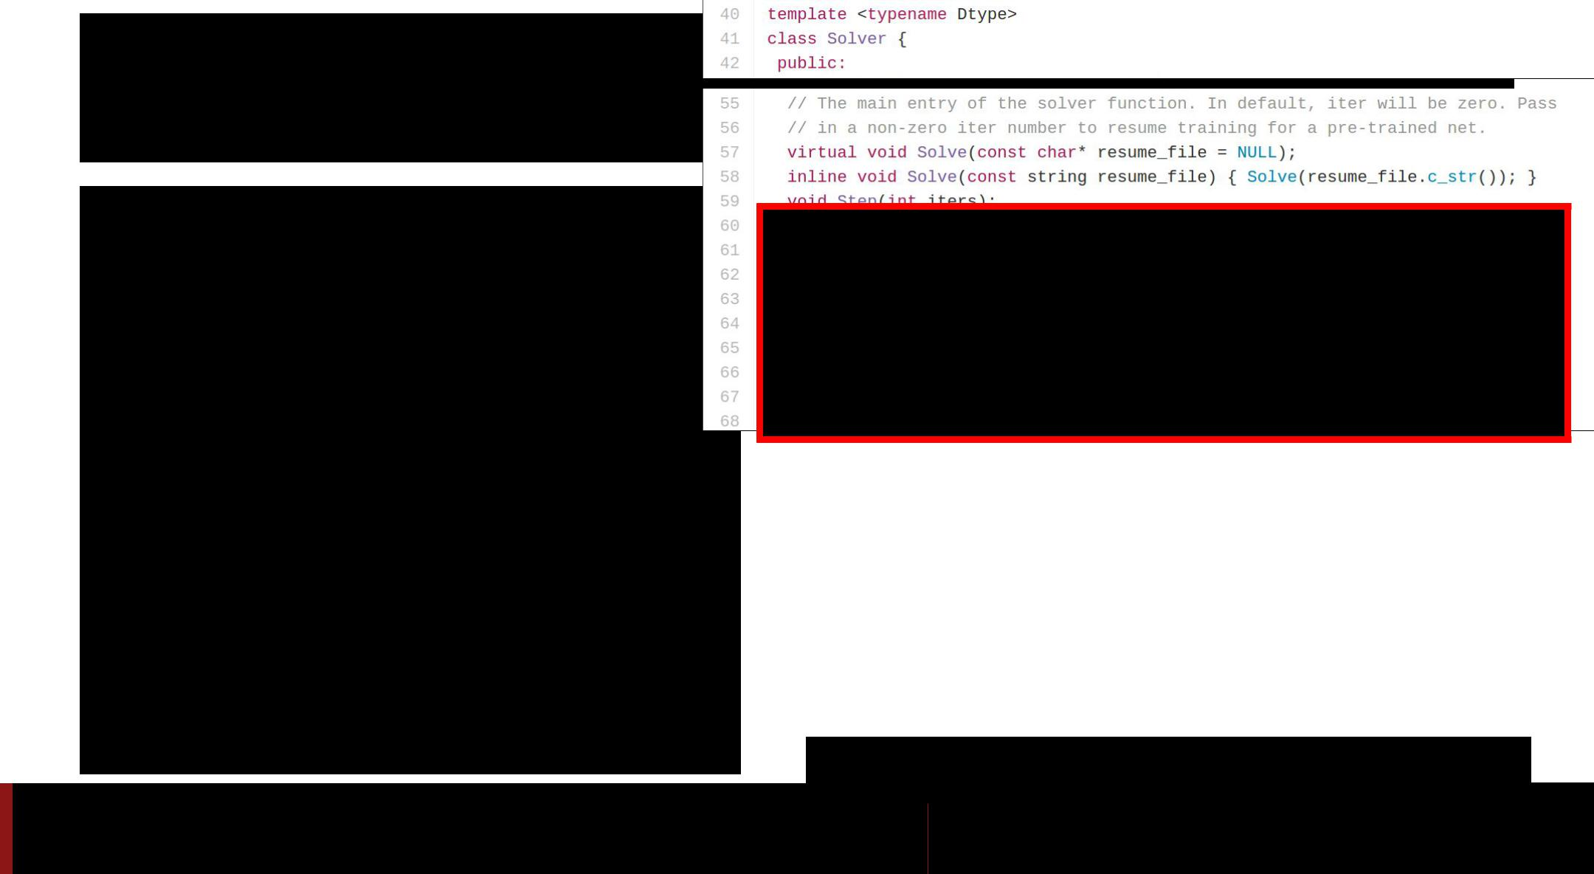**Caffe: Solver**

* Trains a Net by running it forward / backward, updating weights
* Handles snapshotting,  restoring from snapshots

<https://github.com/BVLC/caffe/blob/master/include/caffe/solver.hpp>

Fei-Fei Li & Andrej Karpathy & Justin Johnson Lecture 12 176 22 Feb 2016

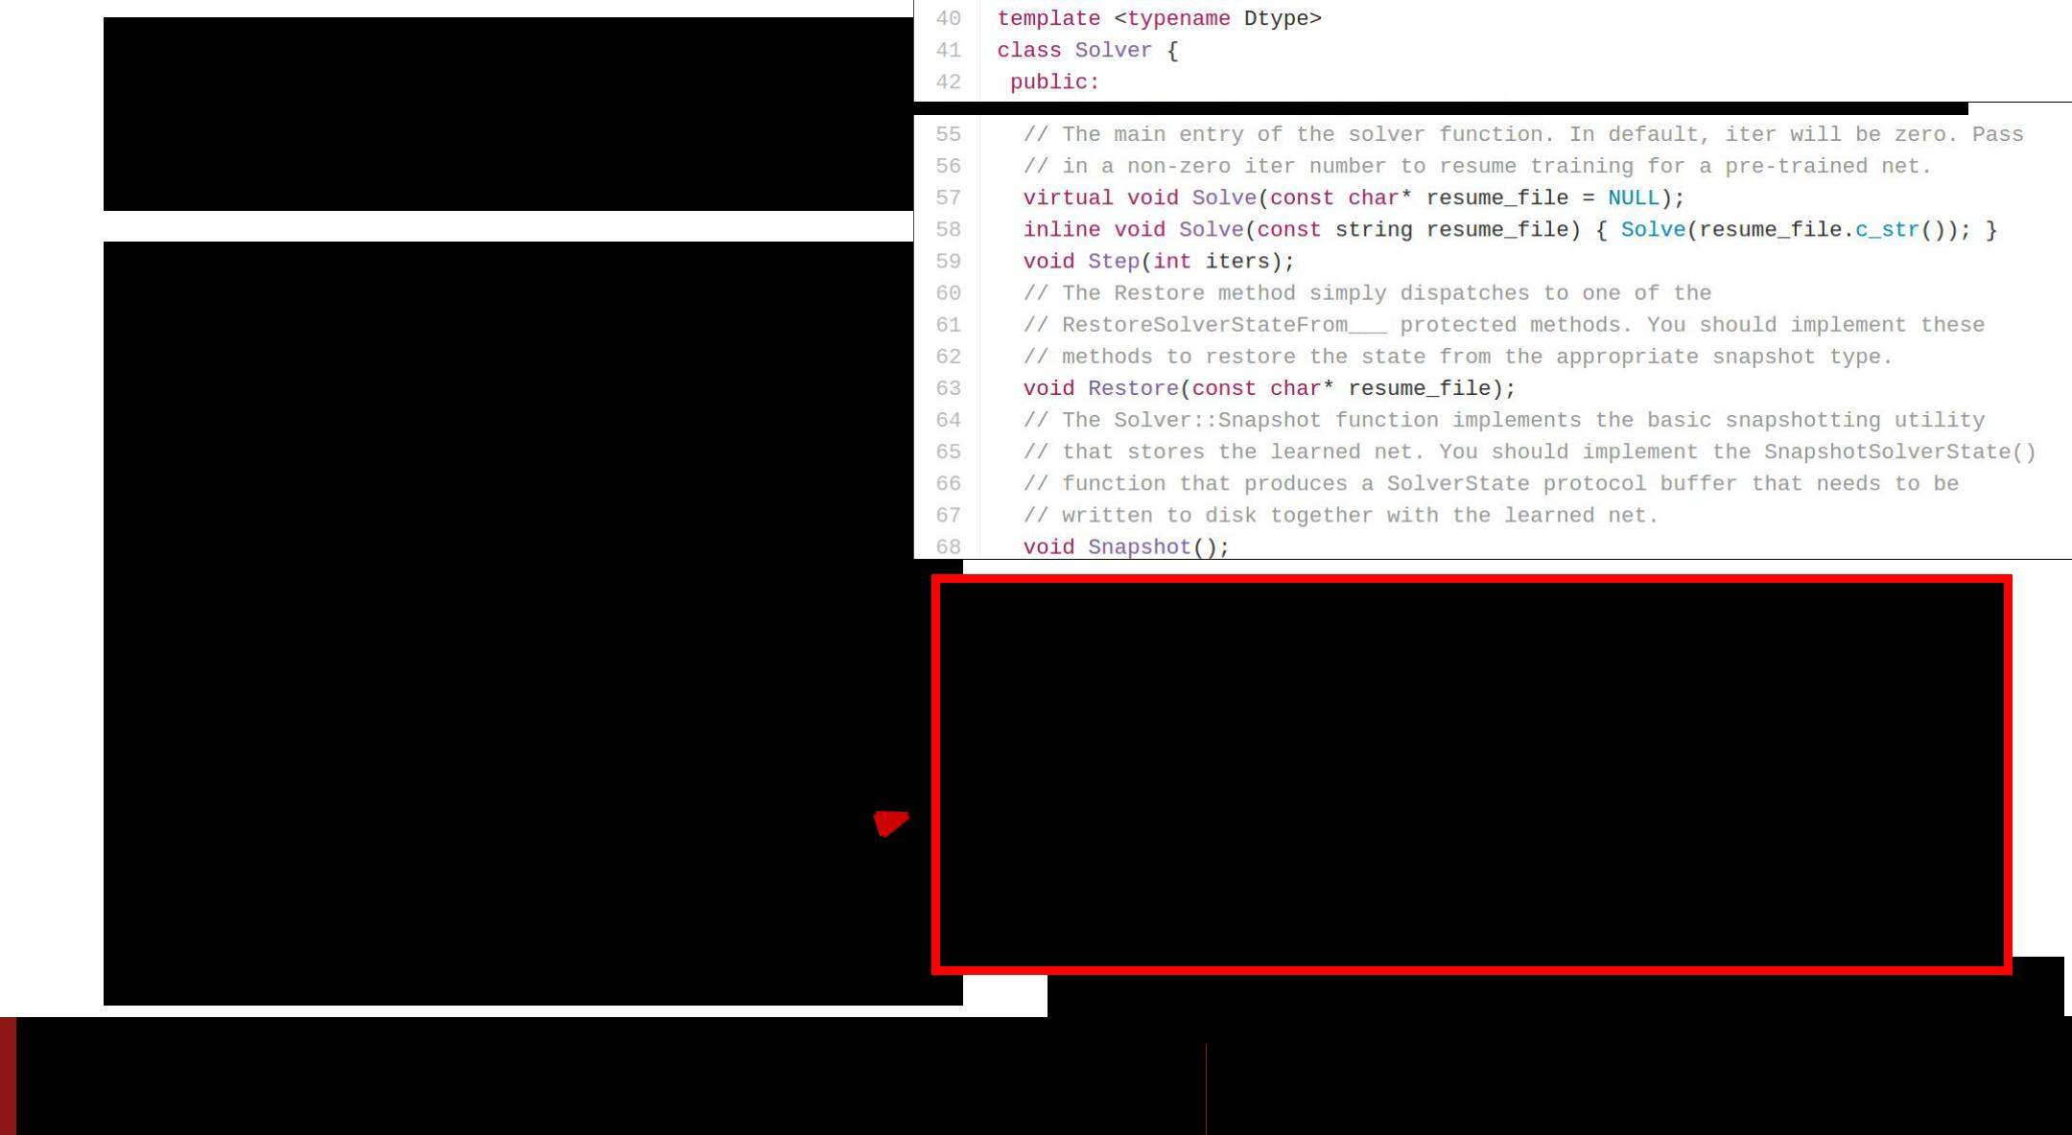**Caffe: Solver**

* Trains a Net by running it forward / backward, updating weights
* Handles snapshotting,

restoring from snapshots

* Subclasses implement different update rules 

<https://github.com/BVLC/caffe/blob/master/include/caffe/sgd_solvers.hpp>

Fei-Fei Li & Andrej Karpathy & Justin Johnson Lecture 12 177 22 Feb 2016